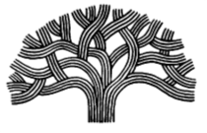

CITY OF OAKLAND
Youth Advisory Commission Meeting Agenda
October 24, 2019
150 Frank Ogawa Plaza, 4th Floor, Conference Room 1
Meeting: 5:00 P.M. – 7:00 P.M.

AGENDA

5:00-5:30pm Welcome
Team Building Activity
Food and Refreshments

5:30-7:00pm Group Dynamics
Facilitation

7:00pm Meeting Adjourned

