**Neighborhood Block Party!**

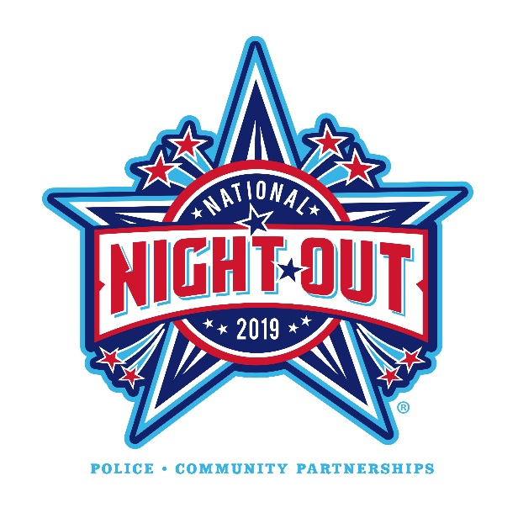

**Get to know your neighbors!**

**Celebrate National Night Out!!!**

Tuesday, August 6, 2019

National Night Out is a nationwide annual event designed to raise crime prevention awareness, strengthen neighborhood spirit and unity, and foster community-police partnerships.

**Come join your neighbors!**

**Location:** ________________________________________________________

**Time:** ___________________________________________________________

**What you should bring:**____________________________________________

**Who to contact:** ________________________________ **Phone:** ___________