City of Oakland
Oakland Police Department



Annual Military Equipment Report
2023

Contents
Preface……………................................................................................................................... 4
Executive Summary............................................................................................................. 5
Definitions…………………………………………………………………………………………………………………….. 7
Summary of Military Equipment……………………………………………………………………………………. 9
Unmanned Aircraft System
DJI Mavic Enterprise 2 Advanced……………………………………………………………………… 9
DJI Mavic Mini………………………………………………………………………………………………….. 10
DJI Matrice 300 RTK…..……………………………………………………………………………………… 10
Unmanned Robots
ICOR Mini Caliber……………………………………………………………………………………………… 11
Avatar Tactical Robot………………………………………………………………………………………… 11
Andros Mark 5A-1…………………………………………………………………………………………….. 11 ERV (Bearcat)/Armored Suburban……………………………………………………………………………………12
Mobile Command Vehicles
OFD/OPD Mobile Command Vehicle…………………………………………………………………. 13
OPD Community Resource Vehicle……………………………………………………………………. 14
HNT…………………………………………………………………………………………………………………… 14
Breaching apparatuses
Remington Breaching Shotgun…………………………………………………………………………. 15
Royal Arms 12 GA Breaching Rounds Tesar………………………………………………………. 16
Royal Arms 12 GA Breaching Rounds Tesar-2…………………………………………………… 16
Royal Arms 12 GA Breaching Rounds Tesar-3…………………………………………………… 17
Dyno Nobel / Primacord 21……………………………………………………………………………… 17
Dyno Nobel / Primacord 10……………………………………………………………………………… 17
Dyno Nobel / Primacord 5……………………………………………………………………………….. 17
Dyno Nobel / Primacord 4y……………………………………………………………………………… 18
Ensign-Bickford / PRIMASHEET………………………………………………………………………… 18
Dyno Nobel / Nonel MS 1.4B…………………………………………………………………………… 18
Specialized firearms and ammunition
Colt LE6920 (AR15) …………………………………………………………………………………………… 19
Noveske N4………………………………………………………………………………………………………. 19
Bravo Company Manufacturing (BCM CQB MCMR 11) ……………………………………. 20
GA Precision Bolt Action .308 Win Rifle……………………………………………………………. 21
Speer LE Gold Dot .223 75 grain ……………………………………………………………………… 21
Winchester (RA 556B 64 grain)………………………………………………………………………… 21
Federal .223 55 grain……………………………………………………………………………………….. 22
Federal 308 Win 165 grain………………………………………………………………………………… 22
Hornady 308 Win ……………………………………………………………………………………………… 22
Light Sound incendiary Device, aka “Flashbang Grenades”, and smoke.
Defense Technology / Riot Control 1082…………………………………………………………… 23
Defense Technology / Triple Chaser 1026…………………………………………………………. 23
Combined Tactical Systems/ Triple Phaser 5231………………………………………………. 24
Defense Technology/ CS Han-Ball 1092……………………………………………………………. 24
Defense Technology/ CS Blast 1097…………………………………………………………………. 24
Combined Tactical System/ 9430 Tear Ball CS…………………………………………………… 24
Defense Technology/ Inert Blast 1098………………………………………………………………. 25
Defense Technology/ Stinger 1087……………………………………………………………………. 25
Defense Technology/ 1032……………………………………………………………………………….. 25
Defense Technology/ CS 1016…………………………………………………………………………… 25
Combined Tactical Systems/ 5230B…………………………………………………………………… 26
Defense Technology/ CS 2262…………………………………………………………………………… 26
Combined Tactical System/ CTS 7290M…………………………………………………………….. 26
CTS 4233 40mm CS Multi 3 Smoke…………………………………………………………………… 26
CTS 9410 Inert Rubber Ball Tear Grenade…………………………………………………………. 27
CTS 1901A Mk9 Hose and Wand OC…………………………………………………………………. 27
CTS 1337 OC Aerosol Fogger 2oz………………………………………………………………………. 27
CTS 9230 CS Smoke Jet Lite Rubber Ball, Pyro…………………………………………………… 27
Long Range Acoustic Devices (LRADs)
LRAD/ 100X………………………………………………………………………………………………………. 28
LRAD/ 450X………………………………………………………………………………………………………. 28
40mm projectile launchers, “bean bags,” and specialty impact munition
(SIM) weapons
Defense Technology (40mm single launcher)……………………………………………………. 29
Penn Arms (PGL 65-40) …………………………………………………………………………………….. 30
Wilson Combat…………………………………………………………………………………………………. 31
Defense Technology/ CS SKAT Shell 6172………………………………………………………….. 31
Defense Technology/ CS Muzzle Blast 6042………………………………………………………. 32
Defense Technology/ Foam Baton 6099……………………………………………………………. 32
Defense Technology/ Direct Impact Marking 6326……………………………………………. 32
Combined Tactical System/ Frangible Impact 4550 Orange Marking Powder……. 32
Combined Tactical System/ 12GA 2581 Super Sock…………………………………………… 33
CTS 4431 40mm CS Powder No Flame Barricade Indoor…………………………………… 33
Crowd- control equipment
Helmet-Non Ballistic…………………………………………………………………………………………. 34
Military Equipment Usage Summary.................................................................................... 35
Geographic Reference Map.................................................................................................. 36
Itemized Military Equipment Usage……….…….…………………………………………………………………..37
Search Warrant Usage Area……………………………………………………………………………………………..68
Complaints Summary........................................................................................................... 68
Internal Audits Regarding Military Equipment Usage.......................................................... 68
Military Equipment Inventory……….….…………………………………………………………………………….. 69
Fiscal Impact by Equipment Type… ……………………………………………………………………………….. 72
Estimated Projected Cost Fiscal Year 2023...........................................................................77
Conclusion.............................................................................................................................84

Links to laws and policy:1 Law enforcement and state agencies: military equipment: funding, acquisition, https://leginfo.legislature.ca.gov/faces/billNavClient.xhtml?bill_id=202120220AB481
Oakland Municipal Code 9.65: Chapter 9.65 - REGULATIONS ON CITY'S ACQUISITION AND USE OF MILITARY AND MILITARISTIC EQUIPMENT
Attached Oakland Police Department Policy related to the use of Military Equipment:
- TB III-G: OPD Crowd Control and Crowd Management Policy
- TB III-P.04: Armored Vehicles
- TB V F.02 Chemical Agents
- TB III-H: Specialty Impact Munitions
- DGO I-25: Unmanned Aerial Systems
- DGO K-3: Use of Force
- DGO K-4: Reporting and Investigating the Use of Force
- DGO K-5: Tactical Operations Team
- DGO K-6: Patrol Rifle Program

Preface

The Oakland Police Department is committed to maintaining public safety by providing the highest quality of police services to the communities in the City of Oakland.
The equipment listed in this annual report are essential tools that may be required from time to time to aid in deescalating intense situations or bringing critical incidents to a safe resolution.
The mere possession of this equipment does not warrant its use in every circumstance. However, having this equipment and adequate resources available if needed, makes our department capable of bringing possible hostile critical conflicts to safe and peaceful resolutions.
Being transparent with our communities regarding all equipment used by the Oakland Police Department not only helps with transparency but helps build trust within the communities we serve.

Executive Summary:
On September 30, 2021, Governor Newsom signed Assembly Bill AB 481 into law, which established protocols for law enforcement agencies regarding the funding, acquisition, use, and reporting of specified law enforcement equipment items. The bill added Government Code Section 7070 that designated numerous vehicles, weapon systems and munitions used by the Oakland Police Department as “military equipment.”
AB-481, Section 7072 states the following:
(a) A law enforcement agency that receives approval for a military equipment use policy pursuant to Section 7071 shall submit to the governing body an annual military equipment report for each type of military equipment approved by the governing body within one year of approval, and annually thereafter for as long as the military equipment is available for use. The law enforcement agency shall also make each annual military equipment report required by this section publicly available on its internet website for as long as the military equipment is available for use. The annual military equipment report shall, at a minimum, include the following information for the immediately preceding calendar year for each type of military equipment:
(1) A summary of how the military equipment was used and the purpose of its use.
(2) A summary of any complaints or concerns received concerning the military equipment.
(3) The results of any internal audits, any information about violations of the military equipment use policy, and any actions taken in response.
(4) The total annual cost for each type of military equipment, including acquisition, personnel, training, transportation, maintenance, storage, upgrade, and other ongoing costs, and from what source funds will be provided for the military equipment in the calendar year following submission of the annual military equipment report.
(5) The quantity possessed for each type of military equipment.
(6) If the law enforcement agency intends to acquire additional military equipment in the next year, the quantity sought for each type of military equipment.
(b) Within 30 days of submitting and publicly releasing an annual military equipment report pursuant to this section, the law enforcement agency shall hold at least one well-publicized and conveniently located community engagement meeting, at which the public may discuss and ask questions regarding the annual military equipment report and the law enforcement agency’s funding, acquisition, or use of military equipment.
The Oakland City Council previously passed Oakland Municipal Code 9.65 Regulations on City’s Acquisition and Use of Military and Militaristic equipment. The code mirrors the Government Code 7070 except for #12: Crowd-control equipment, such as riot batons, riot helmets, and riot shields, but excluding service-issued telescopic or fixed-length straight batons. The Council directed the Department to go through the Oakland Police Commission for any acquisitions and use of controlled equipment.
9.65.010 States the following:
"Annual Controlled Equipment Report" means a publicly released written document that includes, at a minimum, all of the following information for the immediately preceding calendar year:
1. Production descriptions and specifications for controlled equipment and inventory numbers of each type of controlled equipment in the Police Department's possession. The Police Commission may waive the remaining obligations for annual reporting for a specific type of equipment if the Police Department certifies, in advance of issuing the Annual Controlled Equipment Report, that the equipment was not used or purchased in the immediately preceding calendar year.
2. A summary of how controlled equipment was used.
3. If applicable, a breakdown of where controlled equipment was used geographically by police area. For each police area, the Police Department shall report the number of days-controlled equipment was used and what percentage of those daily reported uses were authorized by warrant and by non-warrant forms of court authorization.
4. A summary of any complaints or concerns received concerning controlled equipment.
5. The results of any internal audits, any information about violations of controlled equipment uses policies to the extent permitted by law, and any actions taken in response.
6. The estimated annual cost for each type of controlled equipment, including acquisition, personnel, training, transportation, maintenance, storage, upgrade, and other ongoing costs, and from what source funds will be provided for controlled equipment in the calendar year following submission of the annual report.
7. Impact: An updated assessment specifically identifying any potential impacts that the use of the controlled equipment might have on the welfare, safety, civil rights, and civil liberties of the public, and what specific affirmative measures will be implemented to safeguard the public from potential adverse impacts.
8. Mitigations: Specific, affirmative technical and procedural measures that have been implemented to safeguard the public from such impacts.
9. Alternatives: An updated summary of all alternative method or methods the Police Department considered to accomplish the purposes for which the controlled equipment is proposed to be used, the annual costs of alternative method or methods, and the potential impacts of alternative method or methods on the welfare, safety, civil rights, and civil liberties of the public.

The Oakland Police Department is committed to maintaining public safety by providing the highest quality police services to our communities we serve. We will continue to work with our Police Commission on the mission of transparency and good governance in the realm of law enforcement and public safety. Only with a good partnership can we address challenges facing our community while continuing to provide professional, just, and constitutional policing. In accordance with reporting requirements established in AB-481 and OMC 9.65, the Department has generated the following 2023 Annual Military Equipment Report.

Definitions:
Pursuant to AB-481, the following definitions are applicable only to the Department’s current military equipment inventory and potential future military equipment acquisitions for operational needs. (For a more detailed list, refer to Government Code section 7070, for “military equipment” as defined within the Assembly Bill.)

“Governing body” means the elected body that oversees a law enforcement agency or, if there is no elected body that directly oversees the law enforcement agency, the appointed body that oversees a law enforcement agency. In the case of a law enforcement agency of a county, including a sheriff's department or a district attorney's office, "governing body" means the board of supervisors of the county. [Government Code § 7070(a)]. As it pertains to the City of Oakland, the Oakland City Council is the Governing body, but OPD must go through the Oakland Police Commission for requests or submitting reports pertaining to military equipment.
“Military equipment” means the following listed in Government Code § 7070(c)(1)-(15) and Oakland Municipal Code 9.65:
• Unmanned, remotely piloted, powered aerial or ground vehicles [Government Code § 7070].
• Mine-resistant ambush-protected (MRAP) vehicles or armored personnel carriers. However, police versions of standard consumer vehicles are specifically excluded from this subdivision [Government Code § 7070].
• Wheeled vehicles that are built or modified to provide ballistic protection to their occupants, such as mine-resistant ambush protected (MRAP) vehicles or armored personnel carriers. Police versions of standard consumer vehicles are specifically excluded from this section [OMC 9.65]
• High mobility multipurpose wheeled vehicles (HMMWV), commonly referred to as Humvees, two-and-one-half-ton trucks, five-ton trucks, or wheeled vehicles that have a breaching or entry apparatus attached. However, unarmored all-terrain vehicles (ATVs) and motorized dirt bikes are specifically excluded from this subdivision [Government Code § 7070.
• Wheeled vehicles that are built to operate both on-road and off-road, such as a high mobility multipurpose wheeled vehicle (HMMWV), commonly referred to as a Humvee, a two and one-half (2½)-ton truck, or a five (5)-ton truck, or vehicles built or modified to use a breaching or entry apparatus as an attachment. Unarmored all-terrain vehicles (ATVs) and motorized dirt bikes are specifically excluded from this section [OMC 9.65].
• Tracked armored vehicles that provide ballistic protection to their occupants and utilize a tracked system instead of wheels for forward motion [Government Code § 7070].
• Tracked vehicles that are built or modified to provide ballistic protection to their occupants and utilize a tracked system instead of wheels for forward motion [OMC 9.65].
• Command and control vehicles that are either built or modified to facilitate the operational control and direction of public safety units [Government Code § 7070].
• Weaponized aircraft, vessels, or vehicles of any kind [Government Code § 7070].
• Weapon-bearing aircraft, vessels, or vehicles of any kind, whether manned or unmanned [OMC 9.65].
• Battering rams, slugs, and breaching apparatuses that are explosive in nature. However, items designed to remove a lock, such as bolt cutters, or a handheld ram designed to be operated by one person, are specifically excluded from this subdivision [Government Code § 7070].
• Breaching apparatus designed to provide rapid entry into a building or through a secured doorway, including equipment that is mechanical, such as a battering ram, equipment that is ballistic, such as a slug, or equipment that is explosive in nature, but excluding handheld battering rams that can be operated by one person [OMC 9.65].
• Firearms of .50 caliber or greater. However, standard issue shotguns are specifically excluded from this subdivision [Government Code § 7070] and [OMC 9.65].
• Ammunition of .50 caliber or greater. However, standard issue shotgun ammunition is specifically excluded from this subdivision [Government Code § 7070] and [OMC 9.65].
• Specialized firearms and ammunition of less than .50 caliber, including assault weapons as defined in § 30510 and §30515 of the Penal Code, except for standard issue service weapons and ammunition of less than .50 caliber that are issued to officers, agents, or employees of a law enforcement agency or state agency [Government Code § 7070] and [OMC 9.65].
• Any firearm or firearm accessory that is designed to launch explosive projectiles [Government Code § 7070].
• Active area denial weapons, such as the taser shockwave, microwave weapons, water cannons, and the long-range acoustic device (LRAD). [Government Code § 7070]. [OMC 9.65].
• The following projectile launch platforms and their associated munitions: 40mm projectile launchers, “bean bag,” rubber bullet, and specialty impact munition (SIM) weapons, and "riot guns" used to disperse chemical agents [OMC 9.65]. [Government Code § 7070].
• Any weapon designed for hand-to-hand combat, including any knife designed to be attached to the muzzle of a rifle, shotgun, or long gun for purposes of hand-to-hand combat, but excluding service-issued telescopic or fixed-length straight batons [OMC 9.65].
• Explosives and pyrotechnics, such as "flashbang" grenades and explosive breaching tools, and chemical weapons such as "teargas" and "pepper balls" but excluding standard, service-issued handheld pepper spray [OMC 9.65] [Government Code § 7070].
• Crowd-control equipment, such as riot batons, riot helmets, and riot shields, but excluding service-issued telescopic or fixed-length straight batons [OMC 9.65].
• Military surplus equipment [OMC 9.65].
• Any other equipment as determined by a governing body (City Council) or a state agency to require additional oversight [Government Code § 7070] and [OMC 9.65].

Military Equipment Summary
Unmanned Aircraft Systems
Unmanned Aircraft Systems (UAS): Unmanned, remotely piloted, powered aerial system. An unmanned aircraft of any type that can sustain directed flight, whether pre-programmed or remotely controlled, and all of the supporting or attached systems designed for gathering information through imaging, recording or by any other means.
Capabilities: Remotely piloted aerial vehicle capable of providing live and recorded video
images captured from aerial positions, including images enhanced by Forward Looking Infrared (FLIR),
thermal, and optical zoom lenses.
Purpose/Authorized Uses: Unmanned aerial systems may be utilized to enhance the department’s mission of protecting lives and property when other means and resources are not available or are less effective. Any use of a UAS will be in strict accordance with constitutional and privacy rights and Federal Aviation Administration (FAA) regulations. Only an Incident Commander or Lieutenant and above can authorize its use.
Training Requirements: The ESU Unit Supervisor, or other designated OPD personnel, shall ensure that all authorized operators and required observers have completed all required FAA and department-approved training in the operation, applicable laws, policies, and procedures regarding use of the UAS.
Lifespan: No lifespan indicated by Manufacturer
The Oakland Police Department currently possesses the following types of UAS:
DJI Mavic Enterprise 2 Advanced
Manufacturer: DJI
Manufacturer Description:
The Mavic 2 Enterprise Advanced features a 35 mm format camera with a 48 MP visual camera and high resolution 640 x 512 Thermal Resolution. The cameras can capture up to UHD 4K resolution video at 30 fps, or thermal imaging images and temperature data. The Mavic 2 Enterprise can achieve speeds of up to 44.7 mph, and the four-cell LiPo battery provides up to 31 minutes of flight time. Additionally, there are three modular accessories to include a spotlight, speaker, and beacon. The Mavic 2 Enterprise also has omnidirectional obstacle sensing.
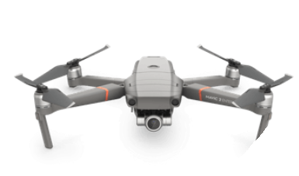

(Description and photo source) https://www.dji.com/search?q=mavic%20enterprise%202%20advanced
DJI Mavic Mini
Manufacturer: DJI
Manufacturer Description:
The Mavic Mini from DJI is a compact drone weighing in at under 9 oz. The Mavic Mini has 3-axis gimbal and sophisticated flight modes that can achieve up to 12MP images, 2.7K Quad HD videos, and complex cinematic shots with access to the DJI Fly app. The Mini drone features up to 30 minutes of flight time on a full battery charge.

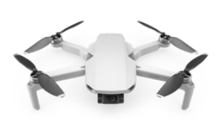
(Description and photo source) https://www.dji.com/search?q=mini

DJI Matrice 300 RTK
Manufacturer: DJI
Manufacturer Description:
The Matrice 300 RTK is a commercial drone features a 1080p video, which provides a live HD view from the aircraft's camera at distances of up to 9.3 miles (15 km). OcuSync Enterprise features the ability to transmit three channels of 1080p video simultaneously and AES-256 encryption ensures secure data transmission. DJI Matrice 300 RTK offers up to 55 minutes of high-performance flight time with TB60 Batteries combined with unrivaled reliability. The advanced flight control system, 6 Directional Sensing and Positioning system, AI spot-checking, Smart Track, PinPoint, Location Sharing, and an all-new Primary Flight Display.

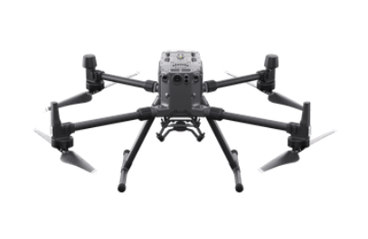

(Description and photo source) https://www.dji.com/search?q=matrice%20300%20rtk

Unmanned Tracked Robots
Small Unmanned Tracked Robots: An unmanned tracked robot of any type that is capable of being remotely controlled as well as supporting or attached systems designed for gathering information through imaging, recording or by any other means.

Capabilities: Designed for rapid tactical missions, the robot is simple to operate and quick to deploy for searching rooms, hallways, stairwells, and confined spaces. With rubber tracks and articulating front and rear flippers, the Mini-CALIBER effortlessly climbs stairs. It also includes an extendible rotating claw arm that simplifies opening door handles.
Purpose/Authorized Uses: Used to assist the Oakland Police Department Operators with clearing residences and/or businesses during tactical operations, assisting officers and the community by clearing potentially dangerous building during tactical situations. Authorized by a Watch Commander or Lieutenant or above.
Training Requirements: The SOD Commander will ensure that only those team members properly trained and certified in the use of the special equipment will utilize the equipment.
Lifespan: No lifespan indicated by Manufacturer
The Oakland Police Department currently possesses the following Unmanned Tracked Robots:
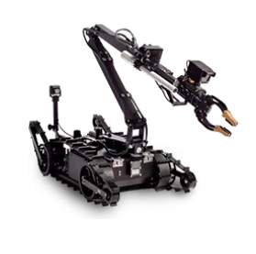
Mini-CALIBER
Manufacturer: ICOR Technology
Manufacturer Description:
Designed for rapid tactical missions, the robot is simple to operate and quick to deploy for searching rooms, hallways, stairwells, and confined spaces. 5 axis Claw Arm on Rotating Turret, 10X optical zoon Pan-Tilt-Zoom (PTZ) Color Camera, Front and Rear Drive Color IR Camera, Drive System (Speeds up to 2.5 mph, Wireless RF Communications, and 2-Way Audio (talk/listen).

(Description and photo source) https://icortechnology.com/robots/mini-caliber/)

Robotex - Avatar Tactical Robot
Manufacturer: ACORN
Manufacturer Description:
The AVATAR Robots are regarded by tactical teams as a standard operational tool, like a firearm, vehicle, or piece of body armor. It is quick and easily deployable. Navigates various terrain including stairs, sand, clothing, grass, etc. Two-way audio and recording capability.

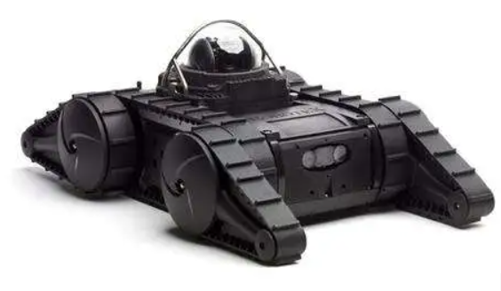

(Description and photo source) https://www.acornpd.com/robotex-avatar-tactical-robot
Remotec Andros Mark 5A-1
Manufacturer: Northrop Grumman
Manufacturer Description:
The Remotec ANDROS Mark V-Al is a highly stable, tough-as-nails partner for hazardous duty operations. First responders world-wide rely on this larger-than-live robot to help assure safe, successful outcome for their most challenging missions. All terrain – climbs stairs. Reliable, affordable, environmentally sealed, Color Surveillance camera with light, 72:1 zoom, pan/tilt, low light switching capability, Gripper with continuous rotate - Many accessories can be added to work with the gripper. Quick disconnect camera mount, 24-inch camera extender, Manipulator arm that can reach up to 8 feet in the air, 2-way audio system with weatherproof speaker and microphone mounted on the robot. Powered by 24VDC - Two 65 amp-hr. 12VDC spiral-cell batteries.

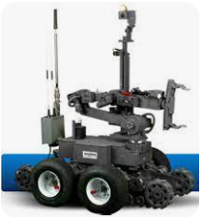

(Description and photo source) https://www.azorobotics.com/equipment-details.aspx?EquipID=412

Armored Personnel Carriers/Mine-Resistant Ambush Protected Vehicles (MRAP)
APCs and MRAPs: Are light tactical vehicles are designed specifically to withstand improvised explosive device attacks and ambushes.

Capabilities: An armored vehicle is a piece of law enforcement equipment that may allow officers to use non-force options to safely resolve incidents involving actual, threatened, or reasonably suspected violence using firearms or explosives. The protective capabilities of an armored vehicle greatly exceed those of a patrol vehicle and proper deployment of armored vehicles may increase the safety of the public, law enforcement officers, and other first responders. Armored vehicles provide improved cover for officers, are stocked with tools that might be needed during a critical incident and increase the options for a safe resolution.

Purpose/Authorized Uses: Commanders (Lieutenants and above) shall only authorize the deployment of armored vehicles when the specific capabilities of the ERV or Armored Suburban are necessary to bring an incident to a safe conclusion. Any authorized departure from an armored vehicle’s place of storage shall be considered a deployment.
Training Requirements: Armored vehicles shall only be operated by officers certified by the Tactical Operations Team commander. This includes, but is not limited to, all members of the Entry Team and Sniper Team elements. It also includes all Patrol Rifle Officers (PRO’s).
Lifespan: Approximately 15 years
The Oakland Police Department currently possesses the following Armored Personnel Carriers:
BearCat G3
Manufacturer: Lenco
Manufacturer Description:
The 2008 BearCat is equipped with emergency lights/sirens, rotating roof hatch, electric winches, running boards, protection against chemical agents, back-up camera, battering ram attachment, CS (tear gas) deployment nozzle, Thermographic cameras, and spot/flood lights. The vehicle is armored with a 0.5 – 1.5” thick steel and ballistic windows rated to stop a 0.50 BMG round.

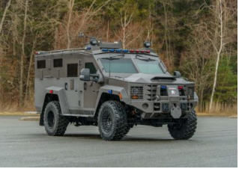

(Description and photo source) https://www.lencoarmor.com/model/ERV-g3-police-government/

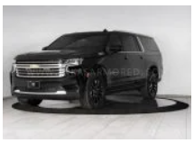
Armored Suburban – SUV
Manufacturer: The Armored Group
Manufacturer Description:
The 2015 Chevrolet 1500 Armored Suburban #1697 is equipped with emergency lights/sirens, steel front bumper, seating capacity for 9 personnel and backup camera. The vehicle is armored with B6 level armor capable of stopping 7.62X51mm rifle round.

(Description and photo source) https://www.armoredcars.com/vehicles/armored-chevy-suburban-1500/

Mobile Command Vehicles
Mobile Command Vehicles: Completely self-contained command vehicles that are designed to provide the Incident Commander with a mobile base of operation, facilitate operational control and direction of public safety units.
(Mobile Command Vehicles, Community Resource Vehicles, and Hostage Negotiation Vehicles).

Capabilities: The vehicle provides mobile, remote access to radio, internet planning and operational resources to assist with the command and control of major incidents and other planned operations. The vehicle also has the capability to dispatch officers and firefighters, as well as receive 9-1-1 calls.

Purpose/Authorized Uses: Traffic Commander (Lieutenants and above) shall only authorize the deployment of a MCV for any incidents which it would be deemed beneficial to do so.
Training Requirements: There are 2 members of OPD, who are assigned to patrol have their Class B license and can operate the OFD/OPD Command Vehicle. The new OPD Command Vehicle can be operated with a Class C license. Members of the HNT are eligible to drive the vehicle.
Lifespan: Approximately 15 years (MCVs & CRVs). None listed by manufacturer for HNT.
The Oakland Police Department currently possesses the following Mobile Command Vehicles:

OFD/OPD Mobile Command Vehicle - (MCV)
Manufacturer: Lynch Diversified Vehicles
Manufacturer Description:
2010 Mobile Command Vehicle #002 was built in conjunction with the Oakland Fire and Oakland Police Departments as a unified command vehicle but can also alternate between fire specific and police specific missions. The vehicle was custom built by Lynch Diversified Vehicles (LDV, Inc.), LDV Model #MCC301181-07 (Requires Class B License).The MCV is not a tactical vehicle but rather a multi-purpose vehicle to help facilitate command and control during field incidents by both the Oakland Fire Department as well as the Oakland Police Department by providing intelligence assets. The vehicle does not have any armor nor is it deployed in such a manner as it to be used in such a way. The vehicle is to be deployed at the periphery of a tactical incident if one such arises. The Traffic Commander is the coordinator of the command vehicles.

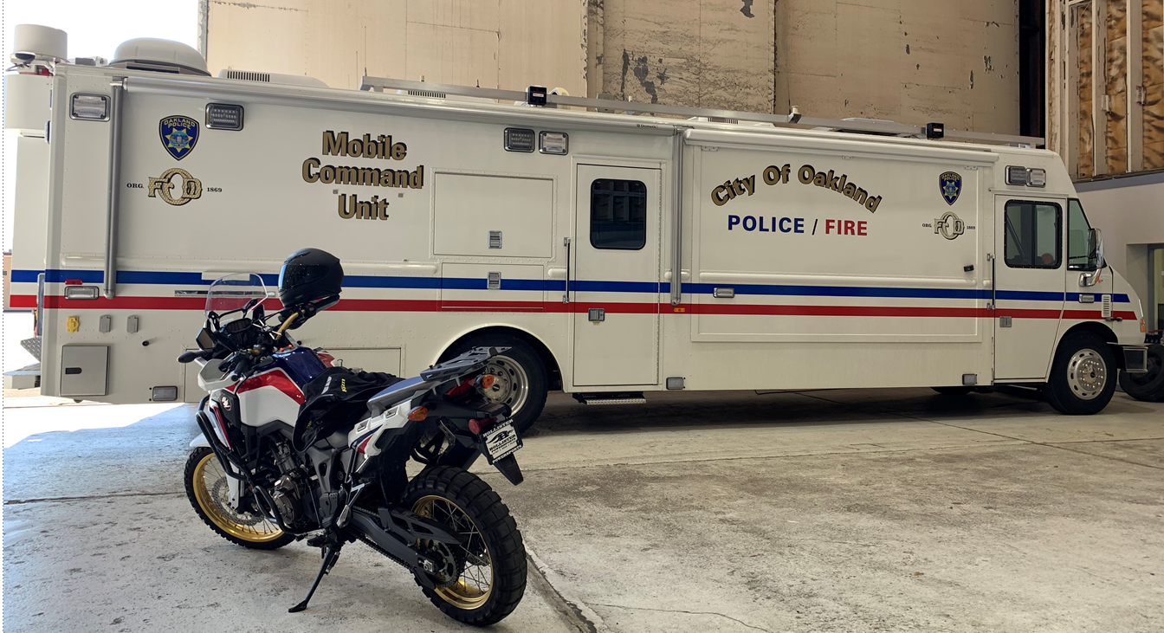

(Description and photo source) https://www.ldvusa.com/truck/oakland-police-department-ca-mobile-command-center/

Community Resource Vehicle - CRV
Manufacturer: Lynch Diversified Vehicles
Manufacturer Description:
Custom Build for OPD on Ford F59 gas chassis, 7.3L V8 engine, 6-speed TorqShift automatic transmission, All aluminum body construction, Extreme duty body storage compartments, LED scene lighting, Emergency lighting and siren package, Flip down step on the rear bumper, Front conference room fixed table, Magnetic surface dry erase white boards, Exterior monitor compartment, High resolution display monitors, Multi-function printer/copier, Custom aluminum cabinetry, (4) Interior workstations, Spider base task chairs, 15kW gasoline generator, Full vehicle surge suppression system, Prewired for future rear mast, Prewired for communications radios, CAT6 network wiring and jacks.

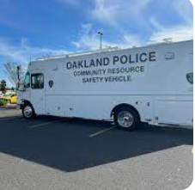

(Description and photo source) https://www.ldvusa.com/truck/oakland-police-department-ca-mobile-command-centers-2/

OPD Weed & Seed MCP Mobile Community Outreach Police Station: (1998) Vehicle was obtained through grant from United States Department of Justice (JAG) Justice Assistance Program. Vehicle used to assist in providing information on mental health counseling, drug treatment and other wellness services in the community. Vehicle also used to visit schools, churches, and merchants in community. Due to age of vehicle and the procurement of newer updated vehicles in the fleet, MCP #4878 is retired – NO LONGER IN USE.

Hostage Negotiation Vehicle - HNV
Manufacturer: Farber Specialty Vehicles
Manufacturer Description:
Farber Vehicle 25’ Chassis Designed for communication, negotiator, and ECM. CINT Commander (Negotiations Recording and Control System). This system also includes software that allows it to be used as a pretext phone call device with digital recording, data logging, and control features. The system includes the following items: 1. COMMBox 2. Software with free software updates online 3. All required cables 4. One headset and four headphones with adapters 5. External room monitor speaker 6. Pelican carrying case 7. Integrated 836 Bluetooth 8. 12-volt cell phone charger adapter 9. Technical Support 10. Five-year limited warranty (refer to warranty information).
In any response to a terrorist or CBRNE incident, specialty vehicles, especially those that provide force protection or include communications and Electronic Counter Measures are critical to a successful resolution to the incident.

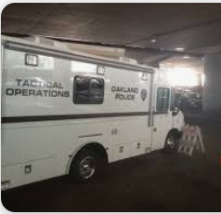

(Description and photo source) https://farberspecialty.com/new-vehicles/emergency-response/hnt-crisis-response-vehicles/

Explosive Breaching Equipment
Breaching Shotguns and Breaching Ammunition: During crisis situations, it may become necessary for DAT, SWAT, and Tactical teams to facilitate an entry into a target location. It is critical the point of entry is breached quickly and as safely as possible.

A quick and effective breach is one key to a successful tactical mission. In some instances, an explosive breach may be required to provide an added degree of safety and tactical advantage to accomplish a mission. A variety of specialized breaching equipment consisting of explosive materials are possessed by the Department. Explosive Breaching Equipment can only be used exclusively by the SWAT Unit’s dedicated breaching personnel.

Capabilities: Explosive breaching, the use of explosive materials to affect a breach, can be an effective tactics option. An explosive breach should be viewed as a cutting tool. An effective breach is a design where the least amount of explosive material is used and still accomplishes its goal. An effective Explosive Breach can defeat fortified doors and walls. Effective breaching techniques allow tactical officers immediate entry with minimal risk to victims, officers, and suspects.

Purpose/Authorized Uses: Used as an option for breaching locked doors with specified frangible breaching
ammunition. All applicable State, Federal and Local laws governing police use of force. Various Oakland Police
Department Policies on Use of Force and Firearms (K-3, K-4 and TB III-G).

Training Requirements: Global Assets Integrated Ballistic Breaching Course is required.
Lifespan: Remington 870 Police Magnum – Limited lifetime warranty. Lifespan varies on operational usage and wear.
Breaching Shotgun Ammunition – Five (5) year limited warranty. Five (5) year shelf life.
The Department currently possesses the following types of breaching shotguns and shotgun ammunition:
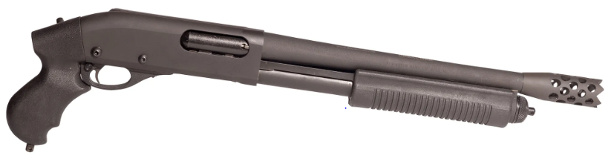
Remington 870 Police Magnum with Royal Arms 14” 12-point Breaching Barrel
Manufacturer: Remington Arms Company
Manufacturer Description:
The Remington 870 Police pump-action shotgun is a rugged 12-gauge with a short, tactical 18” barrel backed by a stout 3” chamber. The all-matte black gun is Parkerized for generalized durability and rust-resistance. Both the pump action forend and stock are robust and tough synthetic.
Royal Arms Breaching Barrel: For Remington 870/1187 Shotguns; We use only high-Quality Factory replacement Barrels. All Barrels we use for the Remington 870 are cylinder smooth bore Police Model. Parkerized. The breacher is locked onto the external threads of the Barrel making it permanently affixed and part of the O.A.L. Specified by ATF. Made from 4140 Mil Spec Chromoly Steel Heat Treated to 56 RC to with stand years of abuse. The 12 Point allows a positive grip on all surfaces since the Serrated teeth are spread across the entire contact area of the breacher standoff.

Remington 870 Police Magnum (pictured above)
(Description and photo source) https://royalarms.com/shop/royal-remington-870-express-breaching-shotgun/

Royal Arms 12 GA Breaching Rounds Tesar
Manufacturer: Royal Arms International
Manufacturer Description:
Orange Cap 2-3/4” 275 Grain Compressed Copper Frangible 12 Ga Shotgun Slug.
- Slug Material: Copper Powder
- Velocity: 1,750 Ft p/sec -18” Barrel
- Use: For Wood Doors, Solid & Hollow
- Defeats: Solid Wood Doors, Locks & Hinges

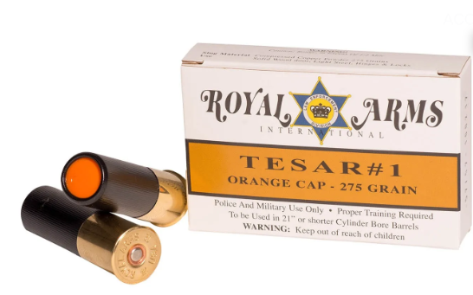

(Description and photo source) https://royalarms.com/shop/orange-cap-275-gr-copper-frangible-12-round-box/
Royal Arms 12 GA Breaching Rounds Tesar-2
Manufacturer: Royal Arms International
Manufacturer Description:
Black Cap 2-3/4” 425 Grain Compressed Copper Frangible 12 Ga Shotgun Slug.

- Slug Material: Copper Powder
- Velocity: 1,525 Ft p/sec -18” Barrel
- Use: For Metal Doors, Locks & Hinges
- Defeats: Heavy Locks, Dead-bolts, and Hinges (Solid Oak – Steel Doors)

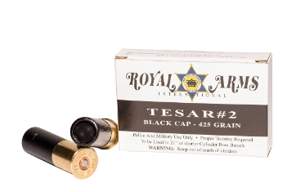

(Description and photo source) https://royalarms.com/shop/black-cap-425-gr-copper-frangible-12ga/
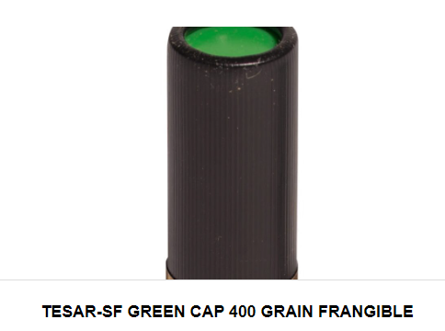
Royal Arms 12 GA Breaching Rounds Tescr-3
Manufacturer: Royal Arms International
Manufacturer Description:
Green Cap 2-3/4” 375 Grain Clayvon® Frangible 12 Ga Shotgun Slug
- Slug Material: Clay with S-70 Steel Shot
- Velocity: 1,650 Ft p/sec -18” Barrel
- Use: All Doors, Locks & Hinges
- Defeats: All Locks, Cross-bolts, and Hinges. (Hollow Core Doors – Light Steel doors)

(Description and photo source) https://royalarms.com/product-tag/tesar-3/
Primacord 21
Manufacturer: Dyno Nobel
Manufacturer Description:
PRIMACORD detonating cords are flexible linear explosives with a core of PETN explosive encased in a textile outer jacket. PRIMACORD detonating cords are designed for use as trunklines and/or downlines in various mining, quarrying and construction applications.

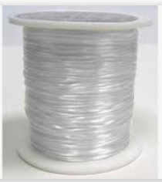

(Description and photo source) https://www.ebad.com/primacord-detonating-cord/
Primacord 10
Manufacturer: Dyno Nobel
Manufacturer Description:
PRIMACORD detonating cords are flexible linear explosives with a core of PETN explosive encased in a textile outer jacket. PRIMACORD detonating cords are designed for use as trunklines and/or downlines in various mining, quarrying and construction applications.
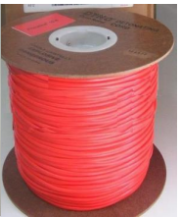

(Description and photo source) https://www.ebad.com/primacord-detonating-cord/
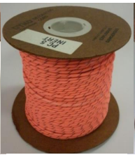
Primacord 5
Manufacturer: Dyno Nobel
Manufacturer Description:
PRIMACORD detonating cords are flexible linear explosives with a core of PETN explosive encased in a textile outer jacket. PRIMACORD detonating cords are designed for use as trunklines and/or downlines in various mining, quarrying and construction applications.
(Description and photo source) https://www.ebad.com/primacord-detonating-cord/
Primacord 4y
Manufacturer: Dyno Nobel
Manufacturer Description:
PRIMACORD detonating cords are flexible linear explosives with a core of PETN explosive encased in a textile outer jacket. PRIMACORD detonating cords are designed for use as trunklines and/or downlines in various mining, quarrying and construction applications.

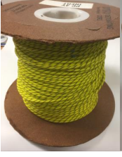

(Description and photo source) https://www.ebad.com/primacord-detonating-cord/
PRIMASHEET
Manufacturer: Dyno Nobel
Manufacturer Description:
PRIMASHEET 1000 Flexible Sheet Explosive (DETASHEET Flexible Explosive) is a waterproof PETN based (63% nominal) flexible sheet explosive. It is manufactured as a continuous roll of varying lengths and thicknesses for a wide range of applications.

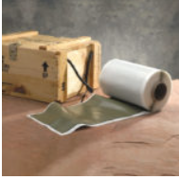
(Description and photo source) https://www.ebad.com/primasheet-sheet-explosive/
NONEL MS 1.4B
Manufacturer: Dyno Nobel
Manufacturer Description:
NONEL® nonelectric delay detonator MS 1.4B units consist of a length of orange shock tube, with a Standard (#8) detonator attached to one end and the other end sealed. A white J-hook is affixed near the sealed end, providing easy means of connection to detonating cord. Easy-to-read, color-coded delay tags display the delay number and nominal firing time prominently. Designed to provide in-hole delay time for underground (non-coal) and surface blast applications in the mining, quarry, and construction industries, the NONEL MS can be used in combination with a detonating cord trunkline, NONEL EZTL, NONEL EZ DET and/or NONEL TD detonators for maximum timing flexibility.

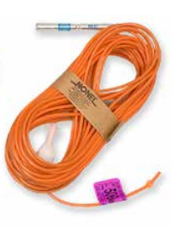
(Descriptiohttps://www.dynonobel.com/~/media/Files/Dyno/ResourceHub/Technical%20Information/North%20America/Initiation%20Systems/NONEL/MS14B.pdf

Specialized Firearms of Less Than .50 Caliber

Equipment Capabilities: A semi-automatic shoulder-fired long gun that fires a rifle caliber cartridge. The Department-approved AR15 style weapon system is designed to fire a .223/5.56 caliber projectile. These weapons provide the capability to pierce hard armor, multiple layers of mild steel, or substantial brick, concrete and other materials that may give hard cover to potential suspects.
Purpose/Authorized Uses: Recognizing that officers are not normally equipped to safely address threats from persons wearing body armor and/or who are at distances beyond the effective range of standard issue police pistols and shotguns, the PRP has been implemented to address such threats and enhance police officer and public safety.
Oakland Police policy DGO K-6: Only members certified as PROs shall be authorized to deploy Departmental patrol rifles.
Training Requirements: Officers must successfully complete a CA POST certified 80-hour patrol rifle course as well as regular department firearms training and qualifications as required by law and policy.
Lifespan: Colt LE6920 (AR15) - Barrel life approximately 15k rounds
Noveske N4 - Barrel life approximately 15k rounds
BCM CQB MCMR 11 - Barrel life approximately 15k rounds
GA Precision Bolt Action .308 Win Rifle - No Lifespan indicated by Manufacturer

The Department currently possesses the following types of Specialized Firearms of Less than .50 Caliber:
Colt LE6920 (AR15)
Manufacturer: Colt
Manufacturer Description:
Colt's reliability, performance, and accuracy provide our Armed Forces the confidence required to accomplish any mission. Colt's LE6920 series shares many features of its combat proven brother, the Colt M4.

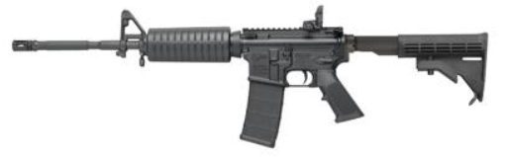
Colt LE6920 (Pictured above)

(Description and photo source) https://www.colt.com/detail-page/colt-le6920-carbine-223556-161-301-pmag-mbus-4-pos-stk-blk

Noveske N4
Manufacturer: Noveske
Manufacturer Description: Action:
Gas Operated Semi-Auto, Air cooled Magazine feed, Barrel Length: 10.5", stainless steel, Chambered in 5.56, Capacity: 30+1

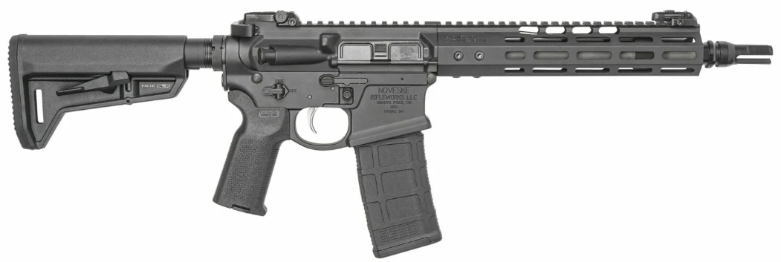
Noveske N4 (pictured above)

(Description and photo source) https://noveske.com/products/10-5-gen-4-shorty-rifle/

(BCM CQB MCMR 11)
Manufacturer: Bravo Company Manufacturing
Manufacturer Description:
Action: Gas Operated Semi-Auto, Air cooled, Magazine feed, Barrel Length: 11.5”, Chambered in 5.56, Capacity: 30+1.

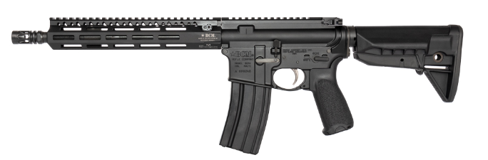

BCM CQB MCMR 11 (pictured above)
(Description and photo source) https://www.bravocompanymfg.com/specification/bcm_cqb11_mcmr.php

GA Precision Bolt Action .308 Win Rifle
Manufacturer: GA Precision
Manufacturer Description:
The rifle is a custom GA Precision product built for Oakland PD, based on their Crusader model. It is built off the Remington 700 short-action receiver platform, but manufactured and outfit by GA Precision, using a variety of components from different manufacturers. The barrel is manufactured by Broughton; it is 22” long, fluted, and has a 1/11.25” twist. The rifle stock is manufactured by Manner. The trigger group is a custom build by GA Precision. The scopes are manufactured by Nightforce (NX8), with Badger Ordnance scope rings and bases. The bipods are manufactured by Harris. The rifles were built from different components but serialized under GA Precision.
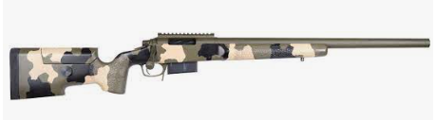
GA Precision Bolt Action .308 Win Rifle – base model (pictured above)
(Description and Photo source) https://www.gaprecision.net/custom-precision-rifles/custom-tactical-rifles/the-crusader.html

Ammunition for Specialized Firearms
Speer LE Gold Dot .223 75 grain
Manufacturer: Speer Ammo
Manufacturer Description:
SPEER LE Gold Dot Duty Rifle brings proven bullet technology to rifle platform. The Gold Dot bullet was the first high performance, bonded-core bullet available in handgun ammunition, and has since set the bar for duty ammunition. The nation's number one law enforcement option is now available in rifle ammunition for agencies everywhere. Gold Dot rifle bullets are optimized to ensure expansion out of barrels down to 10" at a wide variety of velocities out to 200 yards.

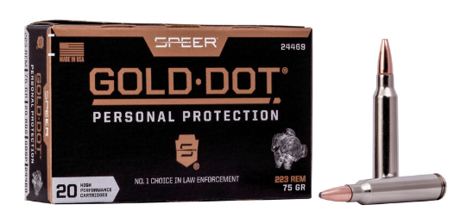

(Description and photo source) https://www.speer.com/ammunition/gold_dot/rifle/gold_dot_rifle_personal_protection/19-24469.html

Winchester RA556B 64 grain
Manufacturer: Winchester Ammunition
Manufacture Description: Designed specifically for delivering exceptional penetration, Ranger Bonded's proprietary core/jacket bonding process is enhanced with a special hollow cavity that aids in controlled expansion.

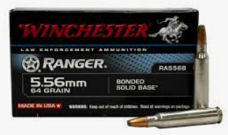
(Description and phone source) https://winchesterle.com/Ammunition/Products/Rifle/Ranger/RA556B
Federal .223 55 grain
Manufacturer: Federal
Manufacture Description:
American Eagle® rifle ammunition offers consistent, accurate performance at a price that's perfect for high-volume shooting. The loads feature quality bullets, reloadable brass cases and dependable primers.
- Ideal for target practice
- Accurate and reliable
- Consistent primers and brass

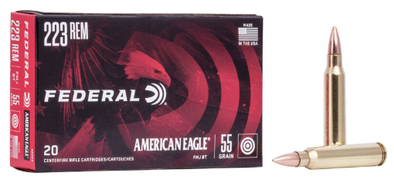

(Description and phone source) https://www.federalpremium.com/rifle/american-eagle/american-eagle-rifle/11-AE223.html
Federal Tactical Bonded 308 Win 165 grain LE308T1
Manufacturer: Federal
Manufacture Description:
The Tactical Bonded line is a trusted partner for some of the most intense conditions. Made exclusively for law enforcement, it achieves accuracy and terminal performance that defeats tough barriers with minimal deviation.


(Description and photo source) https://www.gtdist.com/federal-308win-20-bx-boded-sp-165gr.html

Hornady 308 Win Tap 168 grain ELD Match Tap AR
Manufacturer: Hornady Law Enforcement & Military
Manufacture Description:
The Tactical Bonded line is a trusted partner for some of the most intense conditions. Made exclusively for law enforcement, it achieves accuracy and terminal performance that defeats tough barriers with minimal deviation.

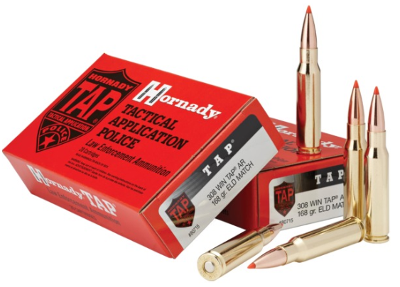

(Description and photo source) https://www.hornadyle.com/rifle-ammunition/168-gr-eld-match-tap-ar#!/

Light Sound incendiary Device, aka “Flashbang Grenades”, Smoke, and Explosive Breaching Tools
Diversionary Devices aka Flashbangs: Canisters that emit a loud noise and bright light.

Equipment Capabilities: Diversionary Devices can release large amounts of stored energy in the form of heat, light, pressure, and noise. They are intended to temporarily distract, confuse, and disorient subjects. They can also be used as “attention-getting” devices.
Purpose/Authorized Uses: Diversionary Devices can be used in high-risk tactical operations as an attention getting device. They can also be used during high-risk warrants, hostage rescue incidents, and some mobile field force incidents to provide an added degree of officer safety by disorienting subjects.
All applicable State, Federal and Local laws governing police use of force. Various Oakland Police Department Policies on Use of Force (K-3, K-4, K-5, TB III-G, and TB V F.02).
Training Requirements: Each operator completes a 10-hour training on Chemical Agents/SIMS Munitions Deployments.
Lifespan: 1082 – 5-year limited manufacturer warranty. No lifespan listed.
5-year shelf life
The Department currently possesses the following types of chemical and/or incendiary devices:
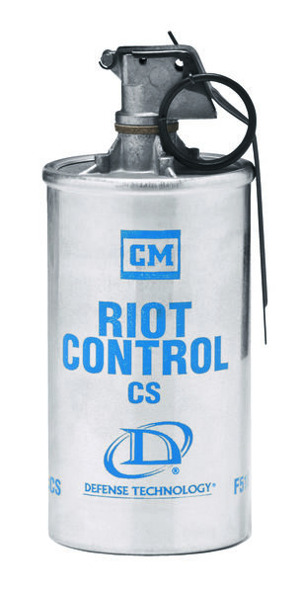
Riot Control 1082
Manufacturer: Defense Technology
Manufacture Description:
The Riot Control CS Grenade is designed specifically for outdoor use in crowd control situations with a high-volume continuous burn that expels its payload in approximately 20-40 seconds through four gas ports located on the top of the canister. This grenade can be used to conceal tactical movement or to route a crowd. The volume of smoke and agent is vast and obtrusive. This launchable grenade is 6.0 in. by 2.35 in. and holds approximately 2.7 oz. of active agent.

(Description and photo source) https://www.defense-technology.com/?s=riot+control+1082
Triple Chaser 1026
Manufacturer: Defense Technology
Manufacture Description:
The Triple-Chaser® CS consists of three separate canisters pressed together with separating charges between each. When deployed, the canisters separate and land approximately 20 feet apart allowing increased area coverage in a short period of time. This grenade can be hand thrown or launched from a fired delivery system. The grenade is 6.5 in. by 2.7 in. and holds an approximately 3.2 oz. of active agent payload. It has an approximate burn time of 20-30 seconds.

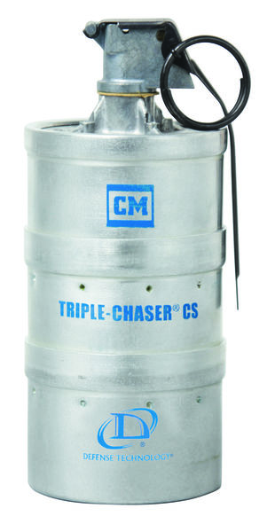
(Description and photo source) https://www.defense-technology.com/?s=1026
Triple Phaser 5231
Manufacturer: Combined Tactical Systems
Manufacture Description:
Manufacture Product Description: Type* Irritant & Smoke Pyrotechnic Grenades, Diameter 2.60” (66 mm) Length 6.20” (157 mm), Fuse Type Model 201, Fuse Delay 1.5 +/- 0.3 sec. Average, Launchable Yes, Overall, Weight 610 gm, Discharge Time 25-45 Seconds, Emission Ports 15.
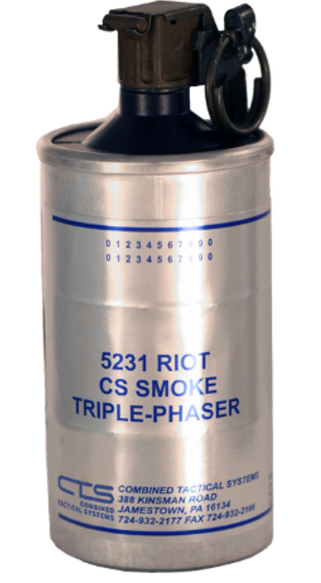
(Description and photo source) https://www.combinedsystems.com/product/5231-triple-phaser-cs-smoke-grenade/
CS Han-Ball 1092
Manufacturer: Defense Technology
Manufacture Description: The Han-Ball™ CS Grenade is an outdoor use grenade expelling its payload in approximately 15-20 seconds. The rubber ball round has an overall size of 4.8 in. tall, including the fuse head, and 3.1 in. diameter. This launchable grenade holds approximately 1.6 oz. of active agent which is expelled through three ports around the equator of the ball. Due the intense heat generated by this grenade, it should not be used inside a building or near flammable material.
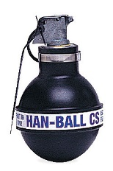
(Description and photo source) https://www.defense-technology.com/?s=CS+Han-Ball+1092

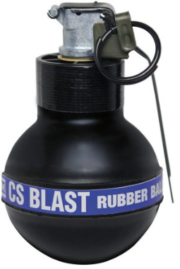
CS Blast 1097
Manufacturer: Defense Technology
Manufacturer Description: The Rubber Ball CS Blast Grenade is a maximum effect device that delivers three stimuli for psychological and physiological effects: light, sound, and CS. The Rubber Ball CS Blast is most widely used as a crowd management tool by Law Enforcement and Corrections. The Rubber Ball CS Blast has an initial 1.5 second delay that initiates fuse assembly separation, followed by another .5 second delay. The Rubber Ball CS Blast Grenade combines loud report and flash with effects of chemical agents.

(Description and photo source) https://www.defense-technology.com/?s=CS+Blast+1097
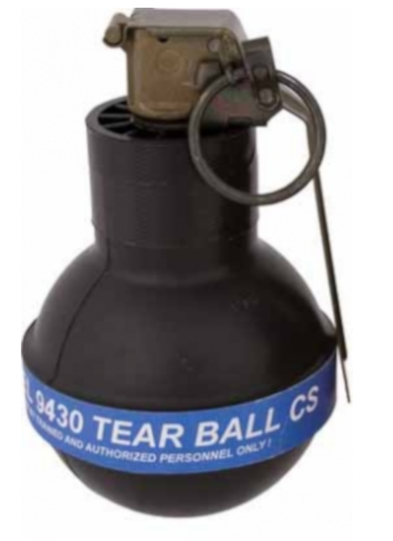
9430 Tear Ball CS
Manufacturer: Combined Tactical Systems
Manufacture Description: Tear Ball Grenades are explosive “rubber-ball” style grenades that upon initiation eject a powder payload of CS, CN, OC or talc into a radius surrounding the device. Tear Balls are primarily used for crowd control in indoor and outdoor situations.

(Description and photo source) https://www.combinedsystems.com/product/9430-tear-ball-grenade/
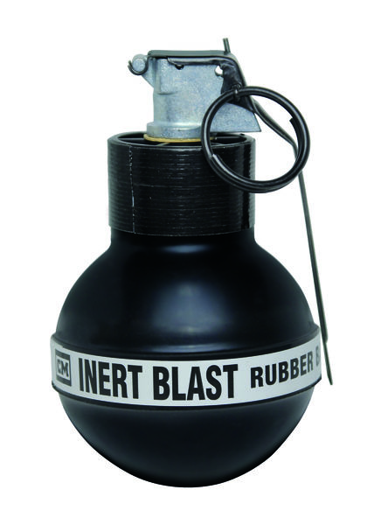
Inert Blast 1098
Manufacturer: Defense Technology
Manufacturer Description: The Rubber Ball CS Blast Grenade is a maximum effect device that delivers three stimuli for psychological and physiological effects: light, sound, and CS. The Rubber Ball CS Blast is most widely used as a crowd management tool by Law Enforcement and Corrections. The Rubber Ball CS Blast has an initial 1.5 second delay that initiates fuse assembly separation, followed by another .5 second delay. The Rubber Ball CS Blast Grenade combines loud report and flash with effects of chemical agents.

(Description and photo source) https://www.defense-technology.com/?s=inert+blast+1098
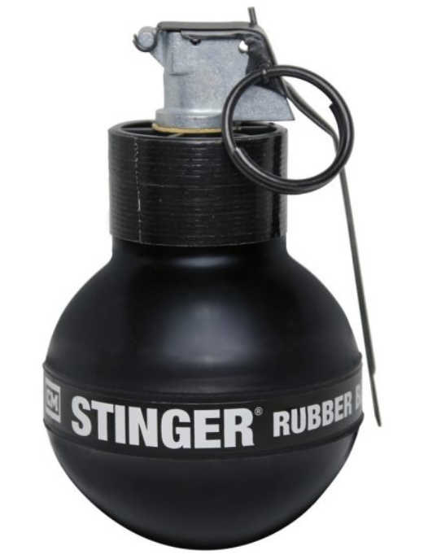
Stinger 1087
Manufacturer: Defense Technology
Manufacturer Description: The Stinger® Grenade with safety clip is a maximum effect device that delivers three stimuli for psychological and physiological effects: rubber pellets, light, and sound. The Stinger® Grenade is most widely used as a crowd management tool.

(Description and photo source) https://www.defense-technology.com/?s=1087
CS 1032
Manufacturer: Defense Technology
Manufacturer Description: The design of the Tri-Chamber Flameless CS Grenade allows the contents to burn within an internal can and disperse the agent safely with reduced risk of fire. The grenade is designed primarily for indoor tactical situations to detect and/or dislodge a barricaded subject. This grenade will deliver approximately .70 oz. of agent during its 20-25 seconds burn time. The Tri-Chamber Flameless Grenade can be used in crowd control as well as tactical deployment situations by Law Enforcement and Corrections but was designed with the barricade situation in mind. Its applications in tactical situations are primarily to detect and/or dislodge barricaded subjects. The purpose of the Tri-Chamber Flameless Grenade is to minimize the risks to all.

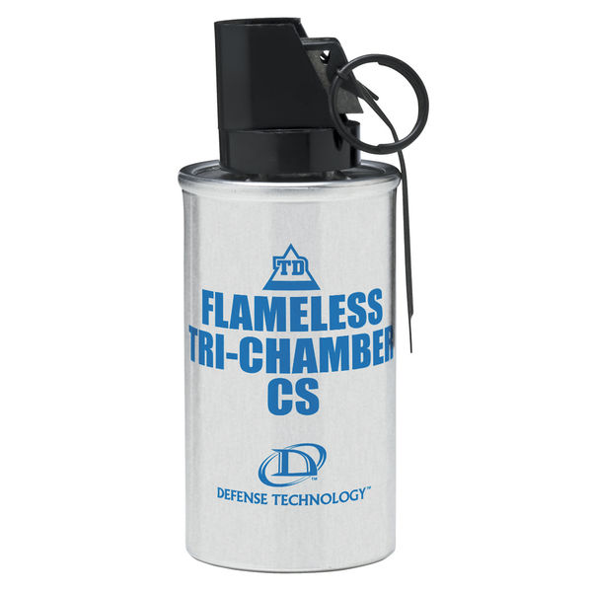

(Description and photo source) https://www.defense-technology.com/?s=1032
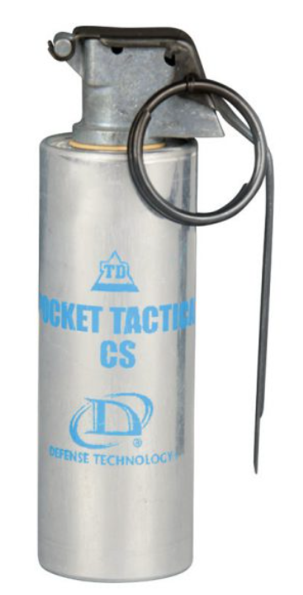
CS 1016
Manufacturer: Defense Technology
Manufacturer Description: The Pocket Tactical CS Grenade is small, and lightweight. The 0.9 oz. of active agent will burn approximately 20-40 seconds. At 4.75 in. by 1.4 inches in size, it easily fits in most tactical pouches. This is a launchable grenade; however, it is normally used as a signaling or covering device. Though this device is slightly over four inches in length, it produces a smoke cloud so fast it appears to be an enveloping screen produced by a full-size tactical grenade.

(Description and photo source) https://www.defense-technology.com/?s=CS+1016
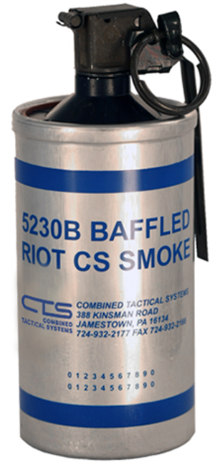
CS 5230B
Manufacturer: Combined Tactical Systems
Manufacture Description: Pyrotechnic grenade designed for indoor use delivering a maximum amount of irritant smoke throughout multiple rooms with minimal risk of fire.

(Description and photo source) https://www.combinedsystems.com/product/5230b-cs-baffled-canister-grenade-pyro- low-flame-potential-2
CS Muzzle Blast 2262
Manufacturer: Defense Technology
Manufacturer Description: The Ferret® 40 mm Barricade Penetrating Round is filled with a CS liquid chemical agent. It is a frangible projectile that is spin stabilized utilizing barrel rifling. It is non-burning and designed to penetrate barriers. Primarily used to dislodge barricaded subjects, it can also be used for area denial. Primarily used by tactical teams, it is designed to penetrate barriers, such as windows, hollow core doors, wallboard, and thin plywood. Upon impact the nose ruptures and instantaneously delivers the agent payload inside a structure or vehicle.

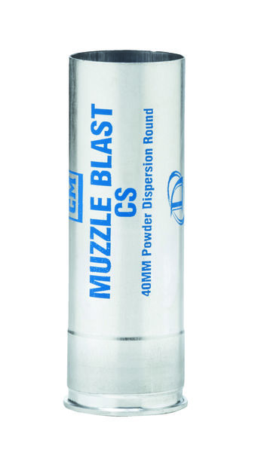
(Description and photo source) https://www.defense-technology.com/?s=cs+2262
CTS 7290m
Manufacturer: Combined Tactical Systems
Manufacture Description: Type: Noise/Flash Diversion Device, Body Material: Steel - Black Chromate Diameter 1.50” (38 mm) Length 5.40” (137 mm), Weight: 430 gm, Blast Ports: 10 on top. 10 on bottom, Fuze Type: Model 201, Fuze Delay: 1.5 +/- 0.3 sec., Average Sound Output: 165-180 Db, Light Output: 2 million Candela, Single Use Only

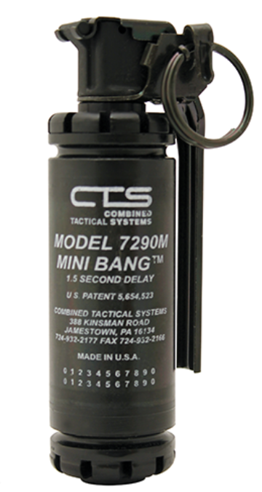

(Description and photo source) https://www.combinedsystems.com/product/7290m-mini-bang-steel-body-priced- individually-must-order-in-quantities-of-12/
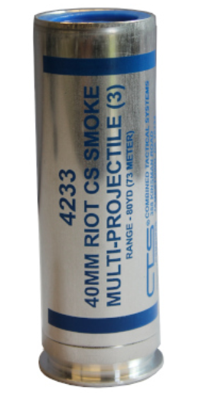
CTS 4233 40mm CS Multi 3 Smoke
Manufacturer: Combined Tactical Systems
Manufacture Description: This 40MM aluminum cartridge launches 3 sub-munitions that emit CS via rapid burning. The munition is used from a stand-off distance, and it is effective to disperse unruly crowds or deny areas during riots and civil disorder.

(Description and photo source) https://www.combinedsystems.com/product/4233-40mm-cs-multi-3-smoke-4-8-long/
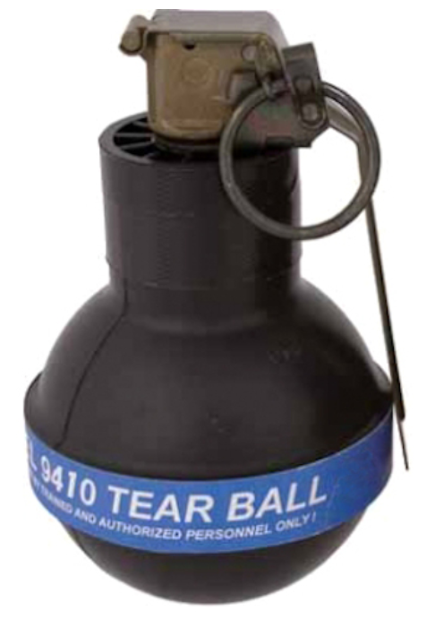
CTS 9410 Inert Rubber Ball Tear Grenade
Manufacturer: Combined Tactical Systems
Manufacture Description: The 9410 Inert Tear Ball Grenades produce a loud blast, emit bright light, and subsequently dispersing a cloud of inert powder. The primary application of this device is for riot control. Tear Balls are primarily used for crowd control in indoor and outdoor situations.

(Description and photo source) https://www.combinedsystems.com/product/9410-inert-tear-ball-grenade/

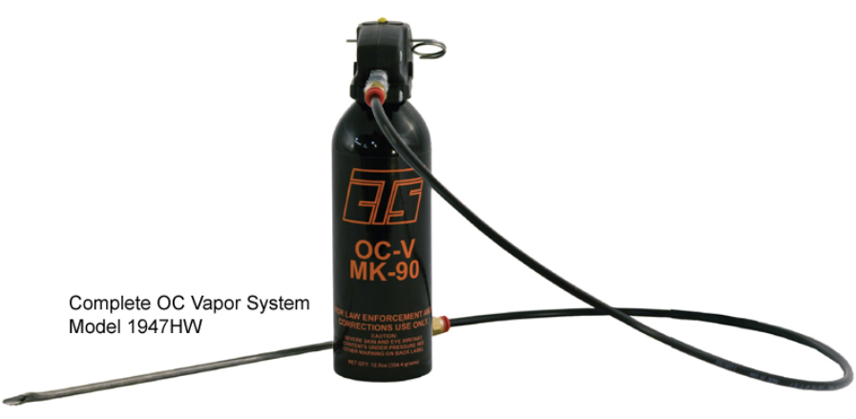
CTS 1901A Mk9 Hose and Wand OC
Manufacturer: Combined Tactical Systems
Manufacture Description: MK-9 offers higher pressure for wider fields of spray and larger capacity for multiple target engagements. It is the go-to alternative to large extinguisher OC Aerosol dispensers.

(Description and photo source) https://www.marklsupply.com/CTS-MK-9-Vapor-Delivery-System-optional-Hose-Wand_p_380.html
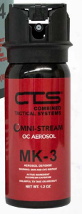
CTS 1337 OC Aerosol Fogger 2oz
Manufacturer: Combined Tactical Systems
Manufacture Description: MK-9 offers higher pressure for wider fields of spray and larger capacity for multiple target engagements. It is the go-to alternative to large extinguisher OC Aerosol dispensers.

(Description and photo source) https://www.combinedsystems.com/wp-content/uploads/2019/03/CSI.LessLethalProducSource-Catalog-revised-1.pdf

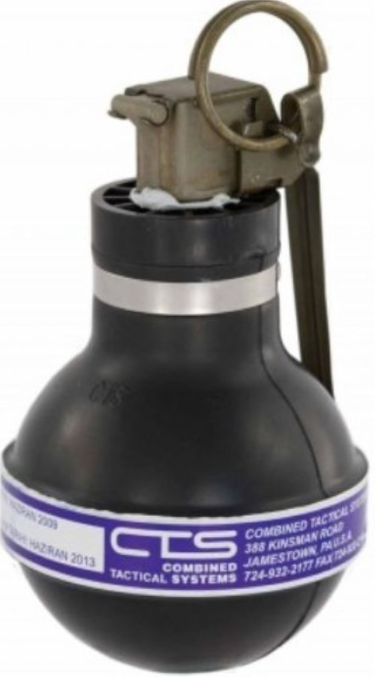
CTS 9230 CS Smoke Jet Lite Rubber Ball, Pyro
Manufacturer: Combined Tactical Systems
Manufacture Description: The 9230 CS Jet-Lite Rubber Ball Grenade is one of the smaller diameters burning grenades that discharges a high volume of chemical agents through multiple emission ports. Specifically for outdoor use and should not be deployed from rooftops, in crawl spaces or indoors due to fire producing capability. Can be hand thrown or launched.

(Description and photo source) https://www.combinedsystems.com/product/9230-cs-jet-lite-rubber-ball-grenade-pyro/

Long Range Acoustic Device (LRAD)
Long Range Acoustic Device (LRAD): The LRAD is a type of loudspeaker system that emits a focused and directional beam of sound.
Equipment Capabilities: The sound levels of this device are controllable and range from a mild public address type speaker sound level, for giving directions, to a high intensity, high pitch sound designed to deter or move subjects from an area.
Purpose/Usage: The LRAD can be used as a PA to issue Emergency Evacuation Orders, communicate with a subject during a law enforcement operation where direct communication is not possible, or to relay directions to a crowd in a noisy environment (unlawful assembly announcements).
All applicable State, Federal and Local laws governing police use of force. Various Oakland Police Department Policies on Use of Force and Firearms (K-3, K-4, K-5, and TB III-G). Command Approval required to use this device.
Training Requirements: Each operator must be trained and be a part of the HNT.
Lifespan: LRAD – Model 100X – One (1) year limited warranty. No lifespan indicated by manufacturer. Lifespan varies on operational usage and wear.
LRAD – Model 450XL - One (1) year limited warranty. No lifespan indicated by manufacturer. Lifespan varies on operational usage and wear.
The Department currently possesses the following types of LRAD’s:
LRAD 100X
Manufacturer: Genasys
Manufacture Description: The LRAD 100X is a self-contained, portable communication system for on-scene and tactical communication. With unparalleled vocal clarity and up to 30db louder than bullhorns, megaphones, and vehicle P.A. systems, the LRAD 100X is also four to six times louder than other acoustic hailers of comparable size and weight. LRAD’s optimized driver and waveguide technology ensures every message is clearly broadcast, heard and understood, even above engine, crowd, siren, and background noise. The LRAD warning tone commands attention to the voice messages that follow and provides a safer alternative to non-lethal and kinetic measures for changing behavior.

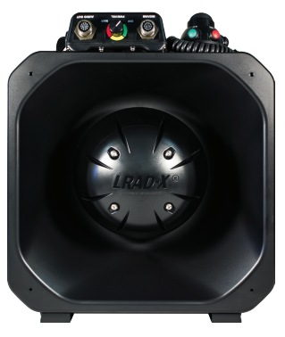

(Description and photo source) https://genasys.com/wp-content/uploads/Datasheet_LRAD_100X_2021_QR.pdf
LRAD 450XL
Manufacturer: Genasys
Manufacture Description: The LRAD 450XL utilizes technology developed and patented* by LRAD Corporation to provide the audio output of larger acoustic hailers almost twice its size and weight, while delivering the same outstanding vocal clarity consistent with all LRAD systems. The LRAD 450XL broadcasts powerful warning tones to command attention to the highly intelligible voice messages that follow enabling operators to change behavior and enhance response capabilities with safe, scalable escalation of force. Lightweight and designed for use on tripods or mounted on vessels, vehicles and Remote Weapon Stations (RWS), the LRAD 450XL is a highly effective, long-range communication and deterrent system in use around the world for public safety, law enforcement, maritime and defense applications.

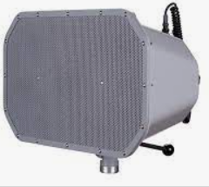

(Description and photo source) https://genasys.com/wp-content/uploads/LRAD-450XL_D00101-Rev.-B_3-4.pdf

40mm Projectile Launchers & Specialty Impact Munition (SIM) weapons
40mm Launchers (Projectile Launch Platforms): A single shot or multi-shot Extended Range Impact Weapon (ERIW) launcher capable for firing a variety of 40mm rounds. The Oakland Police Department also has a small inventory of 37mm launchers that share the same characteristics as 40mm launchers but are chambered for 37mm munitions. (40mm launchers and 37mm launchers are considered “Projectile Launch Platforms” under AB-481).
Equipment Capabilities: 40mm launchers can fire a variety of munitions with a maximum effective range of one hundred twenty (120) feet and deliver 40mm munitions in the form of chemical agents, sponge baton rounds, or combined use sponge baton OC chemical agent rounds.
Purpose/Usage: The Tactical Operations Team may be activated at the discretion of the Patrol Division Watch Commander, or an Area Commander who is on scene and assumes Incident Command. This is covered in Oakland Police Policy DGO K-5 and TB III-G.
Training Requirements: Each operator completes a 10-hour training on Chemical Agents/SIMS Munitions Deployments.
Lifespan: Defense Technology (37mm single launcher) - No lifespan indicated by the manufacturer.
Defense Technology 40mm Launchers – No lifespan indicated by manufacturer.
Penn Arms 40mm Launchers – No lifespan indicated by manufacturer.
Wilson Combat - No lifespan indicated by the manufacturer.

Defense Technology (40mm single launcher)
Manufacturer: Defense Technology
Manufacturer Description: Rifled barrel, Breech fed, Double action/single action, Picatinny rail.
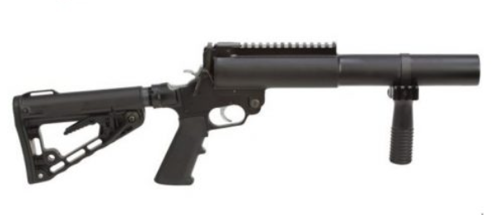
40mm Single Launcher (pictured above)
(Description and photo source) https://www.defense-technology.com/product/40mm-lmt-tactical-single-launcher-expandable-stock/

Penn Arms (PGL 65-40)
Manufacturer: Combined Tactical Systems
Manufacturer Description: A 40mm pump-action advance magazine drum launcher with a fixed stock and combo rail. It has a six-shot capacity and rifled barrel. Previously labeled the PGL-65, the features include Double-action trigger, trigger lock push button and hammer lock safeties.
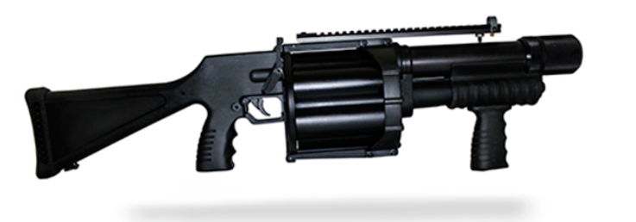
Penn Arms PGL 65-40 (pictured above)
(Description and photo source) https://www.combinedsystems.com/product/p540-1-pump-multi-launcher-5-cyl-fixed-stock-w-combo-rail-pgl-65-40/
Wilson Combat
Manufacturer: Combined Tactical Systems
Manufacturer Description: The Remington 870 Police pump-action shotgun is a rugged 12-gauge with a short, tactical 18” barrel backed by a stout 3” chamber. The all-matte black gun is Parkerized for generalized durability and rust-resistance. Both the pump action forend and stock are robust and tough synthetic.
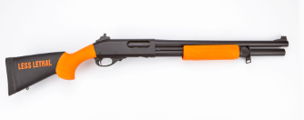
Remington Shotgun 12 gauge (pictured above)
(Description and photo source) https://www.wilsoncombat.com/less-lethal/

Specialty Impact Munition (SIM)
Specialty Impact Munitions (SIM): A non-lethal training ammunition used by law enforcement agencies and militaries worldwide to deliver more realistic close-range firearms training. They consist of low energy, non-lethal cartridges, typically manufactured with a water-soluble color marking compound. These rounds allow for shooters to obtain a visual assessment of round placement in live person training environments.

Equipment Capabilities: When utilized with a training munition bolt carrier group in a 5.56mm rifle platform, SIM’s have an effective range of approximately 27 yards. When utilized in a pistol caliber barrel training platform (9mm), SIMs have an effective range of 25 feet.
Purpose/Usage: The Tactical Operations Team may be activated at the discretion of the Patrol Division Watch Commander, or an Area Commander who is on scene and assumes Incident Command. This is covered in Oakland Police Policy DGO K-5 and TB III-G.
Training Requirements: Each operator completes a 10-hour training on Chemical Agents/SIMS Munitions Deployments.

Lifespan:

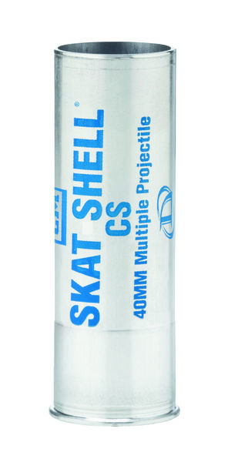
CS SKAT Shell 6172
Manufacturer: Defense Technology
Manufacturer Description:
Launchable 40mm, Burning CS / Outdoor, Risk of fire, Max range 80-100 yards, Discharge time 20-30 seconds, 0.90 oz active agent, 4 separate sub-munitions (40mm- 4).

(Description and photo source) https://www.defense-technology.com/?s=6172
CS Muzzle Blast 6042
Manufacturer: Defense Technology
Manufacturer Description: The 40 mm Muzzle Blast CS Round is widely used as a crowd management tool for the immediate and close deployment. It can also be employed in tactical operations such as barricaded subjects, room clearing, area denial, and for small space contamination, and a means of contaminating crawl spaces and attics. As a pain compliance round, it is an excellent device for deploying chemical-laden CS powder at close ranges for indoor or outdoor operations. The cloud of agent is very effective in filling holes in dispersals lines or engaging crowds at close distances.

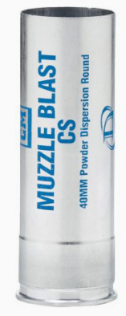
(Description and photo source) https://www.defense-technology.com/?s=CS+Muzzle+Blast+6042
Foam Baton 6099
Manufacturer: Defense Technology
Manufacturer Description: The 40 mm Multiple Foam Baton Round is most widely used as a crowd management tool where stand-off distances are limited. It may also prove valuable in riot situations where police lines and protestors are in close proximity. The round contains three foam projectiles. It utilizes smokeless powder and has more consistent velocities and tighter patterns compared to its 37 mm counterpart. The foam projectile allows for closer deployment, while minimizing injury.

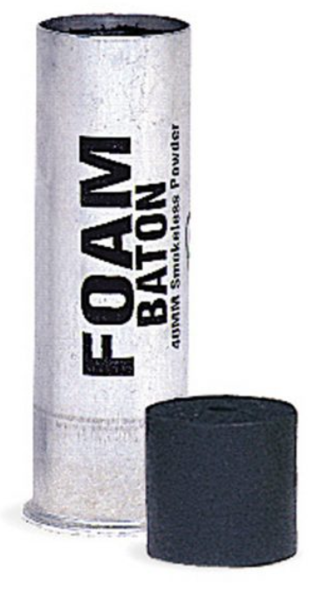
(Description and photo source) https://www.defense-technology.com/?s=Foam+Baton+6099
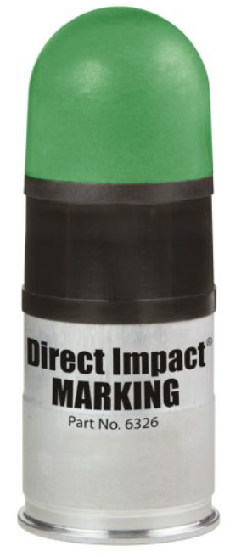
Direct Impact Marking 6326
Manufacturer: Defense Technology
Manufacturer Description: The 40mm Direct Impact® munition is a point-of-aim, point-of-impact direct-fire round. An excellent solution whether you need to incapacitate a single subject or control a crowd. When loaded with a green marking agent, the Direct Impact can be used to indicate the aggressor in a crowd or riot situation to the team on the ground.

(Description and photo source) https://www.defense-technology.com/?s=Direct+Impact+Marking+6326

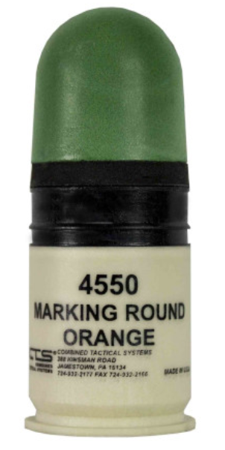
Frangible Impact 4550 Orange Marking Powder
Manufacturer: Combined Tactical Systems
Manufacture Description: The 40mm Direct Impact® munition is a point-of-aim, point-of-impact direct-fire round. An excellent solution whether you need to incapacitate a single subject or control a crowd. When loaded with a green marking agent, the Direct Impact can be used to indicate the aggressor in a crowd or riot situation to the team on the ground.

(Description and photo source) https://www.combinedsystems.com/product/4550-40mm-frangible-impact-orange-marking-powder/

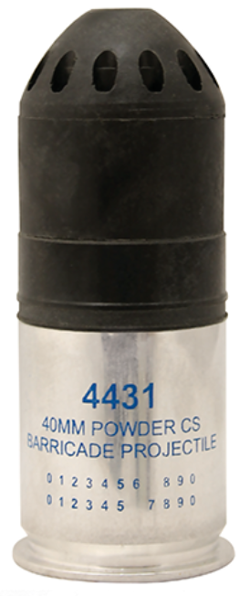
CTS 4431 40mm CS Powder No Flame Barricade Indoor
Manufacturer: Combined Tactical Systems
Manufacture Description: CS powder filled projectile penetrates intermediate barriers and delivers irritant agents into an adjacent room.

(Description and photo source) CSI.LessLethalProducSource-Catalog-revised-1.pdf (combinedsystems.com)
12GA 2581 Super Sock
Manufacturer: Combined Tactical Systems
Manufacture Description: The Model 2581 Super-Sock® is in its deployed state immediately upon exiting the barrel. It does not require a minimum range to “unfold” or “stabilize.” The Super-Sock® is an aerodynamic projectile and its accuracy is relative to the shotgun, barrel length, environmental conditions, and the operator. The Super-Sock® is first in its class providing the point control accuracy and consistent energy to momentarily incapacitate violent, non-compliant subjects. Effective range is 75ft.

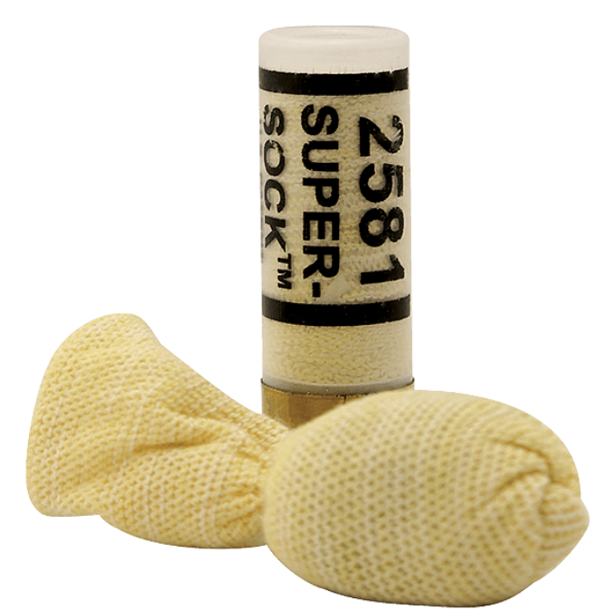
(Description and photo source) https://www.combinedsystems.com/product/2581-12ga-super-sock-bean-bag-priced-individually-per-cartridge-must-order-in-quantities-of-5/

Crowd Control Equipment
Crowd control is defined as those techniques used to address unlawful public assemblies, including a display of formidable numbers of police officers, crowd containment, dispersal tactics, and arrest procedures.
Crowd Control Helmets should only be used during a protest or demonstration to protect members’ head and eyes from thrown objects.
Crowd Control helmets shall not be used unless there is an articulable reason to wear them in public view.
Riot Shields may not be deployed or used until approved in accordance with OMC 9.65.
Equipment Capabilities: See product description
Purpose/Usage: Crowd control helmets should be used at the authorization of a commander or supervisor. Members do not have to wait for objects to be thrown before authorizing/donning helmets. In the event of exigent circumstances, officers can don crowd control helmets to protect themselves. There is no Oakland Police Department Policy that governs the use of shields during Crowd Control situations.
Training Requirements: Each member takes an 8-hour Crowd Control class in the Academy. There is also 2-hours in CPT. There are no training requirements for Shields.
Lifespan: Helmets - No lifespan indicated by the manufacturer.
Riot Shields - No lifespan indicated by the manufacturer.

Helmet-Non Ballistic (906 Series)
Manufacturer: Atlantic Tactical
Manufacturer Description:
- TacElite EPR polycarbonate alloy helmet shell
- Expanded polystyrene liner with padded, sweat-wicking inner liner
- Permanently mounted neck protector with Kydex penetration shield and shock absorbent foam pad
- Detachable 0.150" (3.8mm) thick face shield with liquid seal prevents liquids from seeping into officer's eyes
- Molded lip on top edge of face shield prevents shield from closing over integral visor and striking the face
- Double D-ring fastener provides maximum strength and slip resistance. NIJ compliant quick release buckle also included (user installation required).
- Snap-on nape pad with Kydex penetration shield, shock-absorbent foam pads and chemical-resistant black Cordura cover
- Plastic chin cup for added comfort when harness is tightened. Optional chin pad available.
- Face guard: Steel wire with black nylon coating and welded joints for maximum strength and safety. Wire guard is form fitted to match radius of face shield and is attached by four heavy-duty nylon clips. Viewing area: 2 3/4" x 8 1/2" (7.0cm x 21.6cm) (Model 906C only)
- Weight Model 906: 3.2 lbs. (1.5 Kg)
- Weight Model 906FS6: 3.2 lbs. (1.5 Kg)
- Weight Model 906C: 4 lbs. (1.8 Kg)
Meets or exceeds NIJ Standard for Riot Helmets, NIJ 0104.02* (Model 906 only)

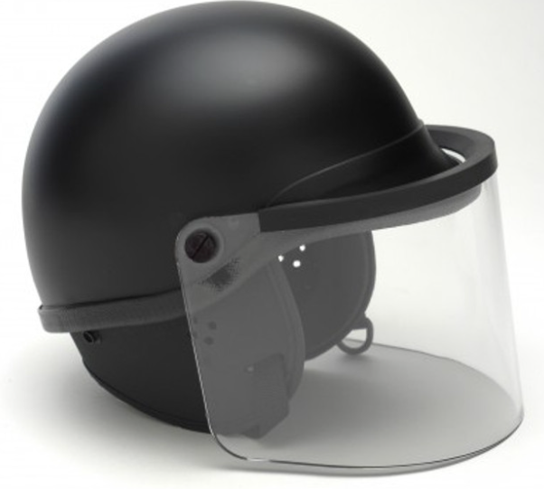

(Description and photo source) Premier Crown 906 Series TacElite EPR Polycarbonate Alloy Riot Helmet - Atlantic Tactical Inc



Military Equipment Use Summary 2023

While the Oakland Police Department’s inventory of military equipment is varied, the mere possession of the equipment does not warrant its use for every incident. The Oakland Police Department recognizes that critical incidents are unpredictable and can vary in nature. A variety of military equipment options can greatly assist incident commanders, officers, and specific units in bringing those incidents to a swift resolution in a safe manner. The use of military equipment is restricted for use only in certain instances and in some cases only by certain units. This section outlines the military equipment usage for 2023. Certain items of military equipment, particularly consumables (ammunition, diversionary devices, chemical agents, etc.) are used throughout the year on a regular basis for training to maintain proficiency. Training usage is not captured. This section only provides data for the operational use of military equipment listed within this Annual Equipment Report.

Geographic Reference

The City of Oakland is divided into two Bureau of Field Operations, six Areas, and thirty-five policing beats.
Reference map below.

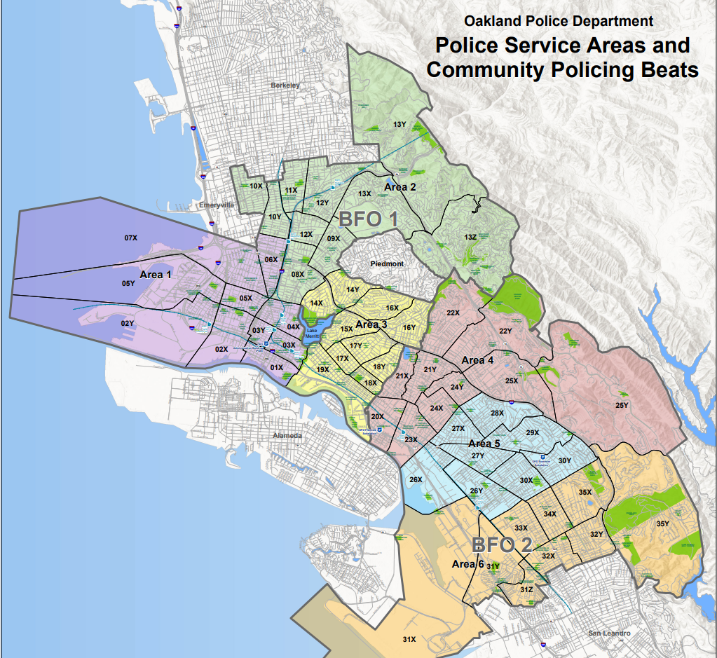

Military Equipment Usage Summary 2023

The following is approximate data for military equipment deployment/usage by Department area and category for 2023. (1 Jan 23 – 31 December 23)

Unmanned Aircraft Systems Usage – Drones & Robots
The Unmanned Drones were deployed a total of 183 times. 75 of those deployments were for warrants.
The breakdown is as follows: Mavic (114 days), Mini (68 days), and Matrice (1 day).
The total number of deployments for drones (183) and robots (36) was 219 times.
The total number of deployments for warrants for drones (75) and robots (17) was 92 times.
NOTE: Number deployed, and numbers of days differ due to multiple units per deployment.
The usage was under the following categories.
- Search & Arrest Warrants
- Barricaded Suspects
- Fleeing Subjects & Perimeter Searches

DJI Mavic Enterprise 2 Advanced
Number Deployed | 166
Number of Deployment for warrants | 44
Geographical Location of Deployment | Total number of days-controlled equipment was used | Number of those daily reported uses authorized by warrant | Number of those daily reported uses authorized by non-warrant forms of court authorization
AREA 1 | 25 | 5 | 0
AREA 2 | 5 | 2 | 0
AREA 3 | 13 | 9 | 0
AREA 4 | 14 | 2 | 0
AREA 5 | 24 | 8 | 0
AREA 6 | 16 | 12 | 0
AREA 7 | 2 | 2 | 0
OUTSIDE OF AREA | 15 | 4 | 0
Total number of Days Controlled Equipment was used | 114 | 44 | 0

The DJI Mavic Enterprise 2 Advanced was deployed in the last year. Any adverse impacts fell within the previously identified impacts in the previously released Impact Statement (See attachment).

DJI Mavic Mini
Number Deployed | 188
Number of Deployment for warrants | 31
Geographical Location of Deployment | Total number of days-controlled equipment was used | Number of those daily reported uses authorized by warrant | Number of those daily reported uses authorized by non-warrant forms of court authorization
AREA 1 | 6 | 4 | 0
AREA 2 | 4 | 1 | 0
AREA 3 | 15 | 7 | 0
AREA 4 | 8 | 2 | 0
AREA 5 | 10 | 5 | 0
AREA 6 | 19 | 10 | 0
AREA 7 | 1 | 1 | 0
OUTSIDE OF AREA | 5 | 1 | 0
Total number of Days Controlled Equipment was used | 68 | 31 | 0
The DJI Mavic Mini was deployed in the last year. Any adverse impacts fell within the previously identified impacts in the previously released Impact Statement (See attachment).

DJI Matrice 300 RTK
Number Deployed | 1
Number of Deployment for warrants | 0
Geographical Location of Deployment | Total number of days-controlled equipment was used | Number of those daily reported uses authorized by warrant | Number of those daily reported uses authorized by non-warrant forms of court authorization
AREA 1 | 1 | 0 | 0
AREA 2 | 0 | 0 | 0
AREA 3 | 0 | 0 | 0
AREA 4 | 0 | 0 | 0
AREA 5 | 0 | 0 | 0
AREA 6 | 0 | 0 | 0
AREA 7 | 0 | 0 | 0
OUTSIDE AGENCY | 0 | 0 | 0
Total number of Days Controlled Equipment was used | 1 | 0 | 0
The DJI Matrice 300RTK was deployed in the last year. Any adverse impacts fell within the previously identified impacts in the previously released Impact Statement (See attachment).

Unmanned Robots Usage
The Unmanned Robots: Icor Mini (28), and Avatar (8) were deployed a total of 36 times. 17 of those deployments were for warrants. Multiple robots were on scene per incident. The usage was under the following categories.
- Use of force
- Deployment
- Fleeing subjects & perimeter searches
- DAT, TACTICAL, & SWAT protection
ICOR Mini Caliber
Number Deployed | 28
Number of Deployment for warrants | 15
Geographical Location of Deployment | Total number of days-controlled equipment was used | Number of those daily reported uses authorized by warrant | Number of those daily reported uses authorized by non-warrant forms of court authorization
AREA 1 | 4 | 1 | 0
AREA 2 | 2 | 1 | 0
AREA 3 | 1 | 1 | 0
AREA 4 | 9 | 3 | 0
AREA 5 | 4 | 2 | 0
AREA 6 | 5 | 5 | 0
AREA 7 | 1 | 1 | 0
OUTSIDE AGENCY | 2 | 1 | 0
Total number of Days Controlled Equipment was used | 28 | 15 | 0
The ICOR Mini Caliber was deployed in the last year. Any adverse impacts fell within the previously identified impacts in the previously released Impact Statement (See attachment).
Avatar Tactical Robot
Number of Deployments | 8
Number of Deployment for warrants | 2
Geographical Location of Deployment | Total number of days-controlled equipment was used | Number of those daily reported uses authorized by warrant | Number of those daily reported uses authorized by non-warrant forms of court authorization
AREA 1 | 3 | 0 | 0
AREA 2 | 0 | 0 | 0
AREA 3 | 1 | 2 | 0
AREA 4 | 3 | 0 | 0
AREA 5 | 1 | 0 | 0
AREA 6 | 0 | 0 | 0
AREA 7 | 0 | 0 | 0
OUTSIDE AGENCY | 0 | 0 | 0
Total number of Days Controlled Equipment was used | 8 | 2 | 0
The Avatar Tactical Robot was not deployed in the last year. Any adverse impacts fell within the previously identified impacts in the previously released Impact Statement (See attachment).
Andros Mark 5A
Number Deployed | 0
Number of Deployment for warrants | 0
Geographical Location of Deployment | Total number of days-controlled equipment was used | Number of those daily reported uses authorized by warrant | Number of those daily reported uses authorized by non-warrant forms of court authorization
AREA 1 | 0 | 0 | 0
AREA 2 | 0 | 0 | 0
AREA 3 | 0 | 0 | 0
AREA 4 | 0 | 0 | 0
AREA 5 | 0 | 0 | 0
AREA 6 | 0 | 0 | 0
Total number of Days Controlled Equipment was used | 0 | 0 | 0
The Andros Mark 5A was not deployed in the last year, and the Department has not identified additional impacts from the previously released Impact Statement (See attachment).
BearCat & Armored Suburban (Armored Personnel Carrier) Usage
The BearCat (123) and Armored Suburban (142) were deployed a total of 265 times. 78 of the deployments were for warrants. The usage was under the following categories.
- Use of force
- Deployment
- Fleeing subjects & perimeter searches
- DAT, TACTICAL, & SWAT protection
- De-escalation
Bearcat/ERV
Number Deployed | 123
Number of Deployment for warrants | 31
Geographical Location of Deployment | Total number of days-controlled equipment was used | Number of those daily reported uses authorized by warrant | Number of those daily reported uses authorized by non-warrant forms of court authorization
AREA 1 | 6 | 3 | 0
AREA 2 | 4 | 1 | 0
AREA 3 | 13 | 4 | 0
AREA 4 | 27 | 5 | 0
AREA 5 | 29 | 6 | 0
AREA 6 | 43 | 11 | 0
AREA 7 | 0 | 0
OUTSIDE OF AREA | 1 | 1 | 0
Total number of Days Controlled Equipment was used | 123 | 31 | 0
The BearCat was deployed in the last year. Any adverse impacts fell within the previously identified impacts in the previously released Impact Statement (See attachment). The Armored Suburban was deployed in the last year. Any adverse impacts fell within the previously identified impacts in the previously released Impact Statement (See attachment).

Armored Suburban
Number Deployed | 142
Number of Deployment for warrants | 47
Geographical Location of Deployment | Total number of days-controlled equipment was used | Number of those daily reported uses authorized by warrant | Number of those daily reported uses authorized by non-warrant forms of court authorization
AREA 1 | 32 | 6 | 0
AREA 2 | 12 | 3 | 0
AREA 3 | 24 | 11 | 0
AREA 4 | 20 | 4 | 0
AREA 5 | 25 | 8 | 0
AREA 6 | 24 | 11 | 0
AREA 7 | 0 | 0 | 0
OUTSIDE AREA | 5 | 4 | 0
Total number of Days Controlled Equipment was used | 142 | 47 | 0
The Armored Suburban was deployed in the last year. Any adverse impacts fell within the previously identified impacts in the previously released Impact Statement (See attachment).

Mobile Command Vehicle Usage
Mobile Command Vehicles were utilized a total of (18) times, (5) times for warrants. Mobile Command (7), Community Resource Vehicle (7) times, Hostage Negotiation Vehicle (3) times. Some of the Mobile Command Vehicles, the deployments lasted multiple days depending on the scope and duration of the mission. The usage breakdown is as follows:
- Fourth of July Holiday Traffic Shut Down – Officer Command Post
- Halloween Trunk or Treat
- High Visibility Crime Prevention Details
- Community Events
- Protection for DAT – Designated Arrest Team
The Mobile Command Vehicle was deployed in the last year. Any adverse impacts fell within the previously identified impacts in the previously released Impact Statement (See attachment).

Mobile Command Vehicle - MCV #0222
Number Deployed | 7
Number of Deployment for warrants | 2
Geographical Location of Deployment | Total number of days-controlled equipment was used | Number of those daily reported uses authorized by warrant | Number of those daily reported uses authorized by non-warrant forms of court authorization
AREA 1 | 1 | 0 | 0
AREA 2 | 0 | 0 | 0
AREA 3 | 0 | 0 | 0
AREA 4 | 1 | 0 | 0
AREA 5 | 2 | 1 | 0
AREA 6 | 3 | 1 | 0
AREA 7 | 0 | 0 | 0
OUSIDE AGENCY | 0 | 0 | 0
Total number of Days Controlled Equipment was used | 7 | 2 | 0
The Mobile Command Vehicle was deployed in the last year. Any adverse impacts fell within the previously identified impacts in the previously released Impact Statement (See attachment).
Community Resource Vehicle - CRV: #1102/#1103/#1104
Number Deployed | 8
Number of Deployment for warrants | 0
Geographical Location of Deployment | Total number of days-controlled equipment was used | Number of those daily reported uses authorized by warrant | Number of those daily reported uses authorized by non-warrant forms of court authorization
AREA 1 | 0 | 0 | 0
AREA 2 | 0 | 0 | 0
AREA 3 | 3 | 0 | 0
AREA 4 | 0 | 0 | 0
AREA 5 | 5 | 0 | 0
AREA 6 | 0 | 0 | 0
AREA 7 | 0 | 0
OUTSIDE OF AREA | 0 | 0 | 0
Total number of Days Controlled Equipment was used | 8 | 0 | 0
The Community Resource Vehicle was deployed in the last year. Any adverse impacts fell within the previously identified impacts in the previously released Impact Statement (See attachment).

HNT Vehicle (Hostage Negotiation Vehicle) #1197 - QTY 1
Number Deployed | 3
Number of Deployment for warrants | 3
Geographical Location of Deployment | Total number of days-controlled equipment was used | Number of those daily reported uses authorized by warrant | Number of those daily reported uses authorized by non-warrant forms of court authorization
AREA 1 | 1 | 1 | 0
AREA 2 | 1 | 1 | 0
AREA 3 | 0 | 0 | 0
AREA 4 | 0 | 0 | 0
AREA 5 | 0 | 0 | 0
AREA 6 | 1 | 1 | 0
AREA 7 | 0 | 0 | 0
OUTSIDE OF AREA | 0 | 0 | 0
Total number of Days Controlled Equipment was used | 3 | 3 | 0
The Hostage Negotiation Vehicle was not deployed in the last year, and the Department has not identified additional impacts from the previously released Impact Statement (See attachment).
Breaching Shotgun & Breaching Ammunition Usage
Breaching Shotguns and Breaching Ammunition were utilized zero (0) times operationally in 2023.
Remington Breaching Shotgun
Number Deployed | 0
Number of Deployment for warrants | N/A
Geographical Location of Deployment | Total number of days-controlled equipment was used | Number of those daily reported uses authorized by warrant | Number of those daily reported uses authorized by non-warrant forms of court authorization
AREA 1 | 0 | 0 | 0
AREA 2 | 0 | 0 | 0
AREA 3 | 0 | 0 | 0
AREA 4 | 0 | 0 | 0
AREA 5 | 0 | 0 | 0
AREA 6 | 0 | 0 | 0
AREA 7 | 0 | 0 | 0
OUTSIDE OF AREA | 0 | 0 | 0
Total number of Days Controlled Equipment was used | 0 | 0 | 0
The Remington Breaching Shotgun was not deployed in the last year, and the Department has not identified additional impacts from the previously released Impact Statement (See attachment).

Royal Arms 12 GA Breaching Rounds Tesar
Number Deployed | 0
Number of Deployment for warrants | N/A
Geographical Location of Deployment | Total number of days-controlled equipment was used | Number of those daily reported uses authorized by warrant | Number of those daily reported uses authorized by non-warrant forms of court authorization
AREA 1 | 0 | 0 | 0
AREA 2 | 0 | 0 | 0
AREA 3 | 0 | 0 | 0
AREA 4 | 0 | 0 | 0
AREA 5 | 0 | 0 | 0
AREA 6 | 0 | 0 | 0
AREA 7 | 0 | 0 | 0
OUTSIDE OF AREA | 0 | 0 | 0
Total number of Days Controlled Equipment was used | 0 | 0 | 0
The Royal Arms 12 GA Breaching Rounds Tesar was not deployed in the last year, and the Department has not identified additional impacts from the previously released Impact Statement (See attachment).

Royal Arms 12 GA Breaching Rounds Tesar-2
Number Deployed | 0
Number of Deployment for warrants | N/A
Geographical Location of Deployment | Total number of days-controlled equipment was used | Number of those daily reported uses authorized by warrant | Number of those daily reported uses authorized by non-warrant forms of court authorization
AREA 1 | 0 | 0 | 0
AREA 2 | 0 | 0 | 0
AREA 3 | 0 | 0 | 0
AREA 4 | 0 | 0 | 0
AREA 5 | 0 | 0 | 0
AREA 6 | 0 | 0 | 0
AREA 7 | 0 | 0 | 0
OUTSIDE OF AREA | 0 | 0 | 0
Total number of Days Controlled Equipment was used | 0 | 0 | 0
The Royal Arms 12 GA Breaching Rounds Tesar-2 was not deployed in the last year, and the Department has not identified additional impacts from the previously released Impact Statement (See attachment).

Royal Arms 12 GA Breaching Rounds Tescr-3
Number Deployed | 0
Number of Deployment for warrants | N/A
Geographical Location of Deployment | Total number of days-controlled equipment was used | Number of those daily reported uses authorized by warrant | Number of those daily reported uses authorized by non-warrant forms of court authorization
AREA 1 | 0 | 0 | 0
AREA 2 | 0 | 0 | 0
AREA 3 | 0 | 0 | 0
AREA 4 | 0 | 0 | 0
AREA 5 | 0 | 0 | 0
AREA 6 | 0 | 0 | 0
AREA 7 | 0 | 0 | 0
OUTSIDE OF AREA | 0 | 0 | 0
Total number of Days Controlled Equipment was used | 0 | 0 | 0
The Royal Arms 12 GA Breaching Rounds Tesar-3 was not deployed in the last year, and the Department has not identified additional impacts from the previously released Impact Statement (See attachment).

Dyno Nobel / Primacord 21
Number Deployed | 0
Number of Deployment for warrants | N/A
Geographical Location of Deployment | Total number of days-controlled equipment was used | Number of those daily reported uses authorized by warrant | Number of those daily reported uses authorized by non-warrant forms of court authorization
AREA 1 | 0 | 0 | 0
AREA 2 | 0 | 0 | 0
AREA 3 | 0 | 0 | 0
AREA 4 | 0 | 0 | 0
AREA 5 | 0 | 0 | 0
AREA 6 | 0 | 0 | 0
AREA 7 | 0 | 0 | 0
OUTSIDE OF AREA | 0 | 0 | 0
Total number of Days Controlled Equipment was used | 0 | 0 | 0
The Dyno Nobel Primacord 21 was not deployed in the last year, and the Department has not identified additional impacts from the previously released Impact Statement (See attachment).

Dyno Nobel / Primacord 10
Number Deployed | 0
Number of Deployment for warrants | N/A
Geographical Location of Deployment | Total number of days-controlled equipment was used | Number of those daily reported uses authorized by warrant | Number of those daily reported uses authorized by non-warrant forms of court authorization
AREA 1 | 0 | 0 | 0
AREA 2 | 0 | 0 | 0
AREA 3 | 0 | 0 | 0
AREA 4 | 0 | 0 | 0
AREA 5 | 0 | 0 | 0
AREA 6 | 0 | 0 | 0
AREA 7 | 0 | 0 | 0
OUTSIDE OF AREA | 0 | 0 | 0
Total number of Days Controlled Equipment was used | 0 | 0 | 0
The Dyno Nobel Primacord 10 was not deployed in the last year, and the Department has not identified additional impacts from the previously released Impact Statement (See attachment).

Dyno Nobel / Primacord 4y
Number Deployed | 0
Number of Deployment for warrants | N/A
Geographical Location of Deployment | Total number of days-controlled equipment was used | Number of those daily reported uses authorized by warrant | Number of those daily reported uses authorized by non-warrant forms of court authorization
AREA 1 | 0 | 0 | 0
AREA 2 | 0 | 0 | 0
AREA 3 | 0 | 0 | 0
AREA 4 | 0 | 0 | 0
AREA 5 | 0 | 0 | 0
AREA 6 | 0 | 0 | 0
AREA 7 | 0 | 0 | 0
OUTSIDE OF AREA | 0 | 0 | 0
Total number of Days Controlled Equipment was used | 0 | 0 | 0
The Dyno Nobel Primacord 4y was not deployed in the last year, and the Department has not identified additional impacts from the previously released Impact Statement (See attachment).

Ensign-Bickford / PRIMASHEET
Number Deployed | 0
Number of Deployment for warrants | N/A
Geographical Location of Deployment | Total number of days-controlled equipment was used | Number of those daily reported uses authorized by warrant | Number of those daily reported uses authorized by non-warrant forms of court authorization
AREA 1 | 0 | 0 | 0
AREA 2 | 0 | 0 | 0
AREA 3 | 0 | 0 | 0
AREA 4 | 0 | 0 | 0
AREA 5 | 0 | 0 | 0
AREA 6 | 0 | 0 | 0
AREA 7 | 0 | 0 | 0
OUTSIDE OF AREA | 0 | 0 | 0
Total number of Days Controlled Equipment was used | 0 | 0 | 0
The Ensign-Bickford Primasheet was not deployed in the last year, and the Department has not identified additional impacts from the previously released Impact Statement (See attachment).

Dyno Nobel / Nonel MS 1.4B
Number Deployed | 0
Number of Deployment for warrants | N/A
Geographical Location of Deployment | Total number of days-controlled equipment was used | Number of those daily reported uses authorized by warrant | Number of those daily reported uses authorized by non-warrant forms of court authorization
AREA 1 | 0 | 0 | 0
AREA 2 | 0 | 0 | 0
AREA 3 | 0 | 0 | 0
AREA 4 | 0 | 0 | 0
AREA 5 | 0 | 0 | 0
AREA 6 | 0 | 0 | 0
AREA 6 | 0 | 0 | 0
AREA 7 | 0 | 0 | 0
OUTSIDE OF AREA | 0 | 0 | 0
Total number of Days Controlled Equipment was used | 0 | 0 | 0
The Dyno Nobel Nonel MS 1.4B was not deployed in the last year, and the Department has not identified additional impacts from the previously released Impact Statement (See attachment).

Specialized Firearms & Ammunition Usage
Specialized rifles were deployed on 212 incidents. 59 were for warrants. Multiple rifles were on scene per incident. The breakdown is as follows: AR-15 rifle (484), .308 Win Rifle (30), and BCM Rifle (187), and Noveske N4 (9). The usage was under the following categories.
- Use of Force
- Deployment
- Officer Involved Shootings

Colt LE6920 (AR15)
Total Number Deployed | 484
Number of Deployment for warrants | 38
Geographical Location of Deployment | Total number of days-controlled equipment was used | Number of those daily reported uses authorized by warrant | Number of those daily reported uses authorized by non-warrant forms of court authorization
AREA 1 | 30 | 8 | 0
AREA 2 | 10 | 1 | 0
AREA 3 | 21 | 4 | 0
AREA 4 | 32 | 5 | 0
AREA 5 | 35 | 7 | 0
AREA 6 | 38 | 11 | 0
AREA 7 | 1 | 1 | 0
Outside Area | 2 | 1 | 0
Total number of Days Controlled Equipment was used | 169 | 38 | 0
The Colt LE6920 AR15 was deployed in the last year. Any adverse impacts fell within the previously identified impacts in the previously released Impact Statement (See attachment).
Noveske N4
Total Number Deployed | 9
Number of Deployment for warrants | 4
Geographical Location of Deployment | Total number of days-controlled equipment was used | Number of those daily reported uses authorized by warrant | Number of those daily reported uses authorized by non-warrant forms of court authorization
AREA 1 | 1 | 1 | 0
AREA 2 | 1 | 1 | 0
AREA 3 | 1 | 0 | 0
AREA 4 | 3 | 1 | 0
AREA 5 | 0 | 0 | 0
AREA 6 | 1 | 1 | 0
AREA 7 | 0 | 0 | 0
OUTSIDE OF AREA | 0 | 0 | 0
Total number of Days Controlled Equipment was used | 7 | 4 | 0
The Noveske N4 was not deployed in the last year, and the Department has not identified additional impacts from the previously released Impact Statement (See attachment).
Bravo Company Manufacturing (BCM CQB MCMR 11)
Total Number Deployed | 187
Number of Deployment for warrants | 12
Geographical Location of Deployment | Total number of days-controlled equipment was used | Number of those daily reported uses authorized by warrant | Number of those daily reported uses authorized by non-warrant forms of court authorization
AREA 1 | 1 | 1 | 0
AREA 2 | 2 | 1 | 0
AREA 3 | 3 | 2 | 0
AREA 4 | 6 | 2 | 0
AREA 5 | 7 | 1 | 0
AREA 6 | 6 | 2 | 0
AREA 7 | 2 | 2 | 0
OUSTIDE AGENCY | 1 | 1 | 0
Total number of Days Controlled Equipment was used | 28 | 12 | 0
The BCM CQB MCMR 11 was deployed in the last year. Any adverse impacts fell within the previously identified impacts in the previously released Impact Statement (See attachment).

GA Precision Bolt Action .308 Win Rifle
Total Number Deployed | 30
Number of Deployment for warrants | 5
Geographical Location of Deployment | Total number of days-controlled equipment was used | Number of those daily reported uses authorized by warrant | Number of those daily reported uses authorized by non-warrant forms of court authorization
AREA 1 | 1 | 1 | 0
AREA 2 | 1 | 1 | 0
AREA 3 | 1 | 1 | 0
AREA 4 | 3 | 1 | 0
AREA 5 | 1 | 0 | 0
AREA 6 | 1 | 1 | 0
AREA 7 | 0 | 0 | 0
OUTSIDE OF AREA | 0 | 0 | 0
Total number of Days Controlled Equipment was used | 8 | 5 | 0
The GA Bolt Action .308 Win Rifle was deployed in the last year. Any adverse impacts fell within the previously identified impacts in the previously released Impact Statement (See attachment).

Speer LE Gold Dot .223 75 grain
Number Deployed | 0
Number of Deployment for warrants | N/A
Geographical Location of Deployment | Total number of days-controlled equipment was used | Number of those daily reported uses authorized by warrant | Number of those daily reported uses authorized by non-warrant forms of court authorization
AREA 1 | 0 | 0 | 0
AREA 2 | 0 | 0 | 0
AREA 3 | 0 | 0 | 0
AREA 4 | 0 | 0 | 0
AREA 5 | 0 | 0 | 0
AREA 6 | 0 | 0 | 0
AREA 7 | 0 | 0 | 0
OUTSIDE OF AREA | 0 | 0 | 0
Total number of Days Controlled Equipment was used | 0 | 0 | 0
The Speer LE Gold Dot .223 75 grain was not deployed in the last year, and the Department has not identified additional impacts from the previously released Impact Statement (See attachment).

Winchester (RA 556B 64 grain)
Number Deployed | 0
Number of Deployment for warrants | N/A
Geographical Location of Deployment | Total number of days-controlled equipment was used | Number of those daily reported uses authorized by warrant | Number of those daily reported uses authorized by non-warrant forms of court authorization
AREA 1 | 0 | 0 | 0
AREA 2 | 0 | 0 | 0
AREA 3 | 0 | 0 | 0
AREA 4 | 0 | 0 | 0
AREA 5 | 0 | 0 | 0
AREA 6 | 0 | 0 | 0
AREA 7 | 0 | 0 | 0
OUTSIDE OF AREA | 0 | 0 | 0
Total number of Days Controlled Equipment was used | 0 | 0 | 0
The Winchester RA 556B 64 grain was not deployed in the last year, and the Department has not identified additional impacts from the previously released Impact Statement (See attachment).
Federal .223 55 grain
Number Deployed | 0
Number of Deployment for warrants | N/A
Geographical Location of Deployment | Total number of days-controlled equipment was used | Number of those daily reported uses authorized by warrant | Number of those daily reported uses authorized by non-warrant forms of court authorization
AREA 1 | 0 | 0 | 0
AREA 2 | 0 | 0 | 0
AREA 3 | 0 | 0 | 0
AREA 4 | 0 | 0 | 0
AREA 5 | 0 | 0 | 0
AREA 6 | 0 | 0 | 0
AREA 7 | 0 | 0 | 0
OUTSIDE OF AREA | 0 | 0 | 0
Total number of Days Controlled Equipment was used | 0 | 0 | 0
The Federal .223 55 grain was not deployed in the last year, and the Department has not identified additional impacts from the previously released Impact Statement (See attachment).

Federal Tactical Bonded 308 Win 165 grain LE308T1
Number Deployed | 0
Number of Deployment for warrants | N/A
Geographical Location of Deployment | Total number of days-controlled equipment was used | Number of those daily reported uses authorized by warrant | Number of those daily reported uses authorized by non-warrant forms of court authorization
AREA 1 | 0 | 0 | 0
AREA 2 | 0 | 0 | 0
AREA 3 | 0 | 0 | 0
AREA 4 | 0 | 0 | 0
AREA 5 | 0 | 0 | 0
AREA 6 | 0 | 0 | 0
AREA 7 | 0 | 0 | 0
OUTSIDE OF AREA | 0 | 0 | 0
Total number of Days Controlled Equipment was used | 0 | 0 | 0
The Federal Tactical Bonded 308 Win 165 grain LE308T1 was not deployed in the last year, and the Department has not identified additional impacts from the previously released Impact Statement (See attachment).
Hornady 308 Win Tap 168 grain ELD Match Tap AR
Number Deployed | 0
Number of Deployment for warrants | N/A
Geographical Location of Deployment | Total number of days-controlled equipment was used | Number of those daily reported uses authorized by warrant | Number of those daily reported uses authorized by non-warrant forms of court authorization
AREA 1 | 0 | 0 | 0
AREA 2 | 0 | 0 | 0
AREA 3 | 0 | 0 | 0
AREA 4 | 0 | 0 | 0
AREA 5 | 0 | 0 | 0
AREA 6 | 0 | 0 | 0
AREA 7 | 0 | 0 | 0
OUTSIDE OF AREA | 0 | 0 | 0
Total number of Days Controlled Equipment was used | 0 | 0 | 0
The Hornady 308 Win Tap 168 grain ELD Match Tap AR was not deployed in the last year, and the Department has not identified additional impacts from the previously released Impact Statement (See attachment).
Light Sound incendiary Device, aka “Flashbang Grenades” & Explosive Breaching Equipment Usage:
Explosive Breaching Equipment was not utilized operationally in 2023.
Defense Technology / Riot Control 1082
Number Deployed | 0
Number of Deployment for warrants | N/A
Geographical Location of Deployment | Total number of days-controlled equipment was used | Number of those daily reported uses authorized by warrant | Number of those daily reported uses authorized by non-warrant forms of court authorization
AREA 1 | 0 | 0 | 0
AREA 2 | 0 | 0 | 0
AREA 3 | 0 | 0 | 0
AREA 4 | 0 | 0 | 0
AREA 5 | 0 | 0 | 0
AREA 6 | 0 | 0 | 0
AREA 7 | 0 | 0 | 0
OUTSIDE OF AREA | 0 | 0 | 0
Total number of Days Controlled Equipment was used | 0 | 0 | 0
The Defense Technology Riot Control 1082 was not deployed in the last year, and the Department has not identified additional impacts from the previously released Impact Statement (See attachment).

Defense Technology / Triple Chaser 1026
Number Deployed | 0
Number of Deployment for warrants | N/A
Geographical Location of Deployment | Total number of days-controlled equipment was used | Number of those daily reported uses authorized by warrant | Number of those daily reported uses authorized by non-warrant forms of court authorization
AREA 1 | 0 | 0 | 0
AREA 2 | 0 | 0 | 0
AREA 3 | 0 | 0 | 0
AREA 4 | 0 | 0 | 0
AREA 5 | 0 | 0 | 0
AREA 6 | 0 | 0 | 0
AREA 7 | 0 | 0 | 0
OUTSIDE OF AREA | 0 | 0 | 0
Total number of Days Controlled Equipment was used | 0 | 0 | 0
The Defense Technology Triple Chaser 1026 was not deployed in the last year. Any adverse impacts fell within the previously identified impacts in the previously released Impact Statement (See attachment).

Combined Tactical Systems/ Triple Phaser 5231
Number Deployed | 0
Number of Deployment for warrants | N/A
Geographical Location of Deployment | Total number of days-controlled equipment was used | Number of those daily reported uses authorized by warrant | Number of those daily reported uses authorized by non-warrant forms of court authorization
AREA 1 | 0 | 0 | 0
AREA 2 | 0 | 0 | 0
AREA 3 | 0 | 0 | 0
AREA 4 | 0 | 0 | 0
AREA 5 | 0 | 0 | 0
AREA 6 | 0 | 0 | 0
AREA 7 | 0 | 0 | 0
OUTSIDE OF AREA | 0 | 0 | 0
Total number of Days Controlled Equipment was used | 0 | 0 | 0
The CTS Triple Phaser 5231 was not deployed in the last year, and the Department has not identified additional impacts from the previously released Impact Statement (See attachment).

Defense Technology/ CS Han-Ball 1092
Number Deployed | 0
Number of Deployment for warrants | N/A
Geographical Location of Deployment | Total number of days-controlled equipment was used | Number of those daily reported uses authorized by warrant | Number of those daily reported uses authorized by non-warrant forms of court authorization
AREA 1 | 0 | 0 | 0
AREA 2 | 0 | 0 | 0
AREA 3 | 0 | 0 | 0
AREA 4 | 0 | 0 | 0
AREA 5 | 0 | 0 | 0
AREA 6 | 0 | 0 | 0
AREA 7 | 0 | 0 | 0
OUTSIDE OF AREA | 0 | 0 | 0
Total number of Days Controlled Equipment was used | 0 | 0 | 0
The Defense Technology CS Han-Ball 1092 was not deployed in the last year, and the Department has not identified additional impacts from the previously released Impact Statement (See attachment).

Defense Technology/ CS Blast 1097
Number Deployed | 0
Number of Deployment for warrants | N/A
Geographical Location of Deployment | Total number of days-controlled equipment was used | Number of those daily reported uses authorized by warrant | Number of those daily reported uses authorized by non-warrant forms of court authorization
AREA 1 | 0 | 0 | 0
AREA 2 | 0 | 0 | 0
AREA 3 | 0 | 0 | 0
AREA 4 | 0 | 0 | 0
AREA 5 | 0 | 0 | 0
AREA 6 | 0 | 0 | 0
AREA 7 | 0 | 0 | 0
OUTSIDE OF AREA | 0 | 0 | 0
Total number of Days Controlled Equipment was used | 0 | 0 | 0
The Defense Technology CS Blast 1097 was not deployed in the last year. Any adverse impacts fell within the previously identified impacts in the previously released Impact Statement (See attachment).
Combined Tactical System/ 9430 Tear Ball CS
Number Deployed | 0
Number of Deployment for warrants | N/A
Geographical Location of Deployment | Total number of days-controlled equipment was used | Number of those daily reported uses authorized by warrant | Number of those daily reported uses authorized by non-warrant forms of court authorization
AREA 1 | 0 | 0 | 0
AREA 2 | 0 | 0 | 0
AREA 3 | 0 | 0 | 0
AREA 4 | 0 | 0 | 0
AREA 5 | 0 | 0 | 0
AREA 6 | 0 | 0 | 0
AREA 7 | 0 | 0 | 0
OUTSIDE OF AREA | 0 | 0 | 0
Total number of Days Controlled Equipment was used | 0 | 0 | 0
The CTS 9430 Tear Ball CS was not deployed in the last year, and the Department has not identified additional impacts from the previously released Impact Statement (See attachment).

Defense Technology/ Inert Blast 1098
Number Deployed | 0
Number of Deployment for warrants | N/A
Geographical Location of Deployment | Total number of days-controlled equipment was used | Number of those daily reported uses authorized by warrant | Number of those daily reported uses authorized by non-warrant forms of court authorization
AREA 1 | 0 | 0 | 0
AREA 2 | 0 | 0 | 0
AREA 3 | 0 | 0 | 0
AREA 4 | 0 | 0 | 0
AREA 5 | 0 | 0 | 0
AREA 6 | 0 | 0 | 0
AREA 7 | 0 | 0 | 0
OUTSIDE OF AREA | 0 | 0 | 0
Total number of Days Controlled Equipment was used | 0 | 0 | 0
The Defense Technology Inert Blast 1098 was not deployed in the last year, and the Department has not identified additional impacts from the previously released Impact Statement (See attachment).

Defense Technology/ Stinger 1087
Number Deployed | 0
Number of Deployment for warrants | N/A
Geographical Location of Deployment | Total number of days-controlled equipment was used | Number of those daily reported uses authorized by warrant | Number of those daily reported uses authorized by non-warrant forms of court authorization
AREA 1 | 0 | 0 | 0
AREA 2 | 0 | 0 | 0
AREA 3 | 0 | 0 | 0
AREA 4 | 0 | 0 | 0
AREA 5 | 0 | 0 | 0
AREA 6 | 0 | 0 | 0
AREA 7 | 0 | 0 | 0
OUTSIDE OF AREA | 0 | 0 | 0
Total number of Days Controlled Equipment was used | 0 | 0 | 0
The Defense Technology Stinger 1087 was not deployed in the last year, and the Department has not identified additional impacts from the previously released Impact Statement (See attachment).

Defense Technology/ 1032
Number Deployed | 0
Number of Deployment for warrants | N/A
Geographical Location of Deployment | Total number of days-controlled equipment was used | Number of those daily reported uses authorized by warrant | Number of those daily reported uses authorized by non-warrant forms of court authorization
AREA 1 | 0 | 0 | 0
AREA 2 | 0 | 0 | 0
AREA 3 | 0 | 0 | 0
AREA 4 | 0 | 0 | 0
AREA 5 | 0 | 0 | 0
AREA 6 | 0 | 0 | 0
AREA 7 | 0 | 0 | 0
OUTSIDE OF AREA | 0 | 0 | 0
Total number of Days Controlled Equipment was used | 0 | 0 | 0
The Defense Technology 1032 was not deployed in the last year, and the Department has not identified additional impacts from the previously released Impact Statement (See attachment).

Defense Technology/ CS 1016
Number Deployed | 0
Number Deployed | N/A
Geographical Location of Deployment | Total number of days-controlled equipment was used | Number of those daily reported uses authorized by warrant | Number of those daily reported uses authorized by non-warrant forms of court authorization
AREA 1 | 0 | 0 | 0
AREA 2 | 0 | 0 | 0
AREA 3 | 0 | 0 | 0
AREA 4 | 0 | 0 | 0
AREA 5 | 0 | 0 | 0
AREA 6 | 0 | 0 | 0
AREA 7 | 0 | 0 | 0
OUTSIDE OF AREA | 0 | 0 | 0
Total number of Days Controlled Equipment was used | 0 | 0 | 0
The Defense Technology CS 1016 was not deployed in the last year, and the Department has not identified additional impacts from the previously released Impact Statement (See attachment).

Combined Tactical Systems/ 5230B
Number Deployed | 0
Number of Deployment for warrants | N/A
Geographical Location of Deployment | Total number of days-controlled equipment was used | Number of those daily reported uses authorized by warrant | Number of those daily reported uses authorized by non-warrant forms of court authorization
AREA 1 | 0 | 0 | 0
AREA 2 | 0 | 0 | 0
AREA 3 | 0 | 0 | 0
AREA 4 | 0 | 0 | 0
AREA 5 | 0 | 0 | 0
AREA 6 | 0 | 0 | 0
AREA 7 | 0 | 0 | 0
OUTSIDE OF AREA | 0 | 0 | 0
Total number of Days Controlled Equipment was used | 0 | 0 | 0
The CTS 5230B was not deployed in the last year, and the Department has not identified additional impacts from the previously released Impact Statement (See attachment).

Defense Technology/ CS 2262
Number Deployed | 0
Number of Deployment for warrants | N/A
Geographical Location of Deployment | Total number of days-controlled equipment was used | Number of those daily reported uses authorized by warrant | Number of those daily reported uses authorized by non-warrant forms of court authorization
AREA 1 | 0 | 0 | 0
AREA 2 | 0 | 0 | 0
AREA 3 | 0 | 0 | 0
AREA 4 | 0 | 0 | 0
AREA 5 | 0 | 0 | 0
AREA 6 | 0 | 0 | 0
AREA 7 | 0 | 0 | 0
OUTSIDE OF AREA | 0 | 0 | 0
Total number of Days Controlled Equipment was used | 0 | 0 | 0
The Defense Technology CS 2262 was not deployed in the last year, and the Department has not identified additional impacts from the previously released Impact Statement (See attachment).

Combined Tactical System/ CTS 7290M
Number Deployed | 0
Number of Deployment for warrants | N/A
Geographical Location of Deployment | Total number of days-controlled equipment was used | Number of those daily reported uses authorized by warrant | Number of those daily reported uses authorized by non-warrant forms of court authorization
AREA 1 | 0 | 0 | 0
AREA 2 | 0 | 0 | 0
AREA 3 | 0 | 0 | 0
AREA 4 | 0 | 0 | 0
AREA 5 | 0 | 0 | 0
AREA 6 | 0 | 0 | 0
AREA 7 | 0 | 0 | 0
OUTSIDE OF AREA | 0 | 0 | 0
Total number of Days Controlled Equipment was used | 0 | 0 | 0
The CTS 7290M was not deployed in the last year, and the Department has not identified additional impacts from the previously released Impact Statement (See attachment).

CTS 4233 40mm CS Multi 3 Smoke
Number Deployed | 0
Number of Deployment for warrants | N/A
Geographical Location of Deployment | Total number of days-controlled equipment was used | Number of those daily reported uses authorized by warrant | Number of those daily reported uses authorized by non-warrant forms of court authorization
AREA 1 | 0 | 0 | 0
AREA 2 | 0 | 0 | 0
AREA 3 | 0 | 0 | 0
AREA 4 | 0 | 0 | 0
AREA 5 | 0 | 0 | 0
AREA 6 | 0 | 0 | 0
AREA 7 | 0 | 0 | 0
OUTSIDE OF AREA | 0 | 0 | 0
Total number of Days Controlled Equipment was used | 0 | 0 | 0
The CTS 4233 40mm CS Multi 3 Smoke was deployed in the last year, and the Department has not identified additional impacts from the previously released Impact Statement (See attachment).

CTS 9410 Inert Rubber Ball Tear Grenade
Number Deployed | 0
Number of Deployment for warrants | N/A
Geographical Location of Deployment | Total number of days-controlled equipment was used | Number of those daily reported uses authorized by warrant | Number of those daily reported uses authorized by non-warrant forms of court authorization
AREA 1 | 0 | 0 | 0
AREA 2 | 0 | 0 | 0
AREA 3 | 0 | 0 | 0
AREA 4 | 0 | 0 | 0
AREA 5 | 0 | 0 | 0
AREA 6 | 0 | 0 | 0
AREA 7 | 0 | 0 | 0
OUTSIDE OF AREA | 0 | 0 | 0
Total number of Days Controlled Equipment was used | 0 | 0 | 0
The CTS 9410 Inert Rubber Ball Tear Grenade was not deployed in the last year, and the Department has not identified additional impacts from the previously released Impact Statement (See attachment).

CTS 1901A Mk9 Hose and Wand OC
Number Deployed | 0
Number of Deployment for warrants | N/A
Geographical Location of Deployment | Total number of days-controlled equipment was used | Number of those daily reported uses authorized by warrant | Number of those daily reported uses authorized by non-warrant forms of court authorization
AREA 1 | 0 | 0 | 0
AREA 2 | 0 | 0 | 0
AREA 3 | 0 | 0 | 0
AREA 4 | 0 | 0 | 0
AREA 5 | 0 | 0 | 0
AREA 6 | 0 | 0 | 0
AREA 7 | 0 | 0 | 0
OUTSIDE OF AREA | 0 | 0 | 0
Total number of Days Controlled Equipment was used | 0 | 0 | 0
The CTS 1901A MK9 Hose and Wand OC was not deployed in the last year, and the Department has not identified additional impacts from the previously released Impact Statement (See attachment).

CTS 1337 OC Aerosol Fogger 2oz
Number Deployed | 0
Number of Deployment for warrants | N/A
Geographical Location of Deployment | Total number of days-controlled equipment was used | Number of those daily reported uses authorized by warrant | Number of those daily reported uses authorized by non-warrant forms of court authorization
AREA 1 | 0 | 0 | 0
AREA 2 | 0 | 0 | 0
AREA 3 | 0 | 0 | 0
AREA 4 | 0 | 0 | 0
AREA 5 | 0 | 0 | 0
AREA 6 | 0 | 0 | 0
AREA 7 | 0 | 0 | 0
OUTSIDE OF AREA | 0 | 0 | 0
Total number of Days Controlled Equipment was used | 0 | 0 | 0
The CTS 1337 OC Aerosol Fogger 2oz was not deployed in the last year, and the Department has not identified additional impacts from the previously released Impact Statement (See attachment).

CTS 9230 CS Smoke Jet Lite Rubber Ball, Pyro
Number Deployed | 0
Number of Deployment for warrants | N/A
Geographical Location of Deployment | Total number of days-controlled equipment was used | Number of those daily reported uses authorized by warrant | Number of those daily reported uses authorized by non-warrant forms of court authorization
AREA 1 | 3 | 0 | 0
AREA 2 | 0 | 0 | 0
AREA 3 | 0 | 0 | 0
AREA 4 | 0 | 0 | 0
AREA 5 | 0 | 0 | 0
AREA 6 | 0 | 0 | 0
AREA 7 | 0 | 0 | 0
OUTSIDE OF AREA | 0 | 0 | 0
Total number of Days Controlled Equipment was used | 0 | 0 | 0
The CTS 9230 Smoke Jet Lite Rubber Ball Pyro was deployed in the last year, and the Department has not identified additional impacts from the previously released Impact Statement (See attachment).

Long Range Acoustic Device (LRAD) Usage
The LRAD’s were utilized twice (2) times operationally.
- Announcement – Violent Armed Robbery Suspects and Commercial Burglary Suspects
LRAD - 100X
Number Deployed | 2
Number of Deployment for warrants | 1
Geographical Location of Deployment | Total number of days-controlled equipment was used | Number of those daily reported uses authorized by warrant | Number of those daily reported uses authorized by non-warrant forms of court authorization
AREA 1 | 1 | 1 | 0
AREA 2 | 0 | 0 | 0
AREA 3 | 0 | 0 | 0
AREA 4 | 0 | 0 | 0
AREA 5 | 1 | 0 | 0
AREA 6 | 0 | 0 | 0
AREA 7 | 0 | 0 | 0
OUTSIDE OF AREA | 0 | 0 | 0
Total number of Days Controlled Equipment was used | 1 | 0 | 0
The LRAD 100X was deployed in the last year. Any adverse impacts fell within the previously identified impacts in the previously released Impact Statement (See attachment).

LRAD - 450X
Number Deployed | 0
Number of Deployment for warrants | N/A
Geographical Location of Deployment | Total number of days-controlled equipment was used | Number of those daily reported uses authorized by warrant | Number of those daily reported uses authorized by non-warrant forms of court authorization
AREA 1 | 0 | 0 | 0
AREA 2 | 0 | 0 | 0
AREA 3 | 0 | 0 | 0
AREA 4 | 0 | 0 | 0
AREA 5 | 0 | 0 | 0
AREA 6 | 0 | 0 | 0
AREA 7 | 0 | 0 | 0
OUTSIDE OF AREA | 0 | 0 | 0
Total number of Days Controlled Equipment was used | 0 | 0 | 0
The LRAD 450X was not deployed in the last year, and the Department has not identified additional impacts from the previously released Impact Statement (See attachment).

Projectile Launchers & Specialty Impact Munition (SIM) weapons Usage
- Projectile Launchers & Specialty Impact Munition (SIM) Equipment was utilized (6) times operationally
Defense Technology (40mm single launcher)
Number Deployed | 6
Number of Deployment for warrants | 2
Geographical Location of Deployment | Total number of days-controlled equipment was used | Number of those daily reported uses authorized by warrant | Number of those daily reported uses authorized by non-warrant forms of court authorization
AREA 1 | 0 | 0 | 0
AREA 2 | 0 | 0 | 0
AREA 3 | 0 | 0 | 0
AREA 4 | 3 | 1 | 0
AREA 5 | 1 | 0 | 0
AREA 6 | 2 | 1 | 0
AREA 7 | 0 | 0 | 0
OUTSIDE OF AREA | 0 | 0 | 0
Total number of Days Controlled Equipment was used | 6 | 2 | 0
The equipment, Defense Technology (40mm single launcher), was not deployed in the last year, and the Department has not identified additional impacts from the previously released Impact Statement (See attachment).

Penn Arms (PGL 65-40)
Number Deployed | 0
Number of Deployment for warrants | N/A
Geographical Location of Deployment | Total number of days-controlled equipment was used | Number of those daily reported uses authorized by warrant | Number of those daily reported uses authorized by non-warrant forms of court authorization
AREA 1 | 0 | 0 | 0
AREA 2 | 0 | 0 | 0
AREA 3 | 0 | 0 | 0
AREA 4 | 0 | 0 | 0
AREA 5 | 0 | 0 | 0
AREA 6 | 0 | 0 | 0
AREA 7 | 0 | 0 | 0
OUTSIDE OF AREA | 0 | 0 | 0
Total number of Days Controlled Equipment was used | 0 | 0 | 0
The equipment, Penn Arms (PGL 65-40), was not deployed in the last year, and the Department has not identified additional impacts from the previously released Impact Statement (See attachment).

Wilson Combat
Number Deployed | 0
Number of Deployment for warrants | N/A
Geographical Location of Deployment | Total number of days-controlled equipment was used | Number of those daily reported uses authorized by warrant | Number of those daily reported uses authorized by non-warrant forms of court authorization
AREA 1 | 0 | 0 | 0
AREA 2 | 0 | 0 | 0
AREA 3 | 0 | 0 | 0
AREA 4 | 0 | 0 | 0
AREA 5 | 0 | 0 | 0
AREA 6 | 0 | 0 | 0
AREA 7 | 0 | 0 | 0
OUTSIDE OF AREA | 0 | 0 | 0
Total number of Days Controlled Equipment was used | 0 | 0 | 0
The equipment, Wilson Combat, was not deployed in the last year, and the Department has not identified additional impacts from the previously released Impact Statement (See attachment).

Defense Technology/ CS SKAT Shell 6172
Number Deployed | 0
Number of Deployment for warrants | N/A
Geographical Location of Deployment | Total number of days-controlled equipment was used | Number of those daily reported uses authorized by warrant | Number of those daily reported uses authorized by non-warrant forms of court authorization
AREA 1 | 0 | 0 | 0
AREA 2 | 0 | 0 | 0
AREA 3 | 0 | 0 | 0
AREA 4 | 0 | 0 | 0
AREA 5 | 0 | 0 | 0
AREA 6 | 0 | 0 | 0
AREA 7 | 0 | 0 | 0
OUTSIDE OF AREA | 0 | 0 | 0
Total number of Days Controlled Equipment was used | 0 | 0 | 0
The equipment, Defense Technology/ CS SKAT Shell 6172, was not deployed in the last year, and the Department has not identified additional impacts from the previously released Impact Statement (See attachment).

Defense Technology/ CS Muzzle Blast 6042
Number Deployed | 0
Number of Deployment for warrants | N/A
Geographical Location of Deployment | Total number of days-controlled equipment was used | Number of those daily reported uses authorized by warrant | Number of those daily reported uses authorized by non-warrant forms of court authorization
AREA 1 | 0 | 0 | 0
AREA 2 | 0 | 0 | 0
AREA 3 | 0 | 0 | 0
AREA 4 | 0 | 0 | 0
AREA 5 | 0 | 0 | 0
AREA 6 | 0 | 0 | 0
AREA 7 | 0 | 0 | 0
OUTSIDE OF AREA | 0 | 0 | 0
Total number of Days Controlled Equipment was used | 0 | 0 | 0
The equipment, Defense Technology/ CS Muzzle Blast 6042, was not deployed in the last year, and the Department has not identified additional impacts from the previously released Impact Statement (See attachment).

Defense Technology/ Foam Baton 6099
Number Deployed | 2
Number of Deployment for warrants | 1
Geographical Location of Deployment | Total number of days-controlled equipment was used | Number of those daily reported uses authorized by warrant | Number of those daily reported uses authorized by non-warrant forms of court authorization
AREA 1 | 1 | 1 | 0
AREA 2 | 0 | 0 | 0
AREA 3 | 0 | 0 | 0
AREA 4 | 0 | 0 | 0
AREA 5 | 0 | 0 | 0
AREA 6 | 0 | 0 | 0
AREA 7 | 0 | 0 | 0
OUTSIDE OF AREA | 0 | 0 | 0
Total number of Days Controlled Equipment was used | 2 | 1 | 0
The equipment, Defense Technology/ Foam Baton 6099, was not deployed in the last year, and the Department has not identified additional impacts from the previously released Impact Statement (See attachment).

Defense Technology/ Direct Impact Marking 6326
Number Deployed | 0
Number of Deployment for warrants | N/A
Geographical Location of Deployment | Total number of days-controlled equipment was used | Number of those daily reported uses authorized by warrant | Number of those daily reported uses authorized by non-warrant forms of court authorization
AREA 1 | 0 | 0 | 0
AREA 2 | 0 | 0 | 0
AREA 3 | 0 | 0 | 0
AREA 4 | 0 | 0 | 0
AREA 5 | 0 | 0 | 0
AREA 6 | 0 | 0 | 0
AREA 7 | 0 | 0 | 0
OUTSIDE OF AREA | 0 | 0 | 0
Total number of Days Controlled Equipment was used | 0 | 0 | 0
The equipment, Defense Technology/ Direct Impact Marking 6326, was not deployed in the last year, and the Department has not identified additional impacts from the previously released Impact Statement (See attachment).

Combined Tactical System/ Frangible Impact 4550 Orange Marking Powder
Number Deployed | 0
Number of Deployment for warrants | N/A
Geographical Location of Deployment | Total number of days-controlled equipment was used | Number of those daily reported uses authorized by warrant | Number of those daily reported uses authorized by non-warrant forms of court authorization
AREA 1 | 0 | 0 | 0
AREA 2 | 0 | 0 | 0
AREA 3 | 0 | 0 | 0
AREA 4 | 0 | 0 | 0
AREA 5 | 0 | 0 | 0
AREA 6 | 0 | 0 | 0
AREA 7 | 0 | 0 | 0
OUTSIDE OF AREA | 0 | 0 | 0
Total number of Days Controlled Equipment was used | 0 | 0 | 0
The equipment, Combined Tactical System/ Frangible Impact 4550 Orange Marking Powder, was not deployed in the last year, and the Department has not identified additional impacts from the previously released Impact Statement (See attachment).

CTS 4431 40mm CS Powder No Flame Barricade Indoor
Number Deployed | 0
Number of Deployment for warrants | N/A
Geographical Location of Deployment | Total number of days-controlled equipment was used | Number of those daily reported uses authorized by warrant | Number of those daily reported uses authorized by non-warrant forms of court authorization
AREA 1 | 0 | 0 | 0
AREA 2 | 0 | 0 | 0
AREA 3 | 0 | 0 | 0
AREA 4 | 0 | 0 | 0
AREA 5 | 0 | 0 | 0
AREA 6 | 0 | 0 | 0
AREA 7 | 0 | 0 | 0
OUTSIDE OF AREA | 0 | 0 | 0
Total number of Days Controlled Equipment was used | 0 | 0 | 0
The equipment, CTS 4431 40mm CS Powder No Flame Barricade Indoor, was not deployed in the last year, and the Department has not identified additional impacts from the previously released Impact Statement (See attachment).

Combined Tactical System/ 12GA 2581 Super Sock
Number Deployed | 14
Number of Deployment for warrants | 3
Geographical Location of Deployment | Total number of days-controlled equipment was used | Number of those daily reported uses authorized by warrant | Number of those daily reported uses authorized by non-warrant forms of court authorization
AREA 1 | 1 | 0 | 0
AREA 2 | 0 | 0 | 0
AREA 3 | 0 | 0 | 0
AREA 4 | 6 | 2 | 0
AREA 5 | 0 | 0 | 0
AREA 6 | 3 | 1 | 0
AREA 7 | 0 | 0 | 0
OUTSIDE OF AREA | 0 | 0 | 0
Total number of Days Controlled Equipment was used | 10 | 5 | 0
The equipment, Combined Tactical System/ 12GA 2581 Super Sock, was not deployed in the last year, and the Department has not identified additional impacts from the previously released Impact Statement (See attachment).

Crowd-Control Equipment Usage
- Crowd Control Equipment was not utilized operationally.
Helmet - Non-Ballistic
Number Deployed | 0
Number of Deployment for warrants | N/A
Geographical Location of Deployment | Total number of days-controlled equipment was used | Number of those daily reported uses authorized by warrant | Number of those daily reported uses authorized by non-warrant forms of court authorization
AREA 1 | 0 | 0 | 0
AREA 2 | 0 | 0 | 0
AREA 3 | 0 | 0 | 0
AREA 4 | 0 | 0 | 0
AREA 5 | 0 | 0 | 0
AREA 6 | 0 | 0 | 0
AREA 7 | 0 | 0 | 0
OUTSIDE OF AREA | 0 | 0 | 0
Total number of Days Controlled Equipment was used | 0 | 0 | 0
The equipment, Helmet - Non-Ballistic, was not deployed in the last year, and the Department has not identified additional impacts from the previously released Impact Statement (See attachment

Search Warrant Usage
- Military Equipment was utilized in approximately (74) warrant apprehensions.
WARRANTS | OCCURRANCES | AREA
Armed Carjacking | 1 | 5
Armed Robbery Suspect | 2 | 2,5
Assault W/Deadly Weapon Suspect | 3 | 1
Assist Outside Agency | 9 | 1,3,4,5,6, Outside Area
Carjacking Suspect | 1 | 1
Domestic Violence | 2 | 3,6
Firearm Possession Suspect | 1 | 4
Firearm Trafficking Suspect | 2 | 5
Gang Suspects | 1 | 5
Home Invasion | 1 | 4
Homicide Suspect | 5 | 1,2,4,6, Outside of Area
Human Trafficking | 1 | 6
Illegal Firearm Possession Suspect | 1 | 6
Illegal Gambling Facilities | 5 | 3
Kidnapping | 1 | 6
Murder Suspect | 8 | 3,6,7, Outside of Area
Rape of a Minor | 1 | 7
Robbery Suspect | 2 | 2,6
Search & Arrest Warrants Services | 6 | 1,3,6
Sexual Assaults | 1 | 6
Shootings | 16 | 1,4,5,6,7, Outside of Area
Shot Spotter Activations | 4 | 5, 6

Complaints Summary and Internal Audits Regarding Military Equipment Usage
- There were no known IAD or CPRA complaints for the direct deployment of militarized equipment.

Impact: An updated assessment specifically identifying any potential impacts that the use of the controlled equipment might have on the welfare, safety, civil rights, and civil liberties of the public, and what specific affirmative measures will be implemented to safeguard the public from potential adverse impacts.
- The Department’s Public Information Office (PIO) indicated there were no known adverse impacts from the use of controlled equipment.

Military Equipment Inventory
Department Inventory of Military Equipment – Calendar Year 2023 (Jan 2023 – Dec 2023)
(*NOTE: The inventory of certain items of consumable military equipment (i.e., ammunition, diversionary devices, chemical agents, etc.) can fluctuate throughout the year. This can be due to operational usage, training usage, operational wear, and/or manufacturer recommended replacement guidelines. While the Department strives to provide accuracy in its inventory reporting as prescribed by law, this appendix reflects approximations of certain consumable items of military equipment at the time of this report’s publication.)

UNMANNED AIRCRAFT SYSTEMS (UAS)
DRONES | QTY | IN USE/RETIRED | QTY SOUGHT IN NEXT YEAR
MAVIC Enterprise 2 Advanced - DJI | 7 | In Use | 8
MAVIC MINI - DJI | 5 | In Use | 10
MATRICE 300 RTK - DJI | 1 | In Use | 1
UNMANNED TRACKED ROBOTS
ROBOTS | QTY | IN USE/RETIRED | QTY SOUGHT IN NEXT YEAR
MINI CALIBER - ICOR TECHNOLOGY | 1 | In Use | 1
AVATAR TACTICAL ROBOT - ROBOTEX | 2 | In Use | 0
ANDROS MARK 5A-1 - NORTHROP GRUMMAN | 1 | In Use | 0
RECON SCOUT RECONNAISSANCE | 1 | In Use | 0
POLE CAMERAS | QTY | IN USE/RETIRED | QTY SOUGHT IN NEXT YEAR
ZISTOS TACTICAL SYSTEM | 1 | In Use | 0
TACTICAL ELECTRONICS LPSS3 LONG POLICE WIRELESS VIDEO CAMERA | 2 | In Use | 0
ARMORED PERSONNEL CARRIERS | QTY | IN USE/RETIRED | QTY SOUGHT IN NEXT YEAR
BEARCAT - LENCO | 1 | In Use | unk-dependent on authorization to replace
ARMORED SUBURBAN - THE ARMORED GROUP | 1 | In Use | 2
COMMAND POST VEHICLES | QTY | IN USE/RETIRED | QTY SOUGHT IN NEXT YEAR
OFD/OPD MOBILE COMMAND VEHICLES #0222 - LYNCH DIVERSIFIED VEHICLES | 1 | In Use | 0
OPD COMMUNITY RESOURCE VEHICLES #1102/1103/1104 - LYNCH DIVERSIFIED VEHICLES | 3 | In Use | 1
HOSTAGE NEGOTIATION TEAM #1197 - FARBER SPECIALTY VEHICLES | 1 | In Use | 0

BREACHING APPARATUSES | QTY | IN USE/RETIRED | QTY SOUGHT IN NEXT YEAR
Remington Breaching Shotgun - REMINGTON ARMS COMPANY | 2 | In use | 0
Royal Arms 12 GA Breaching Rounds Tesar - ROYAL ARMS INTERNATIONAL | 0 | In use | 50rds
Royal Arms 12 GA Breaching Rounds Tesar-2 - ROYAL ARMS INTERNATIONAL | 4 boxes (5mds) | In use | 50rds
Royal Arms 12 GA Breaching Rounds Tescr-3 - ROYAL ARMS INTERNATIONAL | 4 boxes (5mds) | In use | 50rds
Dyno Nobel / Primacord 21 | 2324 ftt | In use | 0
Dyno Nobel / Primacord 10 | 2003 4ft | In use | 0
Dyno Nobel / Primacord 5 | 2931 ft | In use | 0
Dyno Nobel / Primacord 4y | 1998.21 ft | In use | 0
Ensign-Bickford / PRIMASHEET | 8 lbs | In use | 0 phasing out
Dyno Nobel / Nonel MS 1.4B | 275 units | Expired 3/2024 | 30 units

SPECIALIZED FIREARM RIFLES & AMMUNITION
ASSAULT RIFLES | QTY | IN USE/RETIRED | QTY SOUGHT IN NEXT YEAR
Colt LE6920 (AR15) | 72 | In use | 0
Noveske N4 | 25 | In use | 0
Bravo Company Manufacturing (BCM CQB MCMR 11) | 30 | In use | 3
GA Precision Bolt Action .308 Win Rifle | 12 | In use | 0
Speer LE Gold Dot .223 75 grain | 10 cases | In use | 10 cases
Winchester (RA 556B 64 grain) | 10 cases | In use | 0 phasing out
Federal .223 55 grain | 30 cases | In use | 100,00 rounds (training)
Federal Tactical Bonded 308 Win | 12 cases | In use | 2000 rounds
Hornady 308 Win | 33 cases | In use | 0

FLASHBAND GRENADES & EXPLOSIVE BREACHING TOOLS | QTY | IN USE/RETIRED | QTY SOUGHT IN NEXT YEAR
Defense Technology / Riot Control 1082 | 49 | Expired | 0
Defense Technology / Triple Chaser 1026 | 10 | Expired | 0
Combined Tactical Systems/ Triple Phaser 5231 | 25 | In use | 75
Defense Technology/ CS Han-Ball 1092 | 2 | Expired | 0
Defense Technology/ CS Blast 1097 | 62 | In use | 0
Combined Tactical System/ 9430 Tear Ball CS | 75 | In use | 252
Defense Technology/ Inert Blast 1098 | 0 | In use | 0
Defense Technology/ Stinger 1087 | 0 | Phased Out | 0
Defense Technology/ 1032 | 3 | Phased Out | 0
Defense Technology/ CS 1016 | 17 | Expired | 0
Combined Tactical Systems/ 5230B | 18 | In use | 200
Defense Technology/ CS 2262 | 84 | Expired | 0
Combined Tactical System/ CTS 7290M | 65 | In use | 100
COMBINED TACTICAL SYSTEMS 4233 40mm CS Multi 3 Smoke | 84 | In use | 100
COMBINED TACTICAL SYSTEMS - 9410 Inert Rubber Ball Tear Grenade | 39 | In use | 72
COMBINED TACTICAL SYSTEMS 1901A Mk9 Hose and Wand OC | 5 | In use | 0
COMBINED TACTICAL SYSTEMS 1337 OC Aerosol Fogger 2oz | 20 | In use | 0
COMBINED TACTICAL SYSTEMS 9230 CS Smoke Jet Lite Rubber Ball, Pyro | 50 | In use | 100

40MM LAUNCHERS
AGENTS/SMOKE/SIMS | QTY | IN USE/RETIRED | QTY SOUGHT IN NEXT YEAR
Defense Technology (40mm single launcher | 8 | In use | 2
Penn Arms (PGL 65-40) | 9 | In use | 0
Wilson Combat (orange stock) - COMBINED TACTICAL SYSTEMS | 40 | In use | 0
Defense Technology/ CS SKAT Shell 6172 | 105 | In use | 0
Defense Technology/ CS Muzzle Blast 6042 | 40 | retired | 0 – phased out
Defense Technology/ Foam Baton 6099 | 100 | In use | 0 – phased out
Defense Technology/ Direct Impact Marking 6326 | 300 | In use | 200
Combined Tactical System/ Frangible Impact 4550 Orange Marking Powder | 100 | In use | 200
COMBINED TACTICAL SYSTEMS 4431 40mm CS Powder No Flame Barricade Indoor | 92 | In use | 150
Combined Tactical System/ 12GA 2581 Super Sock | 20 cases | In use | 20 cases

LONG RANGE ACOUSTIC DEVICES
LRAD | QTY | IN USE/RETIRED | QTY SOUGHT IN NEXT YEAR
100X | 1 | In Use | 1
450XL | 1 | In Use | 0
CROWD CONTROL | QTY | IN USE/RETIRED | QTY SOUGHT IN NEXT YEAR
Helmets - ATLANTIC TACTICAL | 703 | In Use | Unknown

Fiscal Impact by Equipment Type – Fiscal Year 2023 (July 2023 – June 2024).

UNMANNED AIRCRAFT SYSTEMS – (UAS)
EQUIPMENT NAME & MANUFACTURER | INITIAL COST & FUNDING SOURCE | ONGOING ANNUAL COST | PROJECTED ANNUAL COST – FY 23
DJI MAVIC E2A | $7,800 | $1,000-$5000 | $7,300 per unit
DJI MAVIC MINI | $900 | $1,000-$5000 | $700 per unit
DJI MATRICE 300 RTK | $35,000 | $1,000-$5000 | $40,000 per unit
UNMANNED TRACKED ROBOTS
EQUIPMENT NAME & MANUFACTURER | INITIAL COST & FUNDING SOURCE | ONGOING ANNUAL COST | PROJECTED ANNUAL COST
ICOR MINI CALIBER | $116,000 | 5,000-$10,000 | $119,000 per unit
AVATAR TACTICAL ROBOT | $40,000 | $3,000 | Unknown
ANDROS MARK 5A-1 | $280000/UASI Homeland Security Grant | $0.00 | Unknown
ARMORED PERSONNEL CARRIERS
EQUIPMENT NAME & MANUFACTURER | INITIAL COST & FUNDING SOURCE | ONGOING ANNUAL COST | PROJECTED ANNUAL COST
ERV | $323726/UASI Homeland Security Grant | $3,000.00 | $3,000 Per Vehicle
ARMORED SUBURBAN | $140000/UASI Homeland Security Grant | $3,000.00 per vehicle | $250,000 per vehicle
COMMAND AND CONTROL VEHICLES
EQUIPMENT NAME & MANUFACTURER | INITIAL COST & FUNDING SOURCE | ONGOING ANNUAL COST | PROJECTED ANNUAL COST
OFD/OPD MOBILE COMMAND VEHICLES | $627,058 | $1,791- $2,449 | $1,791- $2,449 per vehicle
OPD COMMUNITY RESOURCE | $325,049.25. | $1,791- $2,449 | $1,791- $2,449 per vehicle
HOSTAGE NEGOTIATION TEAM – HNT | $226,611.07/UASI Homeland Security Grant | $1,418 | $1,418 per vehicle
EXPLOSIVE BREACHING EQUIPMENT
EQUIPMENT NAME & MANUFACTURER | INITIAL COST & FUNDING SOURCE | ONGOING ANNUAL COST | PROJECTED ANNUAL COST
Remington Breaching Shotgun with Royal Arms 14” 12-point Breaching Barrel | $1,475 | zero cost | $0.00
Royal Arms 12 GA Breaching Rounds Tesar | $4.50 per unit | zero cost | $225.00
Royal Arms 12 GA Breaching Rounds Tesar-2 | $4.50 per unit | zero cost | $225.00
Royal Arms 12 GA Breaching Rounds Tescr-3 | $4.50 per unit | zero cost | $225.00
Dyno Nobel / Primacord 21 | $1,700 per 1600 feet | zero cost | 0
Dyno Nobel / Primacord 10 | $965.96 | zero cost | 0
Dyno Nobel / Primacord 5 | $1,002.39 | zero cost | 0
Dyno Nobel / Primacord 4y | $586.50 | zero cost | 0
Ensign-Bickford / PRIMASHEET | $162 per lbs | zero cost | Zero Cost Phasing Out
Dyno Nobel / Nonel MS 1.4B | $429 per 30 units | zero cost | $14.30 per unit
SPECIALIZED FIREARM RIFLES & AMMUNITION
EQUIPMENT NAME & MANUFACTURER | INITIAL COST & FUNDING SOURCE | ONGOING ANNUAL COST | PROJECTED ANNUAL COST
Colt LE6920 (AR15) | $1099 per unit | zero cost | $0.00
Noveske N4 | $1,500 per unit | zero cost | $0.00
Bravo Company Manufacturing (BCM CQB MCMR 11) | $1,400 per unit | zero cost | $5,000 per item
GA Precision Bolt Action .308 Win Rifle | $9,000 per a rifle | zero cost | $0.00
Speer LE Gold Dot .223 75 grain | $315 per case | $15,795 | $6,800.00
Winchester (RA 556B 64 grain) | $300 per case | No longer ordered | $0.00
Federal .223 55 grain | $182 per case | zero cost | $36,380.00
Federal Tactical Bonded 308 Win | $499 per case | zero cost | $3100.00
Hornady 308 Win | $215 per case | $17,200 | Unknown
Flashbang Grenades & Explosive Breaching Tools
EQUIPMENT NAME & MANUFACTURER | INITIAL COST & FUNDING SOURCE | ONGOING ANNUAL COST | PROJECTED ANNUAL COST
Defense Technology / Riot Control 1082 | $17,200 | Zero Cost | 10 needed  Cost Unknown
Defense Technology / Triple Chaser 1026 | Unknown | Zero Cost | 10 needed  Cost Unknown
Combined Tactical Systems/ Triple Phaser 5231 | Unknown | Zero Cost | $62.40 per unit
Defense Technology/ CS Han-Ball 1092 | Unknown | Zero Cost | 20 needed  Cost Unknown
Defense Technology/ CS Blast 1097 | Unknown | Zero Cost | $0.00
Combined Tactical System/ 9430 Tear Ball CS | Unknown | Zero Cost | $65.55 per unit
Defense Technology/ Inert Blast 1098 | Unknown | Zero Cost | 10 needed  Cost Unknown
Defense Technology/ Stinger 1087 | Unknown | Zero Cost | $0.00 Phasing Out
Defense Technology/ 1032 | Unknown | Zero Cost | $0.00
Defense Technology/ CS 1016 | Unknown | Zero Cost | $0.00 Phasing Out
Combined Tactical Systems/ 5230B | Unknown | Zero Cost | $58.80 per unit
Defense Technology/ CS SKAT Shell 6172 | Unknown | Zero Cost | $0.00
Defense Technology/ CS 2262 | Unknown | Zero Cost | $0.00
Defense Technology/ CS Muzzle Blast 6042 | Unknown | Zero Cost | $0.00 Phasing Out
Defense Technology/ Foam Baton 6099 | Unknown | Zero Cost | $0.00 Phasing Out
Defense Technology/ Direct Impact Marking 6326 | $25 per unit | Zero Cost | $35.00 per unit
Combined Tactical System/ Frangible Impact 4550 Orange Marking Powder | $25 per unit | Zero Cost | $30.00 per unit
Combined Tactical System/ 12GA 2581 Super Sock | $5 per unit | Zero Cost | $700 per case
Combined Tactical System/ CTS 7290M | $40 per a unit | $1,000 | $55.00 per unit
CTS 4233 40mm CS Multi 3 Smoke | $23.59 per unit | Zero Cost | $41.30 per unit
CTS 9410 Inert Rubber Ball Tear Grenade | $35.93 per unit | Zero Cost | $67.73 per unit
CTS 1901A Mk9 Hose and Wand OC | $33.85 per unit | Zero Cost | $0.00
CTS 1337 OC Aerosol Fogger 2oz | $11.97 per unit | Zero Cost | $0.00
CTS 9230 CS Smoke Jet Lite Rubber Ball, Pyro | $25.52 per unit | Zero Cost | $45.70 per unit
CTS 4431 40mm CS Powder No Flame Barricade Indoor | $19.47 per unit | Zero Cost | $45.70 per unit
LONG RANGE ACOUSTIC DEVICES
EQUIPMENT NAME & MANUFACTURER | INITIAL COST & FUNDING SOURCE | ONGOING ANNUAL COST | PROJECTED ANNUAL COST
100X | $14,232/UASI Homeland Security Grant | Zero Cost | $32,000 per item
450X | $41,359.62/UASI Homeland Security Grant | Zero Cost | $0.00
40MM PROJECTILE LAUNCHERS
EQUIPMENT NAME & MANUFACTURER | INITIAL COST & FUNDING SOURCE | ONGOING ANNUAL COST | PROJECTED ANNUAL COST
Defense Technology (40mm single launcher | $500 per unit | Zero Cost | $1,150 per unit
Penn Arms (PGL 65-40) | $1600 per unit | Zero Cost | $0.00
Wilson Combat | $1200 per unit | Zero Cost | $0.00
CROWD CONTROL
EQUIPMENT NAME & MANUFACTURER | INITIAL COST & FUNDING SOURCE | ONGOING ANNUAL COST | PROJECTED ANNUAL COST
Helmets | Approximately $152.48 per unit | Zero Cost | $0.00

Estimated Projected Cost Fiscal Year 2023
There are numerous associated financial next calendar year costs associated with each piece of militarized equipment to include acquisition cost, transportation cost, maintenance cost, training costs, storage costs, upgrade costs, and general ongoing costs. The below tables capture those estimated costs.
Estimated Training Costs were calculated based on the salaries of academy recruits, top step officers, and sergeant 2023 salaries:
Academy trainee rate: $40.80 an hour.
Top step officer rate: $67.25 an hour.
Sergeant rate: $77.59 an hour.

Ongoing training is imperative to ensure department personnel are proficient in the use of authorized equipment and tools in accordance with best practices, the law, and department policy. Training programs are developed for numerous ancillary support teams to ensure their adherence to department policies and the law.

The Entry Team consists of eighteen officers and five sergeants. These members train for approximately 240 hours per calendar year. At the 2023 salary rate the estimated ongoing calendar year training budget for that team is $371,220.00.

The Patrol Rifle program consists of approximately fifty officer members and four sergeant members. Each member trains about 40 hours per calendar year. At the 2023 salary rate the estimated ongoing calendar year training budget for that team is $146,914.40.

The Sniper Team consists of six officers and four sergeants. Each member trains for approximately 240 hours per calendar year. At the 2023 salary rate the estimated ongoing calendar year training budget for that team is $189,938.00.

The Unmanned Aerial System (UAS) consists of nine officers and one sergeant. Each member trains about 240 hours per calendar year. At the 2023 salary rate the estimated ongoing calendar year training budget for that team is $163,881.60.

Academy recruits engage in about fifty hours of shotgun firearm related training per academy at an estimated cost of $50,768.00. This is a one-time cost. They also engage in training requiring the use of the riot helmet for approximately twelve hours per academy at a one-time cost estimate of $12,184.36.

When referencing the below chart and the estimated training cost for the next calendar year, for listed item, it must be noted that the expenditures listed have already been calculated into the above listed annual training costs for their respective team.

For example, for chemical munitions, all patrol rifle program and entry team members engage in at least five hours of annual training to ensure proficiency with use, the law, and department policy. At the 2023 salary rate the estimated ongoing calendar year training budget for chemical munitions is $28,357.61.
The $28,357.61 costs for this training have already been considered in each team’s overall annual budget and does not add any additional expense.

There are no estimated storage costs for the next calendar year for any pieces of militarized equipment.
UNMANNED AIRCRAFT SYSTEMS (UAS)
EQUIPMENT NAME & MANUFACTURER | Estimated Acquisition Cost for Next Calendar Year | Estimated Transportation Cost for Next Calendar Year | Estimated Maintenance Cost for Next Calendar Year | Estimated Training Cost for Next Calendar Year | Estimated Upgrade Cost for Next Calendar Year | Estimated Other Ongoing Cost for Next Calendar Year
DJI MAVIC E2A | $58,400 | $0.00 | $1418 | $158,327 | $0.00 | $1000 - $5000
DJI MAVIC MINI | $7,000 | $0.00 | $1418 | $158,327 | $0.00 | $1000 - $5000
DJI MATRICE 300 RTK | $40,000 | $0.00 | $1418 | $158,327 | $0.00 | $1000 - $5000

UNMANNED TRACKED ROBOTS
EQUIPMENT NAME & MANUFACTURER | Estimated Acquisition Cost for Next Calendar Year | Estimated Transportation Cost for Next Calendar Year | Estimated Maintenance Cost for Next Calendar Year | Estimated Training Cost for Next Calendar Year | Estimated Upgrade Cost for Next Calendar Year | Estimated Other Ongoing Cost for Next Calendar Year
ICOR MINI CALIBER | $119,000 | $0.00 | $0.00 | $158,327 | $0.00 | $5000 - $10000
AVATAR TACTICAL ROBOT | $0.00 | $0.00 | $0.00 | $158,327 | $0.00 | $3000
ANDROS MARK 5A-1 | $0.00 | $0.00 | $0.00 | $158,327 | $0.00 | $0.00

ARMORED PERSONNEL CARRIERS
EQUIPMENT NAME & MANUFACTURER | Estimated Acquisition & Training Cost for Next Calendar Year | Estimated Transportation Cost for Next Calendar Year | Estimated Maintenance Cost for Next Calendar Year | Estimated Training Cost for Next Calendar Year | Estimated Upgrade Cost for Next Calendar Year | Estimated Other Ongoing Cost for Next Calendar Year
BEARCAT | $0.00 | $0.00 | $1,791- $2,449 | $0.00 | $0.00 | Unknown
ARMORED SUBURBAN | $500,000.00 | $0.00 | $3000.00 | $0.00 | $0.00 | 3,000.00 Per vehicle
For additional tracking records prior to this 2023 annual report, please visit the following link: https://www.oaklandca.gov/resources/ad-hoc-committee-on-militarized-equipment#opd-bearcat-armored-vehicle-deployments
COMMAND POST VEHICLES
EQUIPMENT NAME & MANUFACTURER | Estimated Acquisition & Training Cost for Next Calendar Year | Estimated Transportation Cost for Next Calendar Year | Estimated Maintenance Cost for Next Calendar Year | Estimated Training Cost for Next Calendar Year | Estimated Upgrade Cost for Next Calendar Year | Estimated Other Ongoing Cost for Next Calendar Year
OFD/OPD MOBILE COMMAND VEHICLES | $0.00 | $0.00 | $0.00 | $0.00 | $0.00 | Unknown
OPD COMMUNITY RESOURCE | $0.00 | $0.00 | $0.00 | $0.00 | $0.00 | Unknown
HOSTAGE NEGOTIATION TEAM – HNT | $0.00 | $0.00 | $0.00 | $0.00 | $0.00 | Unknown

BREACHING APPARATUSES
EQUIPMENT NAME & MANUFACTURER | Estimated Acquisition Cost for Next Calendar Year | Estimated Transportation Cost for Next Calendar Year | Estimated Maintenance Cost for Next Calendar Year | Estimated Training Cost for Next Calendar Year | Estimated Upgrade Cost for Next Calendar Year | Estimated Other Ongoing Cost for Next Calendar Year
Remington Breaching Shotgun with Royal Arms 14” 12-point Breaching Barrel | $0.00 | $0.00 | $0.00 | $30,886 | $0.00 | Unknown
Royal Arms 12 GA Breaching Rounds Tesar | $0.00 | $0.00 | $0.00 | $30,886 | $0.00 | Unknown
Royal Arms 12 GA Breaching Rounds Tesar-2 | $0.00 | $0.00 | $0.00 | $30,886 | $0.00 | Unknown
Royal Arms 12 GA Breaching Rounds Tescr-3 | $0.00 | $0.00 | $0.00 | $30,886 | $0.00 | Unknown
Dyno Nobel / Primacord 21 | $0.00 | $0.00 | $0.00 | $30,886 | $0.00 | Unknown
Dyno Nobel / Primacord 10 | $0.00 | $0.00 | $0.00 | $30,886 | $0.00 | Unknown
Dyno Nobel / Primacord 5 | $0.00 | $0.00 | $0.00 | $30,886 | $0.00 | Unknown
Dyno Nobel / Primacord 4y | $0.00 | $0.00 | $0.00 | $30,886 | $0.00 | Unknown
Ensign-Bickford / PRIMASHEET | $0.00 | $0.00 | $0.00 | $30,886 | $0.00 | Unknown
Dyno Nobel / Nonel MS 1.4B | $429.00 | $0.00 | $0.00 | $30,886 | $0.00 | Unknown

SPECIALIZED FIREARM RIFLES & AMMUNITION
EQUIPMENT NAME & MANUFACTURER | Estimated Acquisition Cost for Next Calendar Year | Estimated Transportation Cost for Next Calendar Year | Estimated Maintenance Cost for Next Calendar Year | Estimated Training Cost for Next Calendar Year | Estimated Upgrade Cost for Next Calendar Year | Estimated Other Ongoing Cost for Next Calendar Year
Colt LE6920 (AR15) | $32,161 | $0.00 | $0.00 | $32,161 | $0.00 | Unknown
Noveske N4 | $32,161 | $0.00 | $0.00 | $32,161 | $0.00 | Unknown
Bravo Company Manufacturing (BCM CQB MCMR 11) | $15,000.0 | $0.00 | $0.00 | $32,161 | $0.00 | Unknown
GA Precision Bolt Action .308 Win Rifle | $13,794 | $0.00 | $0.00 | $13,794 | $0.00 | Unknown
Speer LE Gold Dot .223 75 grain | $6,800.00 | $0.00 | $0.00 | $6,800.00 | $0.00 | Unknown
Winchester (RA 556B 64 grain) | $0.00 | $0.00 | $0.00 | $0.00 | $0.00 | $0.00
Federal .223 55 grain | $36,380.00 | $0.00 | $0.00 | $36,380.00 | $0.00 | Unknown
Federal Tactical Bonded 308 Win | $3,100.00 | $0.00 | $0.00 | $0.00 | $0.00 | Unknown
Hornady 308 Win | $32,161 | $0.00 | $0.00 | $32,161 | $0.00 | Unknown
FLASHBANG GRENADES & EXPLOSIVE BREACHING TOOLS
EQUIPMENT NAME & MANUFACTURER | Estimated Acquisition Cost for Next Calendar Year | Estimated Transportation Cost for Next Calendar Year | Estimated Maintenance Cost for Next Calendar Year | Estimated Training Cost for Next Calendar Year | Estimated Upgrade Cost for Next Calendar Year | Estimated Other Ongoing Cost for Next Calendar Year
Defense  Technology / Riot Control 1082 | $0.00 | $0.00 | $0.00 | $27,465 | $0.00 | Unknown
Defense Technology / Triple Chaser 1026 | $0.00 | $0.00 | $0.00 | $27,465 | $0.00 | Unknown
Combined Tactical Systems/ Triple Phaser 5231 | $4,680 | $0.00 | $0.00 | $27,465 | $0.00 | Unknown
Defense Technology/ CS Han-Ball 1092 | $0.00 | $0.00 | $0.00 | $27,465 | $0.00 | Unknown
Defense Technology/ CS Blast 1097 | $0.00 | $0.00 | $0.00 | $27,465 | $0.00 | Unknown
Combined Tactical System/ 9430 Tear Ball CS | $16,518.60 | $0.00 | $0.00 | $27,465 | $0.00 | Unknown
Defense Technology/ Inert Blast 1098 | $0.00 | $0.00 | $0.00 | $27,465 | $0.00 | Unknown
Defense Technology/ Stinger 1087 | $0.00 | $0.00 | $0.00 | $0.00 | $0.00 | Unknown
Defense Technology/ 1032 | $0.00 | $0.00 | $0.00 | $27,465 | $0.00 | Unknown
Defense Technology/ CS 1016 | $0.00 | $0.00 | $0.00 | $0.00 | $0.00 | Unknown
Combined Tactical Systems/ 5230B | $11,760.00 | $0.00 | $0.00 | $27,465 | $0.00 | Unknown
Defense Technology/ CS 2262 | $0.00 | $0.00 | $0.00 | $27,465 | $0.00 | Unknown
Combined Tactical System/ CTS 7290M | $5,500.00 | $0.00 | $0.00 | $27,465 | $0.00 | Unknown
COMBINED TACTICAL SYSTEMS 4233 40mm CS Multi 3 Smoke | $4,130.00 | $0.00 | $0.00 | $27,465 | $0.00 | Unknown
CT Systems - 9410 Inert Rubber Ball Tear Grenade | $4,876.56 | $0.00 | $0.00 | $27,465 | $0.00 | Unknown
CT SYSTEMS 1901A Mk9 Hose and Wand OC | $0.00 | $0.00 | $0.00 | $27,465 | $0.00 | Unknown
CT SYSTEMS 1337 OC Aerosol Fogger 2oz | $0.00 | $0.00 | $0.00 | $27,465 | $0.00 | Unknown
CT SYSTEMS 9230 CS Smoke Jet Lite Rubber Ball, Pyro | $4,570.00 | $0.00 | $0.00 | $27,465 | $0.00 | Unknown

LONG RANGE ACOUSTIC DEVICES
EQUIPMENT NAME & MANUFACTURER | Estimated Acquisition Cost for Next Calendar Year | Estimated Transportation Cost for Next Calendar Year | Estimated Maintenance Cost for Next Calendar Year | Estimated Training Cost for Next Calendar Year | Estimated Upgrade Cost for Next Calendar Year | Estimated Other Ongoing Cost for Next Calendar Year
100X | $32,000.00 | $0.00 | $0.00 | $0.00 | $0.00 | Unknown
450X | $0.00 | $0.00 | $0.00 | $0.00 | $0.00 | Unknown

PROJECTILE LAUNCHERS & SPECIALTY IMPACT MUNITION
EQUIPMENT NAME & MANUFACTURER | Estimated Acquisition Cost for Next Calendar Year | Estimated Transportation Cost for Next Calendar Year | Estimated Maintenance Cost for Next Calendar Year | Estimated Training Cost for Next Calendar Year | Estimated Upgrade Cost for Next Calendar Year | Estimated Other Ongoing Cost for Next Calendar Year
Defense Technology (40mm single launcher | $2,300.00 | $0.00 | $0.00 | $0.00 | $0.00 | Unknown
Penn Arms (PGL 65-40) | $0.00 | $0.00 | $0.00 | $27,465 | $0.00 | Unknown
Wilson Combat | $0.00 | $0.00 | $0.00 | $27,465 | $0.00 | Unknown
Defense Technology/ CS SKAT Shell 6172 | $0.00 | $0.00 | $0.00 | $27,465 | $0.00 | Unknown
Defense Technology/ CS Muzzle Blast 6042 | $0.00 | $0.00 | $0.00 | $27,465 | $0.00 | Unknown
Defense Technology/ Foam Baton 6099 | $0.00 | $0.00 | $0.00 | $0.00 | $0.00 | $0.00
Defense Technology/ Direct Impact Marking 6326 | $7,000.00 | $0.00 | $0.00 | $27,465 | $0.00 | Unknown
Combined Tactical System/ Frangible Impact 4550 Orange Marking Powder | $6,000.00 | $0.00 | $0.00 | $27,465 | $0.00 | Unknown
COMBINED TACTICAL SYSTEMS 4431 40mm CS Powder No Flame Barricade Indoor | $5,655.00 | $0.00 | $0.00 | $27,465 | $0.00 | Unknown
Combined Tactical System/ 12GA 2581 Super Sock | $14,000.00 | $0.00 | $0.00 | $27,465 | $0.00 | Unknown

CROWD CONTROL
EQUIPMENT NAME & MANUFACTURER | Estimated Acquisition Cost for Next Calendar Year | Estimated Transportation Cost for Next Calendar Year | Estimated Maintenance Cost for Next Calendar Year | Estimated Training Cost for Next Calendar Year | Estimated Upgrade Cost for Next Calendar Year | Estimated Other Ongoing Cost for Next Calendar Year
Helmets | $0.00 | $0.00 | $0.00 | $35,348 | $0.00 | $11,826

Conclusion


This Annual Military Equipment Report affirms the Oakland Police Department’s commitment to providing transparency and information to our communities and elected officials and ensuring compliance with the law and local ordinance.
The equipment, resources, and training outlined in this report enable Oakland Police Officers to better protect our communities, enhance the safety of the public and officers, and bring critical incidents to a safe resolution.

Public safety is a shared responsibility. The strength of OPD lies not solely within the actions of the individual officer but within the resilience and willingness of our communities to work in partnership with our officers to address crime in their neighborhoods.

