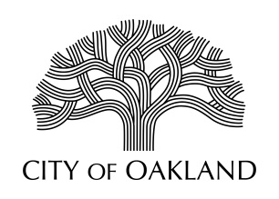
Cultural Affairs Division
Economic & Workforce Development Department

Public Art Advisory Committee
Regular Meeting
April 1, 2024
5:30 - 7:30 pm

MEETING CANCELLED

Next regularly scheduled meeting May 6, 2024
In person
Oakland City Hall
1 Frank Ogawa Plaza, Hearing Room 1
Agenda with Zoom Link will be posted 5/3/2024

Oakland Cultural Affairs - Public Art Program, 1 Frank H. Ogawa Plaza, 9th fl. Oakland, CA 94612 www.oaklandculturalarts.org

