Addenda

New Construction of Multifamily Affordable Rental Housing
2023 NOFA

City of Oakland

Department of Housing and Community Development

January 31, 2023
New Construction of Affordable Multifamily Rental Housing
2023 NOFA

Addenda

Table of Contents
- Addendum #1: Minimum Developer Qualifications 2
- Addendum #2: Guidelines for Developer Fees for Housing Development Projects 8
- Addendum #3: Affirmative Fair Marketing Procedures 12
- Addendum #4: Income Limits, Rent Payment Limits, and Utility Allowance 22
- Addendum #5: Insurance Requirements 28

City Of Oakland
New Construction of Affordable Rental Multifamily Housing
2023 NOFA

Addendum #1: Minimum Developer Qualifications

This section contains criteria for assessing developer experience, competence, and capacity. The criteria can help developers and development teams to evaluate the likelihood of obtaining City funding. Staff is available to discuss any of the criteria provided herein.

Developer Qualifications

The following set of developer criteria apply to the development entity that has applied for funding. All development entities applying for funding must meet the experience requirements below. A developer which does not meet the criteria for experience may joint-venture with a developer which does. Joint-venture criteria are outlined below in Section III.

I. Nonprofit Developers
Development Experience. The development entity applying for funding must have experience successfully completing at least three affordable housing development projects. At least one of the completed projects must be similar to the project for which funding is being sought. This requirement may be met through a joint venture or similar partnership/contract agreement, so long as the rights and responsibilities of all parties are clearly delineated.
Developers must submit the following information concerning completed projects, using the format provided in the Application.

1. The type of project developed (number of units, funding sources, total development cost, new construction or rehabilitation).
2. Location of project.
3. Date of project start and completion.
4. List of staff members involved in the development of the project.
5. The income level of the households that were served.
6. Name, title, and telephone number of staff member of local governing body most familiar with the project.
7. Whether project was on time and on budget (relative to schedule and budget at start of construction). Explain the reasons the project went over budget or planned development timeframe, as applicable.
8. For tax credit projects, Applicant must include the initial construction line item budget as submitted at construction loan closing, the final line item construction budget documented at permanent loan closing or the 8609 Tax Credit cost certification, and the degree to which each project was completed on time and on budget. To the extent time and cost overruns occurred, a description of the reasons for such overruns should be provided. If any developer fee was deferred beyond final equity payment, such deferral should be described along with an explanation of the reasons for the deferral.
9. For tax credit projects, Applicant must submit the last two years’ audited financial statements, and the current year unaudited year-to-date financial statement, for a minimum of three tax credit developments (9% or 4%) for which the developer serves as managing general partner or managing member. These statements should clearly account for operating costs, debt service payments, deposits and withdrawals from replacement, operating, transition (for projects with Project-Based Voucher (PBV) commitments) and other project reserves, as well as balances for all project reserve accounts, tenant security deposit accounts, deferred developer fees, if any, and distribution of residual receipts to public lenders and to the developer, if any.

COMMUNITY HOUSING DEVELOPMENT ORGANIZATIONS (CHDOs). For organizations qualifying as CHDOs for the purposes of HOME funding, the staff with development experience must be paid employees on staff at the organization (not consultants, contractors, board members, or volunteers). Training of staff by consultant may be acceptable on a case-by-case basis.

II. For-Profit Developers
In general, the experience of a for-profit developer will be treated similarly to the experience of a nonprofit developer. For-profit developers must also submit the resumes of the firm principals.
III. Joint Ventures
A. Prior to funding approval, the City must review and approve all joint venture agreements. In all joint ventures, a majority interest and control must be held initially by the development entity meeting the City requirements for experience as described in Sections I & II above.

B. If the joint venture entity is composed of a for-profit developer and a nonprofit developer, the City will decide which criteria are applicable by determining which joint venture partner has the majority interest in the management and operation of the joint venture. The joint venture agreement will be evaluated for the quality of the joint venture based on the following standards:
- equitable/appropriate developer fee, cash flow and management fee sharing arrangements;
- clear and non-redundant division of roles, responsibilities and compensation, including identification of which entity will be responsible for ongoing compliance; and
identification of whether the nonprofit or for-profit developer partner holds the purchase option at the end of the compliance period, or if it is held jointly and in what percentage interests.
On a case-by-case basis, the City may approve joint-venture agreements in which the development entity meeting the City experience requirements does not hold a majority interest in the development, but holds control over key development and management decisions.
IV. City Approvals
The City will require reasonable approval rights over project financing documents, including construction loan, permanent loan, third party subordinate loans and GP or related party loans. For projects proposed as limited partnerships, the City reserves the right to approve the limited partnership agreement.

Development Team Qualifications

The following section addresses the required elements of the development team. Resumes must be included for each development team member to document their qualifications and experience.

I. Required Experience of the Development Team

A. Developer Project Management: Experience with three similar projects is required.
- Please show experience with at least three projects similar to the project proposed.
- For 9% tax credit projects, Applicant must certify that developer qualifies for maximum CTCAC general partner experience points under the current CTCAC Regulations.
- Please show that the lead staff person assigned has completed one project from start to finish, which should be of the same general type and complexity as the project being proposed.
- Submit resumes and job descriptions of key staff.

B. Architect: Experience with three similar projects is required.
- Please show experience with at least three projects similar to the project proposed.
- Please show experience with a project that was financed by similar types of funding sources (e.g. local, state or federal). Experience in this area is desirable, not mandatory.
- Please show experience with similar construction types, e.g. steel or wood frame, podium construction.
- If this is unusually complex, please demonstrate experience with a project of similar complexity.
- Please show that the lead staff person assigned to the project has the required experience.
- Submit resumes and job descriptions of key staff.

C. Attorney: If the developer uses different law firms for different aspects of the projects, then key staff for the assignment should have experience in the relevant area.
- Please show experience in housing law.
- Please show experience in corporation law (nonprofit corporate law desirable, if a nonprofit developer is involved).
- Please show experience in real estate law.
- Please demonstrate experience in low income housing tax credit syndication (if the project is proposed to be syndicated).
- Submit resumes and job descriptions of key staff.

D. Development and/or Financial Consultant: Experience with three similar projects required. A development consultant is not required if the developer and development team possess sufficient experience.
- Please show experience with a project that was financed by similar types of funding sources (e.g. local, state or federal). Experience in this area is mandatory.
- If this project is unusually complex, please demonstrate experience with a project of similar complexity. Please show that the lead staff person assigned has completed one project from start to finish, which should be of the same general type and complexity as the project being proposed.
- Submit resumes and job descriptions of key staff.

E. General Contractor: Experience with three similar projects required. Designation of a general contractor is not required with the NOFA application submission. Upon designation of a general contractor, the following information must be submitted as part of the City approval process.
- Please demonstrate experience with similar construction types, e.g. steel or wood frame, podium construction.
- Please demonstrate experience with similar projects in the City of Oakland or the Bay Area. For LIHTC project, contractor should evidence successful and timely completion of at least three LIHTC projects within proforma budget projections.
- If this project is unusually complex, please demonstrate experience with a project of similar complexity.
- Please show experience with prevailing wage/Davis-Bacon requirements. Experience in this area is desirable. If contractor has been involved with a previous project partially financed by the City, previous performance will be considered.
- Please show experience with local hiring and contracting programs. Experience in this area is desirable. If contractor has acted on a previous project partially financed by the City previous performance will be considered.
- Please demonstrate that the contractor has the capacity to take on the project.
- Please show that the on-site construction supervisor has the experience required of the contractor.
- Submit resumes and job descriptions of key staff including the on-site manager.
- Submit evidence that the contractor has the ability to obtain the required labor and materials, and performance bonds in an amount equal to one hundred percent (100%) of the construction contract amount.

F. Property Manager
- Submit evidence of experience with three similar projects.
- Submit list of all projects managed within the past five years and show the current status.
- Submit evidence of experience with the management of projects that are subject to rent and occupancy restrictions
- For 9% tax credit projects, Applicant must certify that developer qualifies for maximum CTCAC property manager experience points under the current CTCAC Regulations.
- If the proposed project is unusually complex, please demonstrate experience with a project of similar complexity.
- Please show that the lead staff person assigned has the same management experience that is required of the manager.
- Please provide evidence that the management company has the capacity to take on the project.
- Submit resumes and job descriptions of key staff.

G. Identity of Interest

- Each developer partner/entity must provide a description of any interlocking ownerships the entity might have with contractors, management companies, financial institutions or entities, or other contractors or consultants that might be involved in the project, and a description of how these services might be used for the project.

- Developer as Builder: If the developer desires to act as the builder, all the requirements that have been listed under “E. Contractor” must be met by the developer. An identity of interest between the developer and the general contractor will be allowed provided the project adheres to all general contractor and contracting guidelines, at the sole discretion of the City.

- Developer as Property Manager: If the developer desires to act as the property manager, all the requirements that have been listed under “F. Property Manager” must be met by the developer. An identity of interest between the developer and the property manager will be allowed if the proposed property management fees and operating costs are in line with current industry standards, at the sole discretion of the City.

City Of Oakland
New Construction of Affordable Rental Multifamily Housing
2023 NOFA

Addendum #2: Guidelines for Developer Fees for Housing Development Projects
Maximum Developer Fee

Tax Credit Projects

At application for City funds, the total developer fee allowed for tax credit projects (both for 4% and for 9% projects) shall not exceed the maximum allowed under CTCAC Regulations (see CTCAC Regulations Section 10327).

If, after receiving a commitment of City funding, the sponsor is able to leverage additional funding which allows a fee higher than the maximum shown above without a request for additional City funding, the City may negotiate and approve additional developer fees for the project.

Maximum fee
    - For 9% tax credit projects, the maximum developer fee paid from cash through conversion/8609 and deferred developer fee projected to be completely paid by Year 15 that may be included in project costs shall be the lesser of the maximum allowed by CTCAC and shall not exceed: a) $2 million for rehabilitation or adaptive reuse and b) $2.2 million for new construction. Exceptions may be made for GP Contributions tied to increased developer fees above these standards, if and only if the net effect is to increase equity payments to the Project, and reduce the City gap loan. The City in its sole discretion will limit developer fees to these standards.
    - For 4% tax credit projects, the maximum developer fee that may be paid from development sources shall be $2 million with an additional $1.5 million allowed paid from Developer’s share of residual receipts as deferred fee. Between up-front developer fees paid by development sources and deferred fees paid from Developer’s share of residual receipts, developer fee shall not exceed $3.5 million; however,
For 4% tax credit projects with emerging developer applicants, or for joint venture applicants where the emerging developer partner receives at least 20% of the development fee (including 20% of the non-deferred development fee).
The maximum non-deferred developer fee is the sum of 15% of the project’s unadjusted eligible basis and 15% of the basis for non-residential costs included in the project allocated on a pro rata basis (per CTAC regulations Section 10327 (c)(2)(B)(I)). All developer fees in excess of two million five hundred thousand ($2,500,000) dollars plus $20,000 per unit for each Tax Credit unit in excess of 100 shall be deferred or contributed as equity to the project.
    - Including contributed GP equity to increase tax credit basis and equity will be allowed, as permitted by tax counsel, lenders and investors.

Non-Tax Credit Projects

For projects not using tax credits, the following limits will apply.

First 20 units: $33,000 per affordable unit
Unit 21 to unit 40: $22,000 per affordable unit
Units 41 and above: $17,000 per affordable unit

However, the fee for each project is subject to approval by the City of Oakland. Note that fees may also be capped by other financing sources.

Allowable fees for mixed-income projects will be negotiated on a project-by-project basis. If the proposed project includes market-rate units, is an acquisition/rehab or refinance/rehab, please call Housing Development staff as soon as possible prior to submitting your application to discuss the allowable developer fee.

Developer fees are contingent upon satisfactory completion of the project. Where project costs exceed the approved budget, developers will be required to contribute a portion of the developer fee toward the excess costs.
Schedule for Disbursements
The approved total developer fee for the project will be earned based on a schedule agreed upon by the City and the developer. The following standard schedule of disbursement applies, and is expected to be implemented.

    - Construction Closing: Maximum 30%, with City discretion to decrease to 10%
    - Construction Completion: Maximum 20%
    - Conversion: The balance of the fee (minimum 40%)
    - 8609: Minimum 10%, with City discretion to increase to 20%

Controlling disbursement of fees in coordination with other funders
In the case of fees paid from syndication, the City will make the payment schedule a condition of approval of the limited partnership agreement. When developer fees are funded by other lenders, the City may need to negotiate with other lenders and/ or the investor to ensure that the above schedule is followed and to ensure that other City protections are included in financing documents.

The applicant is required to provide the City disbursement schedule to all other funding sources. Subsequently, the City will assume that other funding sources are aware of the disbursement requirements, and that the preceding disbursement schedule will be implemented and followed. The City will not agree to give construction lenders control over the disbursement of any City funds. However, the City will agree to provisions that provide for mutual review and approval of loan disbursements by the project’s construction lenders.

The City will hold a performance retention, which will be retained under the completion of construction and disbursed in accordance with negotiated terms and conditions in an amount of its funds equal to the final developer fee payment until the final project cost certification is reviewed and approved, and the final HOME Completion Report (if applicable) or tenant lease up report is reviewed and approved.

Costs included in "Developer Fee"
Any funds disbursed to the developer or sponsor for administrative costs, provision of guarantees, interest on developer predevelopment loans, construction administration, or fees for services are considered to be a portion of the developer fee. Payments into reserves required by lenders or investors will not be included, but payment of fees for guaranteeing against operating deficits will be included. Specific examples of items to be treated as fees (in addition to any fees charged by the developer) include:
- Administration
- Staff costs, including development consultants (but not historic preservation, environmental, or syndication consultants)
- Net worth guarantee fees
- Marketing and/or rent-up supervision fees
- Tax credit compliance guarantee fees
- All credit consultant fees
- Real estate brokerage fees paid to a related party
- Loan brokerage fees paid to a related party
- Processing agent fees
- Developer overhead and profit
- The cost of any personal guarantees
- Reserves in excess of those customarily required by multi-family housing lenders.
Treatment of "Partnership Management" or “Asset Management” Fees
A Partnership Management fee is allowed to be paid to the General Partner of a tax credit project for handling investor relations, tax preparation, etc., and an Asset Management fee is allowed to be paid to the General Partner for all projects (including those without tax credits) for handling ongoing asset management tasks. The combined Partnership and Asset Management fee for tax credit projects, excluding investor’s fees, should not exceed $25,000, and the General Partner must pay for the cost of an annual project financial audit and may increase at up to 3.5% per year. For non-tax credit projects, Asset Management fees may not exceed $12,500 per year. Both fees may be paid from project cash flow after debt service and deposits to reserves. Deferred partnership/asset management fee can only be paid from the developer sponsor’s portion of the Incentive Management Fee.
Incentive Management Fee
For nonprofits, if a project has no monitoring findings or other violations of City or other agreements, and if excess cash flow from operations is available after payment of operating costs, senior debt, deferred developer fee, and reserves, the developer/sponsor may keep 40% of the remaining cash flow as an Incentive Management Fee. If the project is owned by a partnership, the partnership agreement should clearly indicate that the Incentive Management Fee will be paid to the developer/sponsor. If other lenders also require residual receipts payments, the City’s 60% share of residual receipts will be shared with other soft lenders based on relative loan amounts. City Department staff must be included in any negotiations of residual receipts loan payments, and approve any final agreement regarding the definition and percent sharing of residual receipts. The City will consider provisions that give private lenders priority for repayment of their loans, as long as the City’s repayment rights are adequately recognized and protected.

City of Oakland
New Construction of Affordable Multifamily Rental Housing
2023 NOFA

Addendum #3: Affirmative Fair Marketing Procedures

- Policy on Nondiscrimination and Accessibility

- Owners and managing agents of housing assisted by the City of Oakland must not discriminate against potential tenants or purchasers on the basis of race, color, religion, sex, physical or mental (including cognitive, developmental or emotional) disability, familial status (presence of child under age of 18 and pregnant women), national origin, ancestry, age, marital status, sexual orientation, gender identity or expression, having Acquired Immune Deficiency Syndrome (AIDS) or AIDS related conditions (ARC), immigration status, source of income, any arbitrary basis, or any other status protected by federal, state or local law.

- Owners and managing agents must comply with the Ronald V. Dellums and Simbarashe Sherry Fair Chance Access to Housing Ordinance set forth in City of Oakland Ordinance No. 13581, and codified at Chapter 8.25 of the Oakland Municipal Code. In accordance with this ordinance, an owner of residential rental property (referred to in the ordinance as a “Housing Provider”) shall not, at any time or by any means, whether direct or indirect, inquire about an applicant’s criminal history, require an applicant to disclose criminal history, require an applicant to authorize the release of criminal history or, if such information is received, base an adverse action in whole or in part on an applicant’s criminal history.

- Owners are prohibited from applying screening criteria that may have a disparate impact on a protected class. While negative credit or rental history may be considered, the use of credit scores is prohibited. Applicants who are denied due to negative credit or rental history must be provided an opportunity to submit a statement for consideration of mitigating circumstances. Owners must take into account factors such as debt related to a disability or other extenuating circumstances, length of time since the transaction, and change in circumstances since the transaction.

- Owners must undertake affirmative marketing efforts to reach persons that are unlikely to apply for housing due to its nature, location or other factors.

- Developers receiving Federal funds are required to create units that are accessible to people with disabilities. At least five percent of new units must be accessible to people with mobility impairments and at least two percent must be accessible to people with hearing or vision impairments.

- In addition to Federal laws requiring units for people with physical disabilities, fair housing laws require owners to make reasonable accommodations to people with all types of disabilities who request accommodations due to disability at any time during the application, resident selection and rent-up process. In doing so, owners may be required to make and pay for structural and non-structural modifications to dwelling units and common areas when needed as a reasonable accommodation for tenants or applicants with disabilities. In such cases where providing a requested accommodation would result in an undue financial and administrative burden, developers are required to take any other action that would not result in an undue burden.

- All developers who receive funds from the City are required to enter into loan agreements, and regulatory agreements with the City prior to receiving any funds. These agreements are designed to bind the recipients to all of the program requirements, including the affirmative fair marketing procedures.

- The following document outlines the affirmative fair marketing procedures that must be adhered to by developers and owners of housing units assisted by the City.

II. Training

1. The owner and managing agent shall provide property management staff with all relevant regulations and fair housing provisions. All property management staff shall be required to follow the procedures and policies adopted by the owner and managing agent.

- Property management staff shall annually receive instruction regarding fair housing laws and the development’s Affirmative Fair Marketing Plan. Formal training programs shall include marketing, outreach, data collection, reporting, and record keeping.

- Methods and Practices for Informing the Public

- In order to inform the public, owners, and prospective tenants about Federal fair housing laws and the City's affirmative marketing policies, the City will include the Equal Housing Opportunity logo and/or slogan, and a logo and/or slogan indicating accessibility to persons with disabilities, in all press releases, solicitations, and program information materials.

- In addition, the City provides funding to a number of fair housing agencies to provide information and counseling regarding fair housing laws and policies.

- Marketing and Outreach

- As a condition of the agreements, not less than 180 days prior to project completion, owners must submit a proposed marketing and management plan to the City for review and approval. Prior to commencing marketing activities, owners will be required to meet with City staff to review the proposed marketing strategy to ensure that affirmative marketing efforts will be employed.

Marketing and management plans must include information on strategies for reaching persons and groups not likely to apply including, but not limited to, households that include a member with disabilities. Marketing and management plans must also include procedures for ensuring that people with disabilities who request accessible features are given preference for occupancy of accessible units, as described below. Marketing and management plans must include policies for ensuring reasonable accommodation for persons with disabilities. Marketing and management plans must also contain policies and provisions for recordkeeping and monitoring. The City will provide written guidance on selection of tenants and reasonable accommodation during occupancy, if requested.

- All advertising shall display the Equal Housing Opportunity logo and/or the phrase “Equal Housing Opportunity”, and a logo and/or slogan indicating accessibility to persons with disabilities. Fair housing posters must be displayed at the project rental or sales office.

Marketing and management plans must include use of a welcoming statement to encourage people with disabilities to apply for units, as well as a description of available units, accessible features, eligibility criteria, and the application process. The City will provide developers with sample notices, if requested.

Marketing and management plans must indicate that qualified applicants with disabilities who request accommodation shall receive priority for the accessible units. Open houses and marketing offices must be accessible to allow persons with disabilities to visit the site and retrieve information about accessible units.

- Owners are required to advertise available units in media outlets of general circulation unless the City approves an alternative notification strategy. Owners must also provide notice to neighborhood community groups when units become available. The management agent shall place notices in newspapers, specialized publications, and newsletters to reach potential residents. Applications, notices, and all publications will include a Fair Housing and Equal Opportunity Logo, and the Accessibility Logo. Community media advertisement of the projects may include the following:

  - East Bay Times
  - Oakland Post
  - La Opinion de la Bahia (Spanish)
  - Sing Tao Daily Newspaper (Chinese)
  - Oakland Times Vietnamese Newspaper (Vietnamese)
  - Thoi Bao Magazine (Vietnamese)
  - Eden I&R, Inc. 2-1-1- Information and Referral Line

- Consistent with the resident population each development was designed to serve, the marketing of the project must ensure equal access to appropriate size units for all persons in any category protected by Federal, state, and local laws governing discrimination.

Owners are required to engage in special outreach to persons and groups in the housing market area who, in the absence of such outreach are not likely to apply for the housing. In determining what special outreach is needed, owners should take into account past patterns of discrimination, the racial and ethnic makeup of the neighborhood, language barriers, location, or other factors that might make it less likely that some persons and groups (a) would be aware of the availability of the housing or (b) would be likely to apply for the housing. A completed HUD Form 935-2A (Affirmative Fair Housing Marketing Plan) may be required as part of this analysis.

Special marketing outreach consideration should be given to members of protected classes which have been identified as having disproportionate housing needs, which may include the following groups:

a. African-Americans
b. American Indians
c. Hispanics
d. Asians and Pacific Islanders
e. Persons with disabilities and persons with special supportive housing needs
f. Very low income households of all types (including persons making the transition from homelessness to permanent housing)
g. Non-English speaking residents
h. Large families and families with children

- In particular, owners are required to advertise in media which are reasonably likely to reach such targeted groups, and to provide notice to neighborhood community organizations, fair housing agencies, and other similar organizations. A list of local disability organizations and community development boards will be provided by HCD if requested. HCD will also provide developers with sample advertisements if requested.

Multilingual advertising is encouraged where such efforts would result in reaching persons and groups not likely to apply. Owners and managers must ensure that people with limited English proficiency are not discouraged from applying or discriminated against and are encouraged to provide translation assistance or referrals to community-based organizations that can assist with translation.

- Specific Procedures for Ensuring that Accessible Units are Occupied by People with Disabilities who Require Accessible Features

- Outreach by owners to the disability community shall include the distribution of notices describing:

a. the availability of all units;
b. specific information regarding the availability and features of accessible units;
c. eligibility criteria; and
d. application procedures

- All application forms shall include information indicating that people with disabilities requiring accessible features shall receive priority for accessible units. The application must include a section to be filled out by any applicant requesting an accommodation with details on the applicant’s special needs for accessible features or other accommodations. Under no circumstance should an applicant be required to disclose a disability unless requesting an accommodation. (Housing units targeting seniors or people with disabilities may request documentation of age or disability to verify eligibility, but only if the same questions and documentation are asked of all applicants.) This will allow developers to provide, upfront, any necessary accessible features and/or accommodations for those people requesting accommodations. For more information on tenant selection, request the document entitled “Selection of Individual Tenants.”

- Owners shall take reasonable nondiscriminatory steps to maximize the utilization of accessible units by eligible individuals whose disability requires the accessibility features of the particular unit. To this end, any vacant, accessible unit should first be offered to a current, tenant with disabilities of the same project or comparable project under the owner’s control. The occupant with disabilities must require the features in the vacant unit and must be occupying a unit not having such features. If no such occupant exists, the developer shall then offer the unit to a qualified applicant on the waiting list who has a disability requiring the accessibility features of the unit.

- Owners may offer an accessible rental unit to an applicant without a disability after efforts have been exhausted to occupy the unit by an individual with a disability. However, the owner shall require such an applicant to agree to move to an available comparable non-accessible unit when the accessible unit is needed by a household that includes a member with disabilities. Such an agreement should be incorporated into the lease.

Note: An owner may not prohibit an eligible family with a member who has a disability from accepting a non-accessible unit which may become available before an accessible unit. Owners are generally required to modify such a non-accessible unit as needed or move a household that includes a member with disabilities into a unit that can be altered. If the modifications would result in an undue financial and administrative burden or alteration in the nature of a program, the owner is required to take any other action that would not result in an undue burden. All applicants should be provided information about how to request a reasonable accommodation at the time they apply for admission and at every recertification.

VI. Procedures for Complaints

1. The owner shall maintain written procedures indicating how applicants or tenants can file grievances, appeals, or complaints regarding fair marketing and/or alleged discriminatory practices.

2. Owner shall promptly investigate all applicant or tenant complaints and shall take corrective actions as necessary.

3. Owner shall maintain records of all such complaints, investigations and corrective actions.

VII. Compliance Assessment

1. The owner and managing agent must review the project’s marketing and management plans at least every five years and update as needed to ensure compliance. The advertising sources shall be included in the review to determine if past sources should be changed or expanded.

2 Prior to any follow-up marketing and reopening of the waitlist, the owner and managing agent shall assess the success of affirmative marketing actions for each project. If the demographic data of the applicants and residents vary significantly from the jurisdiction’s population data for the target income group, advertising efforts and outreach should be targeted to underrepresented groups in an attempt to balance the applicants and residents with the demographics of the jurisdiction.

VIII. Data Collection and Record Keeping

1. Owners must establish and maintain an Affirmative Fair Marketing file for each project to hold advertisements, flyers, and other public information documents to demonstrate that the appropriate logo and language have been used. Additionally, owners must keep records of activities to implement the affirmative marketing plan, including other community outreach efforts and an annual analysis. Upon request, owners are required to submit to the City copies of all advertisements indicating the date the advertisements were placed and the media outlets which were used. Owners must also provide copies of notices sent to community groups and a listing of those groups to which notices were sent. Owners must maintain records for at least five years regarding marketing and tenant selection practices.

2. Owners shall keep up-to-date records for each project regarding the characteristics of persons applying for vacant units, persons selected to occupy units and residents of the project (including race, ethnicity, presence of children under the age of 18 in the household, requests for reasonable accommodation for a disability, income, and household size), and records about tenant selection or rejection. Under no circumstance should an applicant be required to disclose a disability unless requesting an accommodation. (Housing units targeting seniors or people with disabilities may request documentation of age or disability to verify eligibility, but only if the same questions and documentation are asked of all applicants.) Applicants cannot be discriminated against due to the presence of children in the household.

3. Application materials must include the “City of Oakland Race and Ethnic Data Intake Form” or a substantially equivalent HUD form 2706-H. The owner and managing agent are required to offer each household member the opportunity to complete the form. Parents or guardians are to complete the form for children under the age of 18. Completed documents for the entire household shall be stapled together and placed in the household’s file.

4. Owners must maintain information regarding the location, description and number of vacant and occupied accessible units. In addition, owners must track and keep records of accessible and non-accessible units that are occupied by tenants requesting reasonable accommodations for a disability. Owners also should document any reasonable accommodations made to, or requested by, tenants during the reporting year.

  - Reporting and Monitoring

As part of the City’s monitoring of assisted housing developments, the City may review the owners’ records to verify that either:

- Each household living in a physical and sensory accessible unit has at least one household member who needs the accessible features of the unit; or
- If an accessible unit is not occupied by a household who has at least one household member who needs the accessible features of the unit, the owner will verify that no such households (either current or prospective tenants) are on a waiting list for the accessible unit. The owner will also provide documentation that the current occupants agree to move to a comparable non-accessible unit when the accessible unit is needed by a household that includes a member with disabilities.

The owner and managing agent shall provide the City access to any pertinent books, documents, papers or other records of their City-assisted properties, as necessary, for determining compliance with civil rights and nondiscrimination requirements.

The duration of monitoring of Affirmative Fair Housing Marketing (AFHM) requirements varies with each housing program. For homeownership programs, AFHM requirements apply through the completion of initial sales transactions on units covered by the approved AFHM plan. For assisted rental housing, AFHM requirements apply throughout the term of the loan and regulatory agreements, including those periods when the project does not maintain occupancy. Assisted housing developments must comply with current City Affirmative Fair Housing Marketing requirements, not the policies in effect when the regulatory agreement was executed. Owners are responsible for researching and implementing the City’s current requirements.

  - Assessment of Success and Corrective Actions

- The City will review records maintained by owners to ensure that affirmative fair marketing requirements are being met. Where the characteristics of applicants are significantly different from the make-up of the City's population (i.e., in cases where specific groups are over-represented or under-represented), the City will examine in more detail the owner's actions to determine if a violation of the requirements has occurred.

- The City may employ a variety of corrective actions. Initially, owners who have not fully complied with the requirements will be directed to engage in targeted marketing efforts to reach groups not initially reached. In cases where owners refuse to comply with the affirmative fair marketing procedures, the City may take additional actions to secure performance under the loan agreement or regulatory agreement, including declaring the loan in default and recapturing the funds.

Attachments

Attachment A: Additional Resources Available from the City of Oakland

Attachment B: Sample Advertisement/Listing
Attachment A

Additional Resources Available from the City of Oakland

- List of local community organizations
- List of local HUD-approved housing counseling organizations, if applicable (available from Homeownership Program)
- List of City-trained loan consultants, if applicable (available from
Homeownership Program)
- List of City-trained real estate professionals, if applicable (available from Homeownership Program)
- Sample Notice of Housing Availability
- Housing Logos and Slogans
  - Accessibility for Persons with Disabilities Logo and Slogan
  - Equal Housing Opportunity Logo and Slogan
- City of Oakland Race and Ethnic Data Intake Form and Instructions
- HUD-27061 “Race and Ethnic Data Reporting Form” and Instructions

Attachment B

Sample Advertisement

(Project name), an affordable housing development in Oakland has (studio, 1, 2, 3, and/or 4) bedroom apartments available at reduced rents for qualified low income households. Applicants with disabilities are encouraged to apply. Income and other restrictions apply. (Section 8 welcome) Equal Opportunity Housing Provider.

City Of Oakland
New Construction of Affordable Rental Multifamily Housing
2023 NOFA

Addendum #4: Income Limits, Rent Payment Limits, and Utility Allowance

Guidance for the City’s Income and Rent Limits is available here: https://www.oaklandca.gov/resources/rent-and-income-limits-for-affordable-housing

Please note: Applicants should use the most restrictive rents when determining income eligibility.

Applicants should assume the income and rent limits prescribed by California Health and Safety Code Sections 50053 and 50052.5 and their implementing regulations. Applicants shall be solely responsible for applying the provisions of Section 50053 and 50052.5 of the Health and Safety Code correctly. Income and rent limits are published here as a courtesy. If these published limits are determined to be incorrect or to conflict with the provisions of state or federal statutes, the state or federal statutes shall prevail.

2022 Income Limits

Income Limit | Household Size
 | One  Person | Two  People | Three  People | Four  People | Five  People | Six  People
20% of AMI  (Extremely Low Income) | $20,000 | $22,866 | $25,733 | $28,566 | $30,866 | $33,166
30% Income Level  (Extremely Low Income) | $30,000 | $34,300 | $38,600 | $42,850 | $46,300 | $49,750
50% Income Level  (Very Low Income) | $50,000 | $57,150 | $64,300 | $71,400 | $77,150 | $82,850
60% of AMI(Low Income) | $57,562 | $65,775 | $73,987 | $82,200 | $88,800 | $95,363
80% Income Level  (Low Income) | $76,750 | $87,700 | $98,650 | $109,600 | $118,400 | $127,150
100% Income Level (Area Median Income) | $99,950 | $114,250 | $128,500 | $142,800 | $154,200 | $165,650
120% Income Level (Moderate Income) | $119,950 | $137,100 | $154,200 | $171,350 | $185,050 | $198,750

2022 Rent Limits

Rent limits are published. To determine which chart is applicable to your project, see the Benchmark Occupancy Standard section below.

RENT LIMITS FOR PROJECTS RECEIVING FEDERAL ASSISTANCE
 | 0 BR | 1 BR | 2 BR | 3 BR | 4 BR
30% of 20% of AMI | $499 | $535 | $642 | $742 | $828
30% of 30% of AMI | $749 | $803 | $963 | $1,113 | $1,242
30% of 50% of AMI | $1,249 | $1,338 | $1,606 | $1,856 | $2,070
30% of 60% of AMI | $1,499 | $1,606 | $1,927 | $2,227 | $2,484
30% of 110% of AMI | $2,748 | $2,945 | $3,533 | $4,083 | $4,555

RENT LIMITS FOR PROJECTS NOT RECEIVING FEDERAL ASSISTANCE
 | 0 BR | 1 BR | 2 BR | 3 BR | 4 BR
30% of 20% of AMI | $499 | $571 | $642 | $714 | $771
30% of 30% of AMI | $749 | $856 | $963 | $1071 | $1,156
30% of 50% of AMI | $1,249 | $1,428 | $1,606 | $1,785 | $1,927
30% of 60% of AMI | $1,499 | $1,713 | $1,927 | $2,142 | $2,313
30% of 110% of AMI | $2,748 | $3,141 | $3,533 | $3,927 | $4,240

The City’s methodology for determining rent limits is described in a memo, available here: https://cao-94612.s3.amazonaws.com/documents/Memo-City-of-Oakland-Income-and-Rent-Limits-Methodology.pdf

Benchmark Occupancy Standard

Pursuant to California Health & Safety Code Section 50052.5, if the applicant anticipates receiving a form of federal assistance that contains a benchmark occupancy standard, apply the federal benchmark occupancy standard for all project units when determining rent limits. Examples of federal assistance include Low Income Housing Tax Credits, HOME Investment Partnership Program funds, or National Housing Trust Fund dollars. Project-based Section 8 vouchers do not prescribe a benchmark occupancy standard and therefore should not be considered when determining benchmark occupancy standards.

Number of Bedrooms | Non-Federally-Assisted Benchmark Occupancy Standard | Federally-Assisted Benchmark Occupancy Standard
0 | 1 person | 1 person
1 | 2 people | 1.5 people
2 | 3 people | 3 people
3 | 4 people | 4.5 people
4 | 5 people | 6 people

Utility Allowances
Applicants must calculate the utility allowances using the HUD Utility Schedule Model, unless you have a commitment of Vash vouchers or Project Based Section 8 vouchers. This model and its instructions can be found in CDS. Projects that have a commitment of Vash or Project Based Section 8 vouchers may use the Utility Allowance Schedule published by the Oakland Housing Authority.

The HUD Utility Model is located here: https://www.huduser.gove/ptal/home.htmlhttps://www.huduser.gov/portal/resources/utilallowance.html

The most recent Utility Allowance schedule is available for download here: http://www.oakha.org/Residents/Housing%20choice-voucher-residents/Pages/default.aspx

HOME Investment Partnerships Program

The City may award HOME funds to some assisted projects. HOME-assisted units shall follow the income and rent limits prescribed by HUD for the Oakland-Fremont HUD Metro FMR Area. If a unit receives assistance from both local funds and HOME funds, units must follow the most restrictive applicable income and rent limits. The City retains sole discretion to determine which funding source is allocated to each project unit.

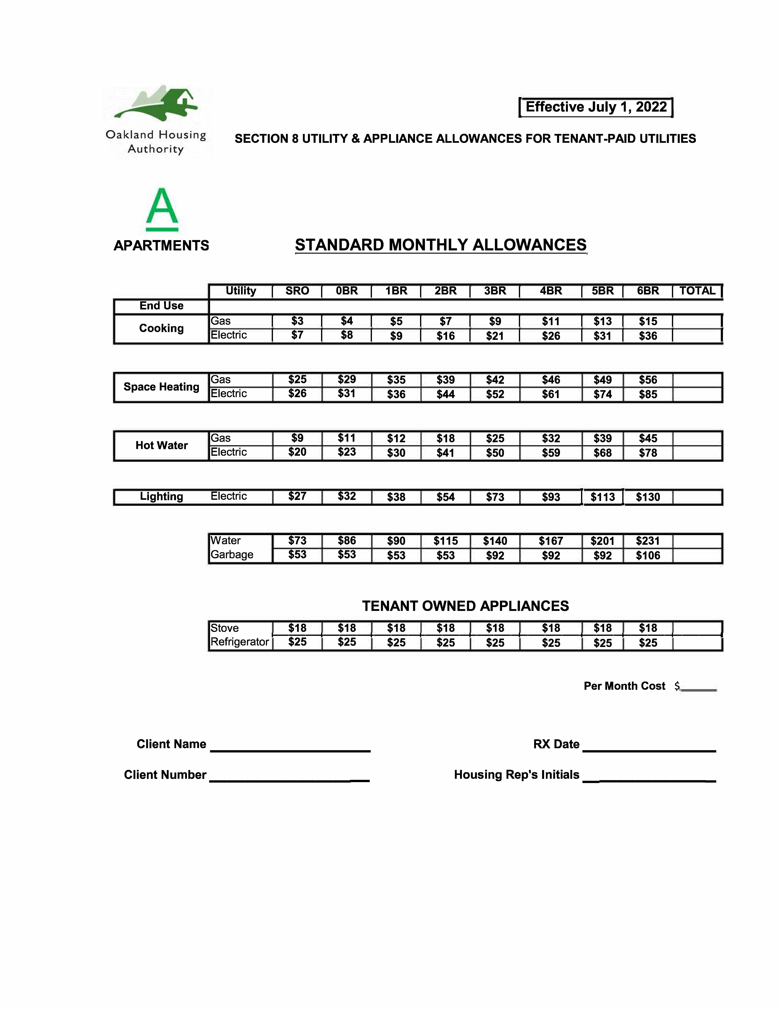
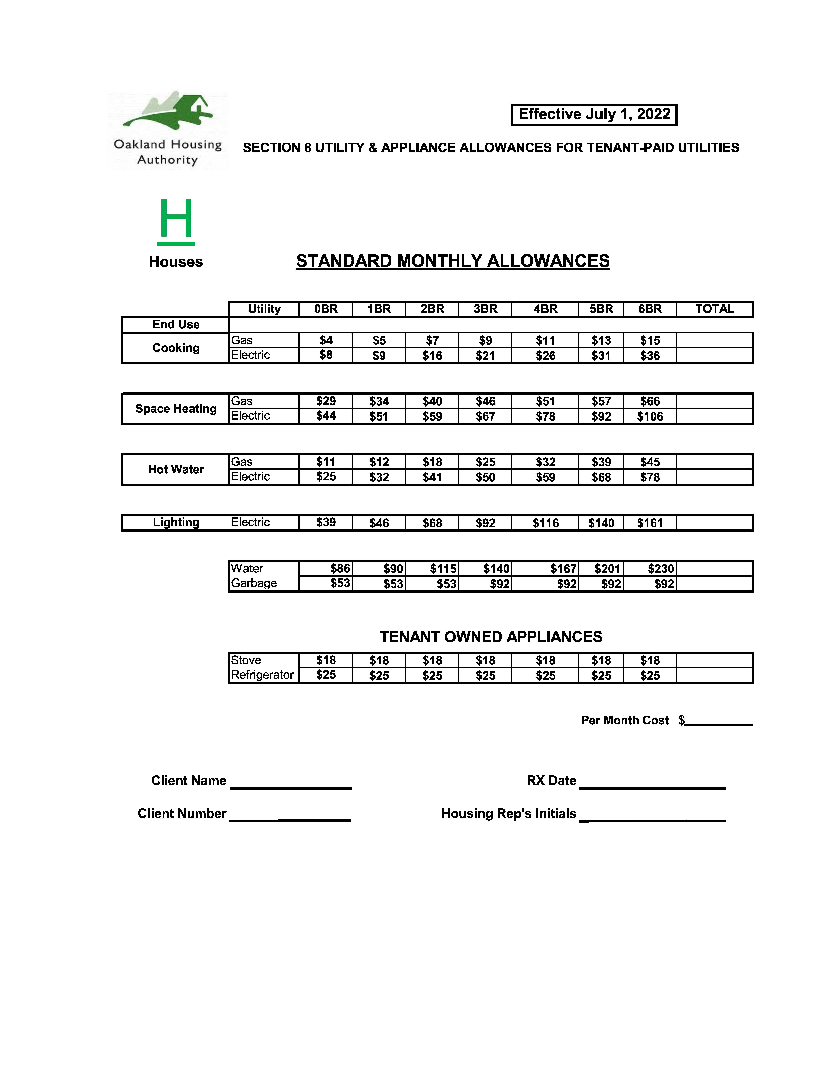
City of Oakland
New Construction of Affordable Rental Multifamily Housing
2023 NOFA

Addendum #5: Insurance Requirements

LOAN AGREEMENT: EXHIBIT I

I. Insurance Coverage Requirements

Borrower shall procure, prior to Loan closing, and keep in force for the term of this Agreement, at Borrower’s own cost and expense, the following policies of insurance or certificates or binders as necessary to represent that coverage as specified below is in place with companies doing business in California and acceptable to Lender. If requested, Borrower shall provide Lender with copies of all insurance policies. The insurance listed hereunder shall be considered minimum requirements and any and all insurance proceeds in excess of the requirements shall be made available to the Lender.

A. Commercial General Liability insurance (CGL), shall cover liability arising from premises, operations, independent contractors, products-completed operations, personal and advertising injury, Bodily Injury, Broad Form Property Damage, and liability assumed under an insured contract (including the tort liability of another assumed in a business contract); Contractual Liability; XCU; and Owners and Contractor Protective Liability. Pollution Liability coverage is required if Loan proceeds are used for the remediation of Hazardous Materials. The CGL policy must contain severability of interest clause or cross liability clause or the equivalent thereof.
i. Coverage afforded on behalf of Lender shall be primary insurance and any other insurance available to Lender under any other policies shall be excess insurance (over the insurance required by this Agreement).

ii. Limits of liability: Borrower must maintain commercial general liability (CGL) and, if necessary, commercial umbrella insurance with a limit of not less than $2,000,000 each occurrence. If such CGL insurance contains a general aggregate limit, it must apply separately to this project. The general aggregate limit shall apply separately to this location/project or the general aggregate limit shall be twice the required occurrence limit.

B. Automobile Liability Insurance. Borrower shall maintain automobile liability insurance for bodily injury and property damage liability with a limit of not less than $1,000,000 each accident. Such insurance shall cover liability arising out of any auto (including owned, hired, and non-owned autos). Coverage shall be at least as broad as Insurance Services Office Form Number CA 00 01.

C. Worker's Compensation insurance as required by the laws of the State of California. Coverage shall include Employers Liability coverage with limits not less than $1,000,000 each accident, $1,000,000 policy limit bodily injury by disease, $1,000,000 each employee bodily injury by disease. Borrower certifies that it is aware of the provisions of section 3700 of the California Labor Code, which require every employer to provide Workers' Compensation coverage, or to undertake self-insurance in accordance with the provisions of that Code. Borrower shall comply with the provisions of section 3700 of the California Labor Code before commencing performance of the work under this Agreement and thereafter as required by that code.

D. Professional Liability/Errors and Omissions insurance as appropriate for design/build operations with limits not less than $2,000,000 each claim and $2,000,000 aggregate. If the professional liability/errors and omissions insurance is written on a claims made form:

i. The retroactive date must be shown and must be before the date of the contract or the beginning of work.

ii. Insurance must be maintained and evidence of insurance must be provided for at least three (3) years after completion of this Agreement.

iii. If coverage is cancelled or non-renewed and not replaced with another claims made policy form with a retroactive date prior to the Agreement effective date, Borrower must purchase extended period coverage for a minimum of three (3) years after completion of work.

E. Builders Risk/Course of Construction Insurance (CP 10 30) covering all risks of loss in an amount equal to the completed value form with no coinsurance penalty provisions and in an amount equal to the initial contract sum, subject to subsequent modification of the contract sum. The insurance shall apply on a replacement cost basis. The insurance shall name as insured the City of Oakland, the Borrower, and all subcontractors in the work. The insurance shall cover the entire work at the site identified herein including reasonable compensation for architectural services, engineering costs, financing costs, legal fees (soft costs) and expenses made necessary by an insured loss. Insured property shall include portions of the work located away from the site but intended for use at the site and shall also cover portions of the work in transit. The policy shall cover the cost of removing debris, including demolition as may be made legally necessary by the operation of any law, ordinance or regulation. The insurance shall be maintained in effect until the Project has been accepted as substantially complete. The insurer shall waive all rights of subrogation against the City.

F. Property Insurance on an all risk coverage basis to the extent of full replacement value of the premises for the duration of the term of the Loan. Coverage amount may be adjusted for fluctuation in replacement values. This coverage is required upon completion of construction of the Project, or upon closing of this Loan if the Project is a rehabilitation project.

G. Loss of Rents Insurance Coverage in the amount of 75% of scheduled annual gross rents.

II. Terms, Conditions, and Endorsements

The aforementioned insurance shall be endorsed and have all the following conditions:

A. Insured Status (Additional Insured): Borrower shall provide additional insured status naming the City of Oakland, its councilmembers, directors, officers, agents, employees and volunteers as additional insured’s under the Commercial General Liability policy. General Liability coverage can be provided in the form of an endorsement to Borrower’s insurance (at least as broad as ISO Form CG 20 10 (11/85) or both CG 20 10 and CG 20 37 forms, if later revisions used). If Borrower submits the ACORD Insurance Certificate, the insured status endorsement must be set forth on an ISO form CG 20 10 (or equivalent). A STATEMENT OF ADDITIONAL INSURED STATUS ON THE ACORD INSURANCE CERTIFICATE FORM IS INSUFFICIENT AND WILL BE REJECTED AS PROOF OF MEETING THIS REQUIREMENT.

B. Loss Payee: Borrower must ensure that the City of Oakland, its Councilmembers, directors, officers, agents, employees and volunteers are named as Loss Payee in the Builders’ Risk Insurance and Property Insurance. Borrower shall provide appropriate Loss Payee endorsement as proof of meeting this requirement.

C. Cancellation Notice: 30-day prior written notice of termination or material change in coverage and 10-day prior written notice of cancellation for non-payment.

D. The Worker’s Compensation policy shall be endorsed with a waiver of subrogation in favor of the City for all work performed by the contractor, its employees, agents and subcontractors.

E. Cross-liability coverage as provided under standard ISO forms’ separation of insureds clause.

F. Certificate holder is to be the same person and address as indicated in the “Notices” section of this Agreement.

G. Insurer must carry an A.M. Best Rating of A VII, or better.

III. Replacement of Coverage

In the case of the breach of any of the insurance provisions of this Agreement, Lender may, at Lender’s option, take out and maintain at the expense of Borrower such insurance in the name of Borrower as is required pursuant to this Agreement, and may deduct the cost of taking out and maintaining such insurance from any sums which may be found or become due to Borrower under this Agreement.

IV. Insurance Interpretation

All endorsements, certificates, forms, coverage and limits of liability referred to herein shall have the meaning given such terms by the Insurance Services Office (ISO) as of the date of this Agreement.

V. Proof of Insurance

Borrower will be required to provide proof of all insurance required for the Loan prior to execution of the Loan Agreement, including copies of Borrower’s insurance policies, if and when requested. Failure to provide the insurance proof requested or failure to do so in a timely manner shall constitute ground for rescission of the Loan Agreement award.

VI. Subcontractors

Should Borrower subcontract out the work required under this Agreement, they shall include all subcontractors as insureds under its policies or shall maintain separate certificates and endorsements for each subcontractor. As an alternative, Borrower may require all subcontractors to provide at their own expense evidence of all the required coverages listed in this Exhibit. If this option is exercised, both Lender and Borrower shall be named as additional insured under the subcontractor’s General Liability policy. All coverages for subcontractors shall be subject to all the requirements stated herein. Lender reserves the right to perform an insurance audit during the course of the project to verify compliance with requirements.

VII. Deductibles and Self-Insured Retentions

Any deductible or self-insured retentions must be declared to and approved by Lender. At the option of Lender, either: the insurer shall reduce or eliminate such deductible or self-insured retentions as respects Lender, its Councilmembers, directors, officers, agents, employees and volunteers; or Borrower shall provide a financial guarantee satisfactory to Lender guaranteeing payment of losses and related investigations, claim administration and defense expenses.

VIII. Waiver of Subrogation

Borrower waives all rights against the City of Oakland and its Councilmembers, officers, directors, employees and volunteers for recovery of damages to the extent these damages are covered by the forms of insurance coverage required above.

IX. Evaluation of Adequacy of Coverage

Lender maintains the right to modify, delete, alter or change these requirements, with reasonable notice, upon not less than ninety (90) days prior written notice.

