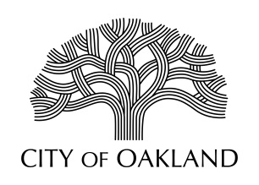
Cultural Affairs Division
Economic & Workforce Development Department

Public Art Advisory Committee
Regular Meeting
January 8, 2024
5:30 - 7:30 pm

MEETING CANCELLED

Next meeting: February 5, 2024
Hearing Room 3
1 Frank Ogawa Plaza, Oakland CA 94612
Agenda with City Hall Meeting Room location and Zoom Link will be posted 2/2/24

Oakland Cultural Affairs - Public Art Program, 1 Frank H. Ogawa Plaza, 9th fl. Oakland, CA 94612 www.oaklandculturalarts.org

